**Expression of Interest (EOI) for Design Development, Implementation and Maintenance of Learning Management System**

**Memo No.:** *CEDP/PMU/P/SD-603 (LMS)/234/2022/1882*

|  |  |
| --- | --- |
| Submitted To: | **Ministry of Education, Government of Bangladesh** Ministry of Education  Probashi Kallayan Bhaban, Level 11:  71-72 Eshkaton Garden Road Ramna, Dhaka – 1100 |
| Submitted by the Joint Venture of: | |
| Lead Bidder | **Sheba Technologies Limited**  8th Floor, Khawja Tower, 95, Mohakhali C/A, Dhaka-1212 |
| Associate Bidder | **WINGS Learning Center.** Dhanmondi R/A, Dhaka-1209  House # 55, Road # 4/A |

|  |
| --- |
|  |
|  |

March 23, 2022

*Date: March 23 2022*

**A K M Mukhlesur Rahman**

Project Director (Additional Secretary) (Field Administration)

CEDP, Ministry of Education

Probashi Kallayan Bhaban, Level 11:

71-72 Eshkaton Garden Road

Ramna, Dhaka - 1100

**Subject: Submission of Expression of “Design Development, Implementation and Maintenance of Learning Management System** *[EOI Ref. No.:CEDP/PMU/P/SD-603 (LMS)/234/2022/1882; Date: 07/03/2022]*

Dear Sir,

With reference to your invitation on the subject mentioned project we are pleased to submit herewith our Expression of Interest for your kind consideration.

We are Submitting the Expression of Interest in following description

**Sheba Technologies Ltd.**

House 55, Road 4/A, Dhanmondi R/A,

Dhaka 1209, Bangladesh

In Association (as a sub-consultant) with

**Wings Learning Center (WLC)**

Dhanmondi R/A, Dhaka-1209

House # 55, Road # 4/A

**Sheba Technologies Ltd. (STL)** is a subsidiary of Sheba Group which has over 20+ years of management experience with proven track record in rendering technologically advanced products and services. STL assists you to develop tailor-made software from scratch. A team of system analysts work on the solution architecture in a way that is designed to solve our client’s business/technological problems. STL brings business and application developer skillsets together to formulate necessary technical requirements and develop the best possible solution. Since its inception, STL has had the privilege to work with top Private, Non-Government and Public organizations where it ensures delivery of world class services and enterprise solutions. Within this short span of period, it also successfully produced and launched a robust in-house developed product.

We are always keen on listening to our customers and are constantly learning from their experiences while rendering Telecom and IT services. This has made us recognize the importance of evolving into the new ‘normal’ which is ‘Data is everything’. With this aspiration, STL is fully committed to bring world class technologically advanced Business Process Automation by delivering architecturally superior Software solution, Off-the-Shelf customizable Software, Digital Identity platform for Citizens, Smart City initiatives, Artificial Intelligence and Machine Learning to our esteemed clients who are also our long-term strategic partners.

**WINGS Learning Center. (WLC)** has been in operation as a leading education provider since 2000 and previously known as Victoria University, Australia in Bangladesh. It has been committed to provide with extraordinary language learning and Business executive development programs since its inception. WINGS Learning Center has become a trusted professional and career development partner for visionary and careerist learners in the competitive era of globalization. It is a full-service, year-round language training and testing services organization. One of the oldest language training institutions of Bangladesh, WLC is also British Council's test center for IELTS, O'Levels and all types of professional exams. Since its establishment, WINGS has helped students to learn English and to continue their studies at so many universities globally. WINGS provided MBA education with partnership of Victoria University, Melbourne, Australia till 2009. And, WLC also supports and runs a range of CPD courses on modern and contemporary Business Management and Development Economics matters in place. It has a research department developed and aimed to lead Economic Development Agenda and to train, to make routine research to aid Policy Makers in Bangladesh towards success of Economic Development in Bangladesh ahead.

To be the premier educational institution in providing high-quality, affordable and accessible educational programme’s serving the needs of business, industry and the diverse campus communities and facilitating the personal and professional development of its students, faculty and staff.

WINGS' vision is to become the ‘provider of choice’ of learning and development solutions in the market it serves. It designs and delivers high quality, original learning and development solutions that meet client’s organizational needs. It is devoted to inspiring people to realize their full potential through a wealth of learning solutions that is engaging, innovative and challenging.

To be a student-centered, dynamic and innovative, unique class campus of WLC-Wings learning Center, promoting excellence in teaching and learning, serving diverse communities and producing lifelong learners who can compete globally.

The EOI has been prepared on the basis of information provided in the invitation, Consultant’s knowledge and experience of similar works. The EOI also reflects our past experience obtained during the last decades in similar assignments at home and abroad.

Now, to substantiate our standing, we enclose herewith the EoI document which is reflective of the adequacy of our professionalism, capabilities and relevant experience. We believe that with the delineated experience, skill and expertise, you will find our EoI document adequate to shortlist us for the stated assignment.

We assure you that we will be available to respond any of your queries should you require any clarification from us.

We would expect to hear from you soon.

Thanking you,

Yours sincerely,

**Farhan Islam**Chief Operating Officer  
Sheba Technologies Limited  
Phone: +8801711547804  
Email: [farhan.islam@shebatech.com.bd](mailto:farhan.islam@shebatech.com.bd)

**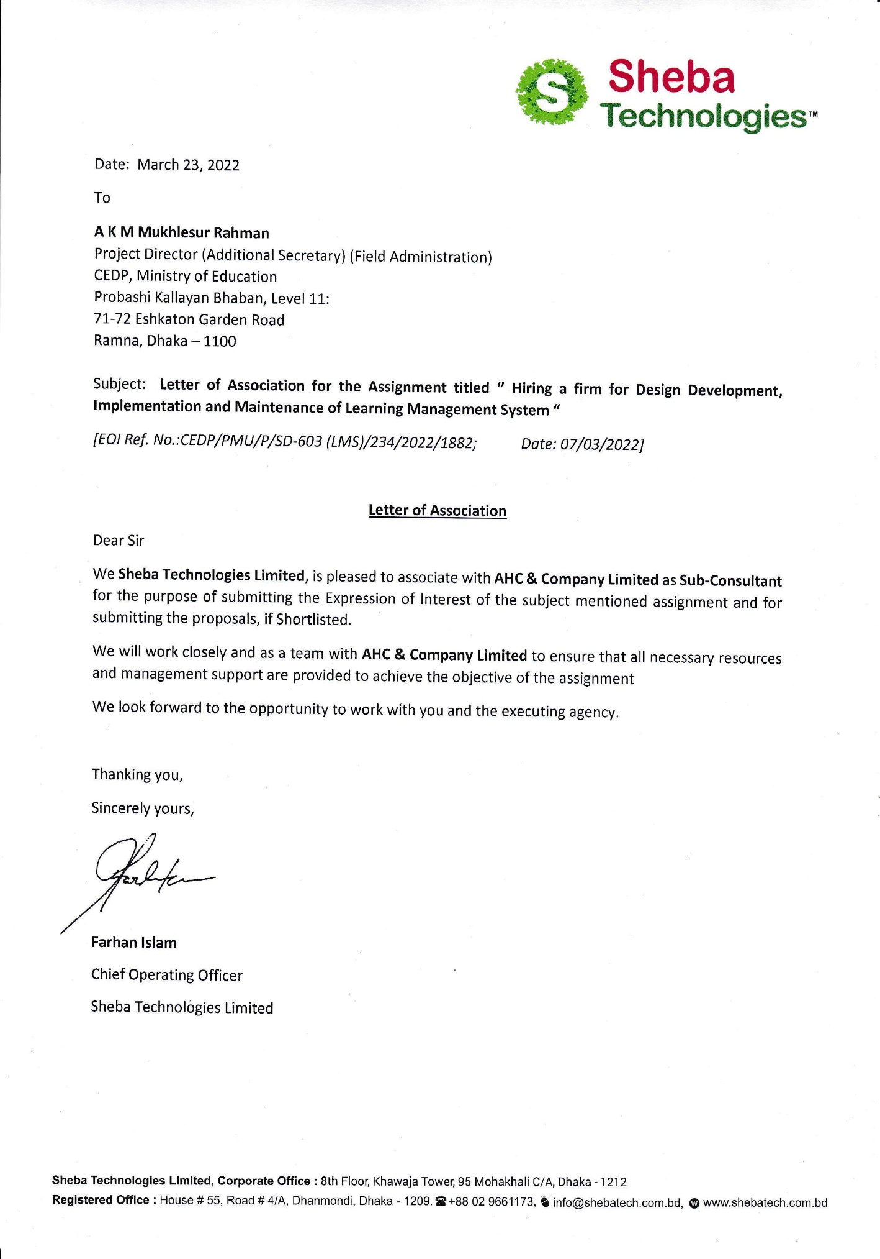*Letter of Association***

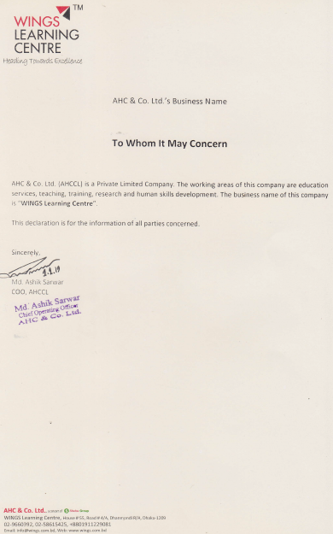

**Table of Content**

1.0 Section-1: Background and General Information of the Firms 7

1.1 Sheba Technologies Ltd (STL) 7

1.1.2 Company Background 7

1.1.3 Our Services 7

1.1.4 STL’s History 8

1.1.5 Management Profile 8

1.1.6 STL Organogram 9

1.1.7 Brochure of STL 10

1.2 Wings Learning Center (WLC) 45

1.2.1 Company Background 45

1.2.2 WLC’s History 45

1.2.3 Products / Services 46

1.2.4 Trainer’s Profile 47

1.2.6 Management Profile 49

1.2.7 Brochure of WLC 50

2.0 Section-2: Experiences of the Firm in Key Operating Areas 56

2.1. Sheba Technologies Ltd. 56

3.0 Section-3: Organizational Capability of the Firms 58

3.1. Sheba Technologies Ltd. 58

4.0 Section-4: Logistics Resources of the Firm 65

4.1. Sheba Technologies Ltd. 65

4.1.2 Efficient Logistic & Equipment 65

4.1.3 Facilities 66

4.1.4 Skill set 66

4.1.5 Work Centre With Modern Facilities 66

4.2. WINGS Learning Center. (WLC) 67

4.2.1 Training Equipment 67

4.2.2 Training Facilities 67

5.0 Section-5: STL Work Experience 69

6.0 Section-6: Availability of Technical Experts for Performing the Assignment 78

7.0 Annexure A STL’s Financial and Legal Document 206

8.0 Annexure B General Experience, Relevant Experience & Consultant’s Experience Form 245

9.0 Annexure C List of Professional Strength (technical and Managerial Personnel) 250

10.0 Annexure D Copy of the Advertisement 252

# 1.0 Section-1: Background and General Information of the Firms

# 1.1 Sheba Technologies Ltd (STL)

* + 1. Company Background

Sheba Technologies Limited (STL) is part of the Sheba Group conglomerate which has been in Tech business for almost quarter of a century. We are always keen on listening to our customers and are constantly learning from their experiences while rendering Telecom and IT services. This has made us recognize the importance of evolving into the new ‘normal’ which is ‘Data is everything’. With this aspiration, STL is fully committed to bring world class technologically advanced Business Process Automation by delivering architecturally superior software solution, off-the-shelf customizable software, digital identity platform for citizens, smart city initiatives, artificial intelligence and machine learning to our esteemed clients. Please see Annexure for legal documents and attached STL full portfolio for details.

* + 1. Our Services

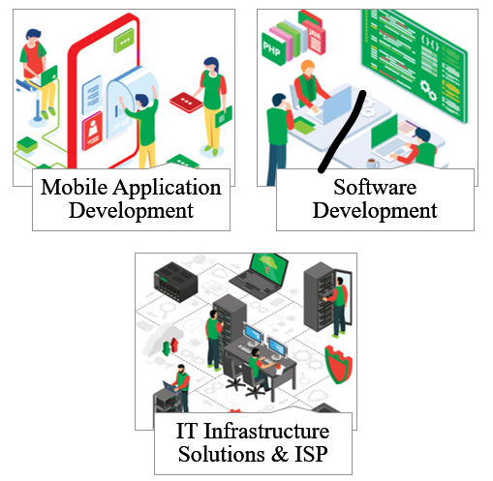

* + 1. STL’s History 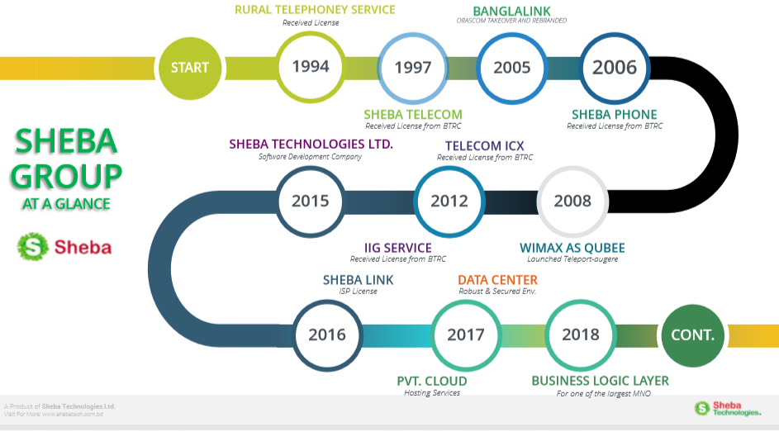
    2. Management Profile

**Afzal H. Choudhury** is the Founder & Group Chairman. He started his career at BTTB and later started his own business. He has a B.S. degree in Electrical Engineering and has obtained advanced training on Satellite Telecommunications in 1973 from the USA.

**Asif H. Choudhury** is the Group Managing Director. He has been involved with Sheba Group since 2002. Prior to joining Sheba Group, he worked for Credit Agricolebank in their project finance unit and also worked at CDIC as an analyst. He has an undergraduate degree in Economics and Political Science from Rutgers University and an MBA from McGill University.

**Reaz U. Ahmed** is the Chief Executive Officer, responsible for Group’s Telecom and ICT business development and operations. He has worked for high tech companies for more than 10 years in the heart of Silicon Valley, California. He has a B.S. degree in Electrical Engineering from Rutgers University.

**Mohammad Somael Kabir** is the Chief Technology Officer for the Group’s Telecom and ICT Planning, Implementation and Operations. He has 16 years of experience in Telecom and ICT infrastructure planning, capacity analysis, business plan development and system implementation. His certifications include: CEH, CICISO, RHCVA, RHCEv5.

* + 1. STL Organogram

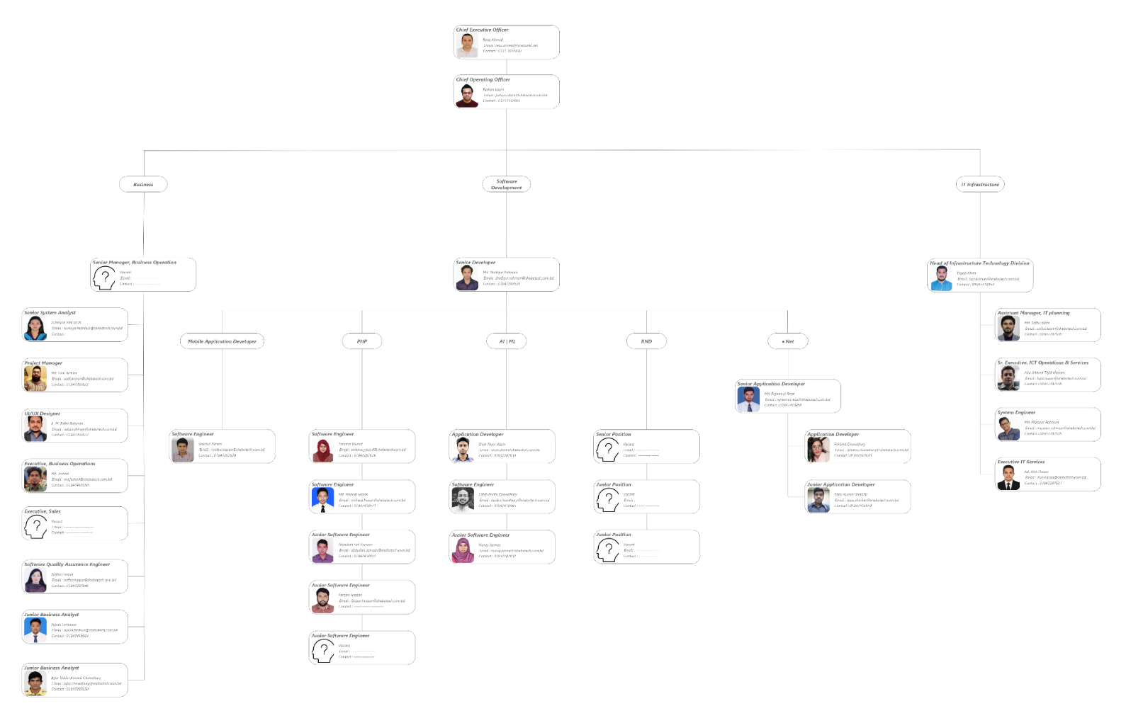

* + 1. Brochure of STL

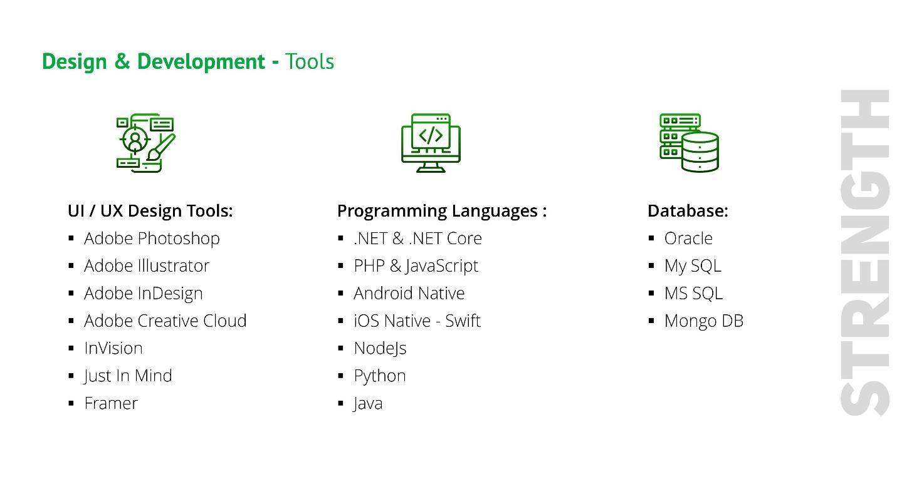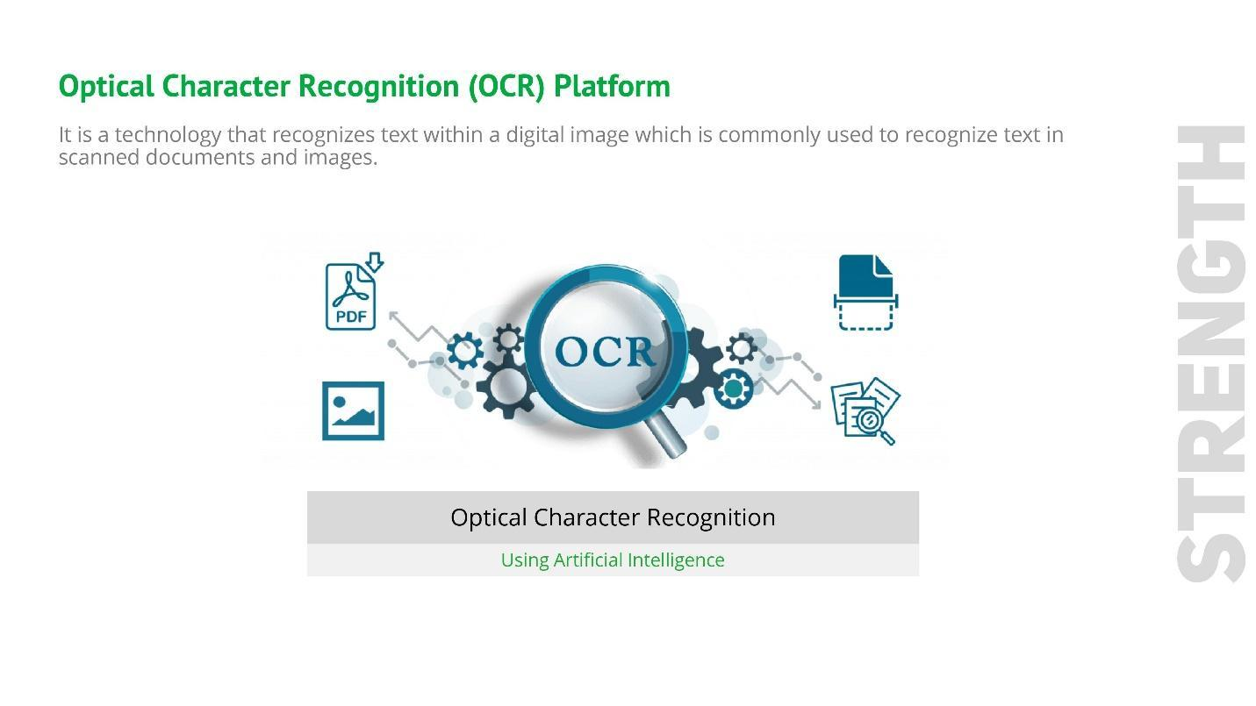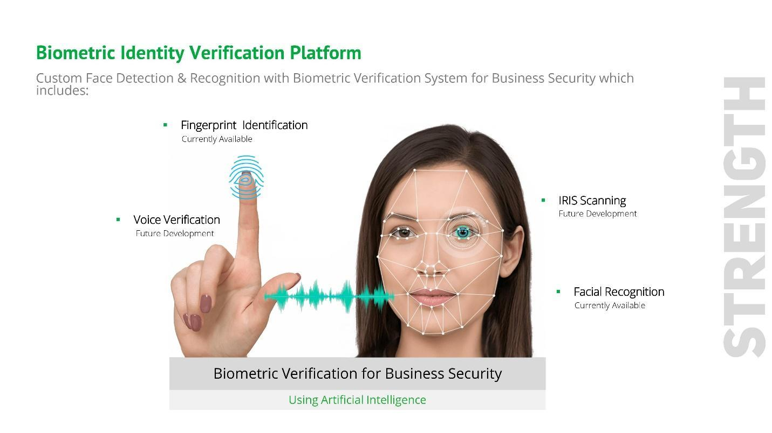

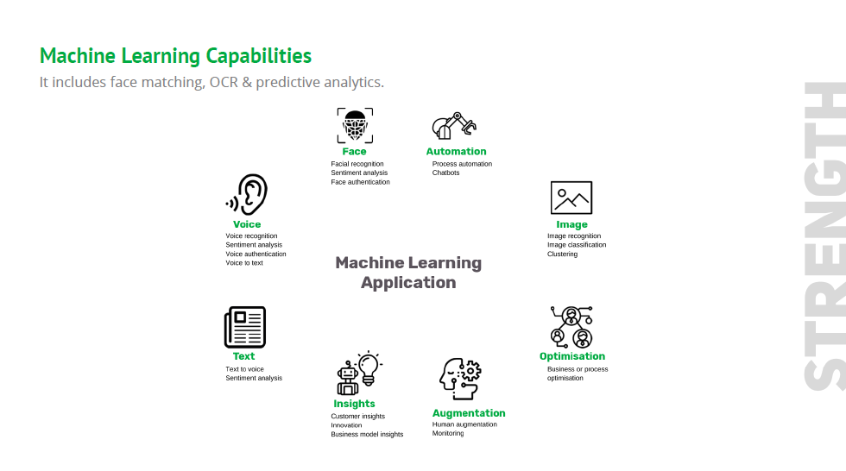

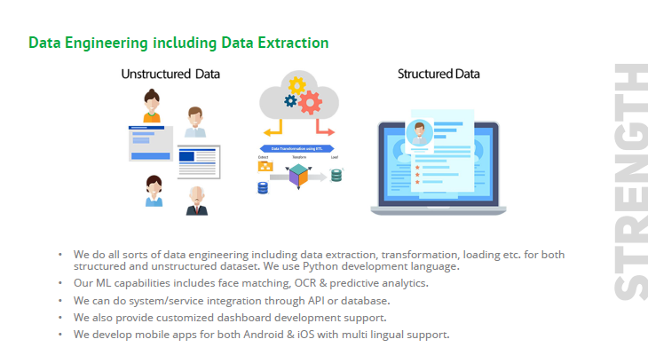

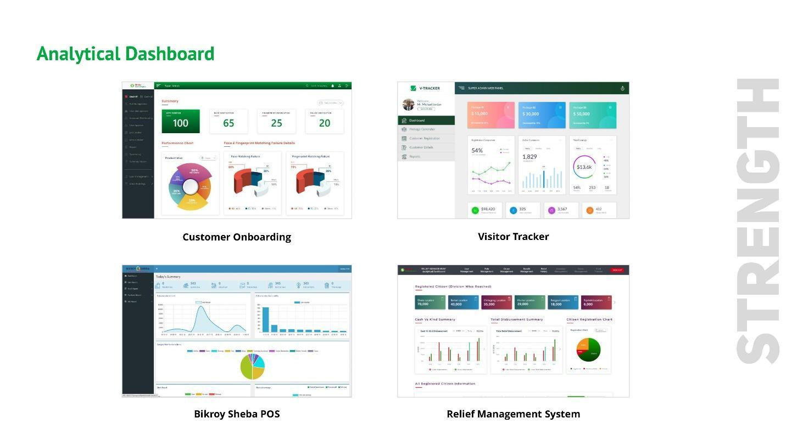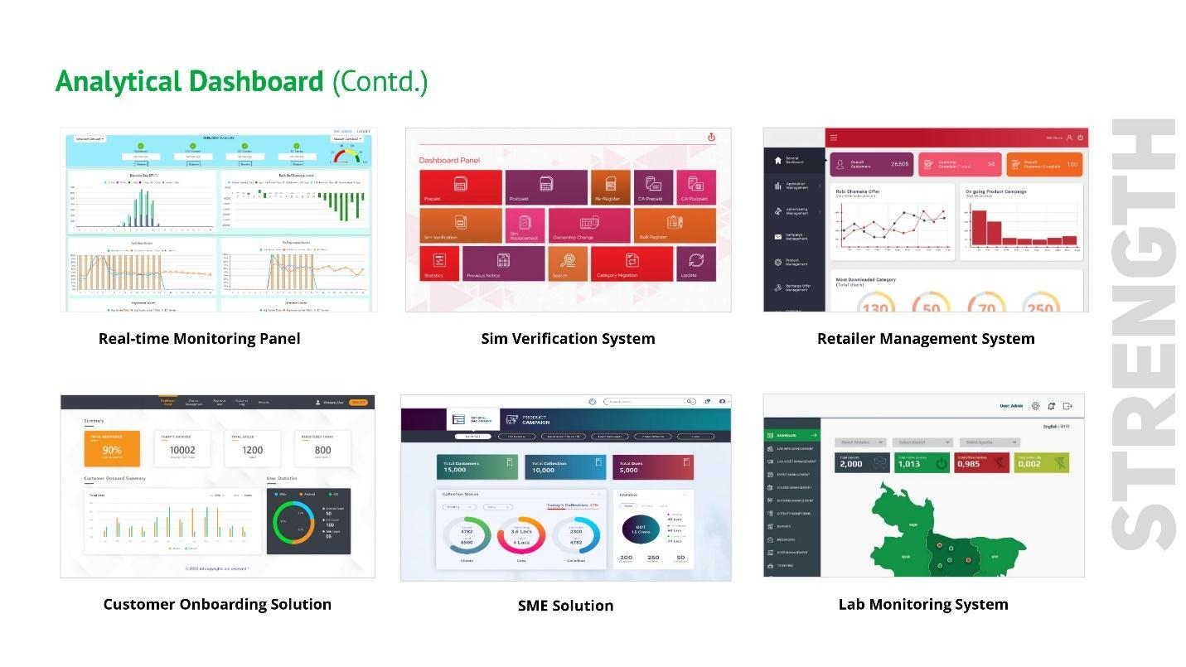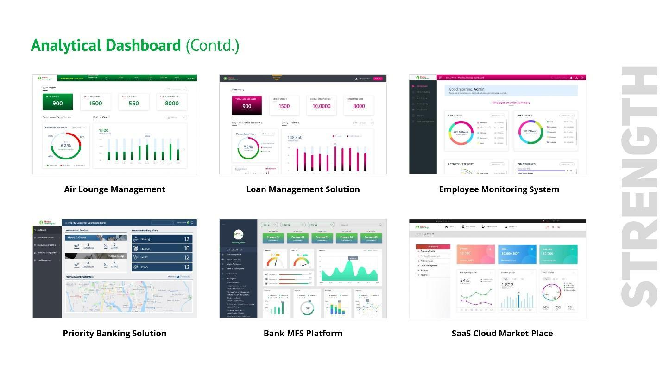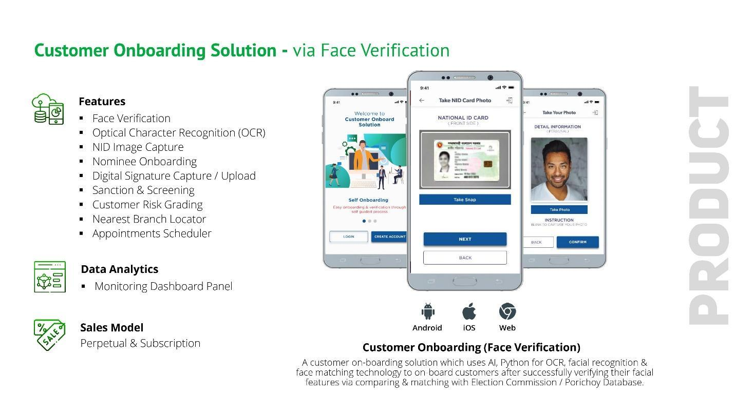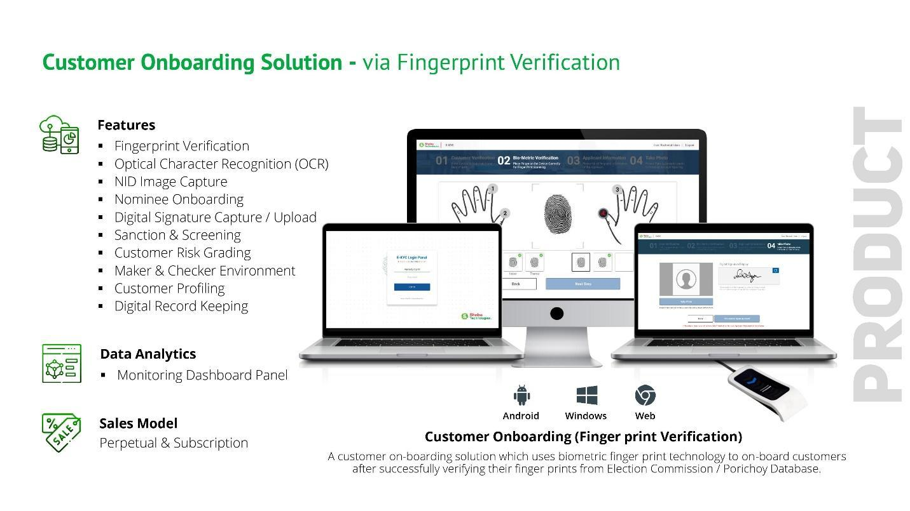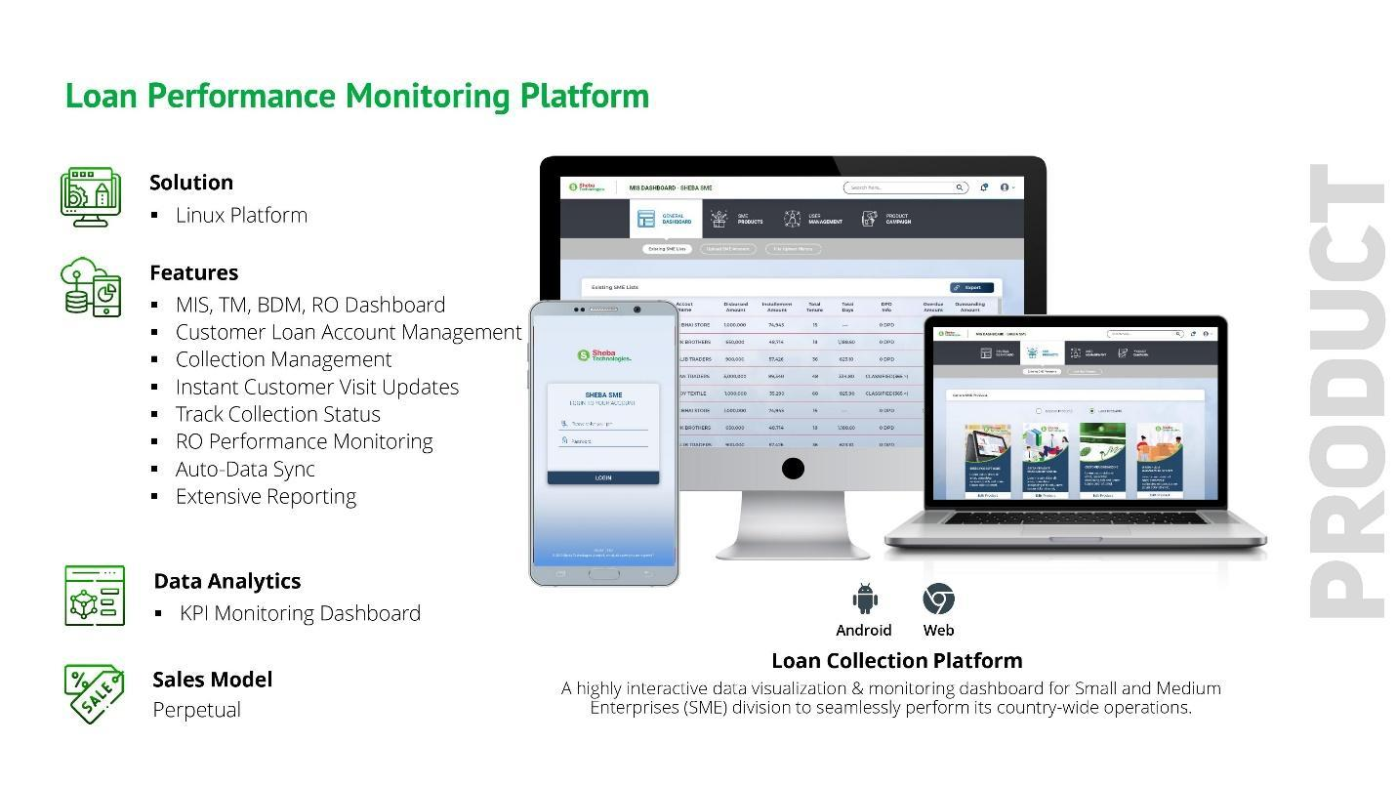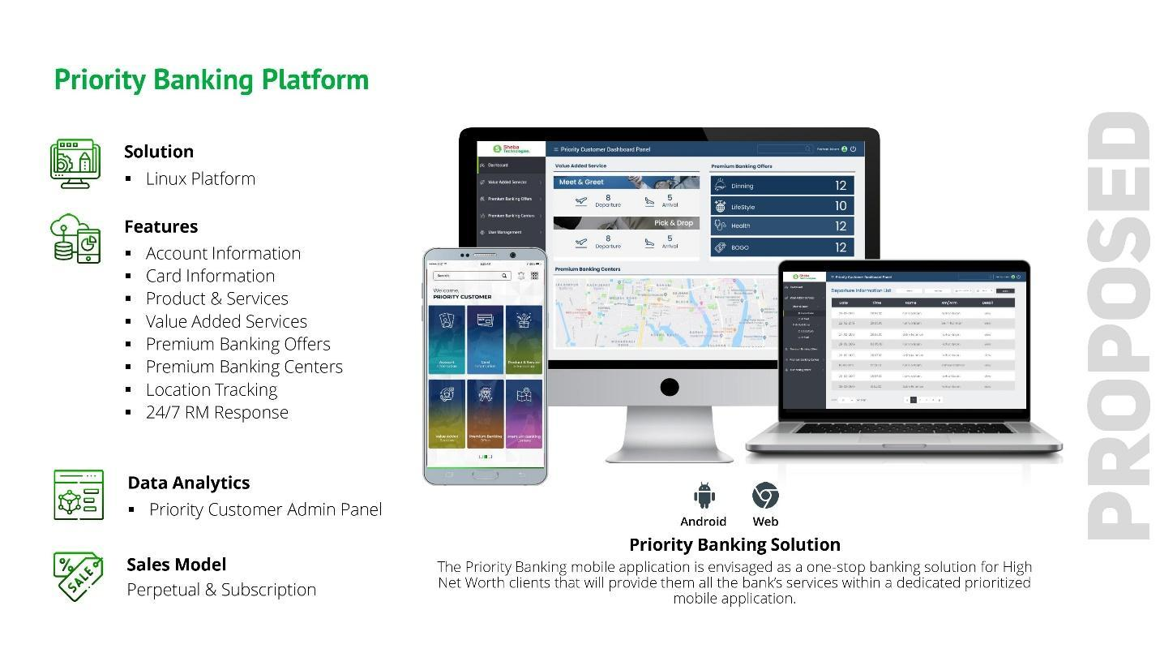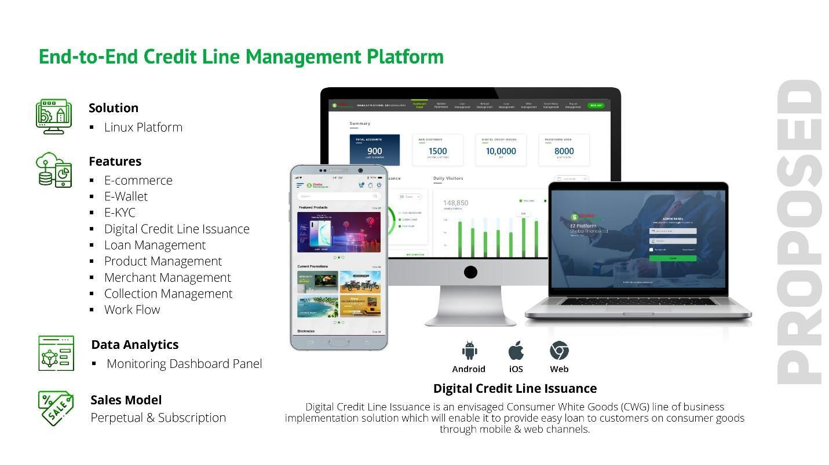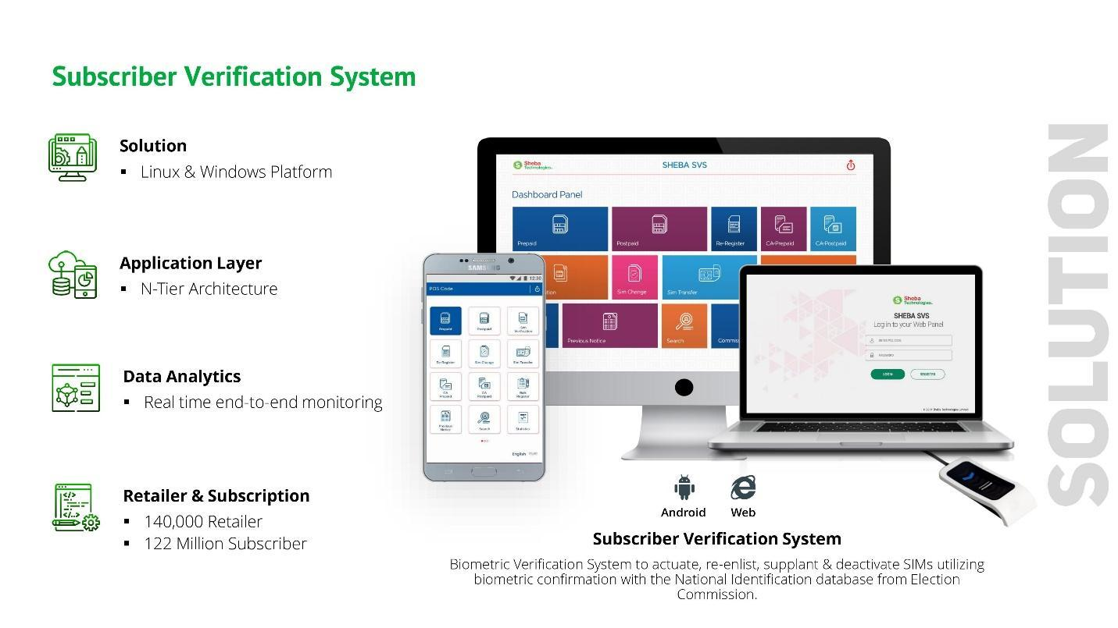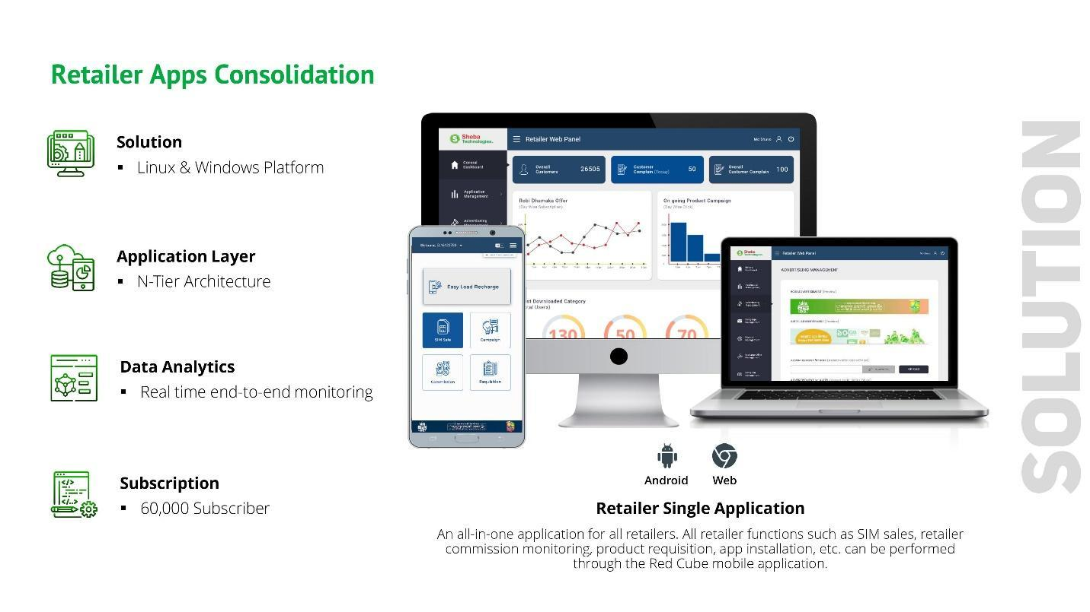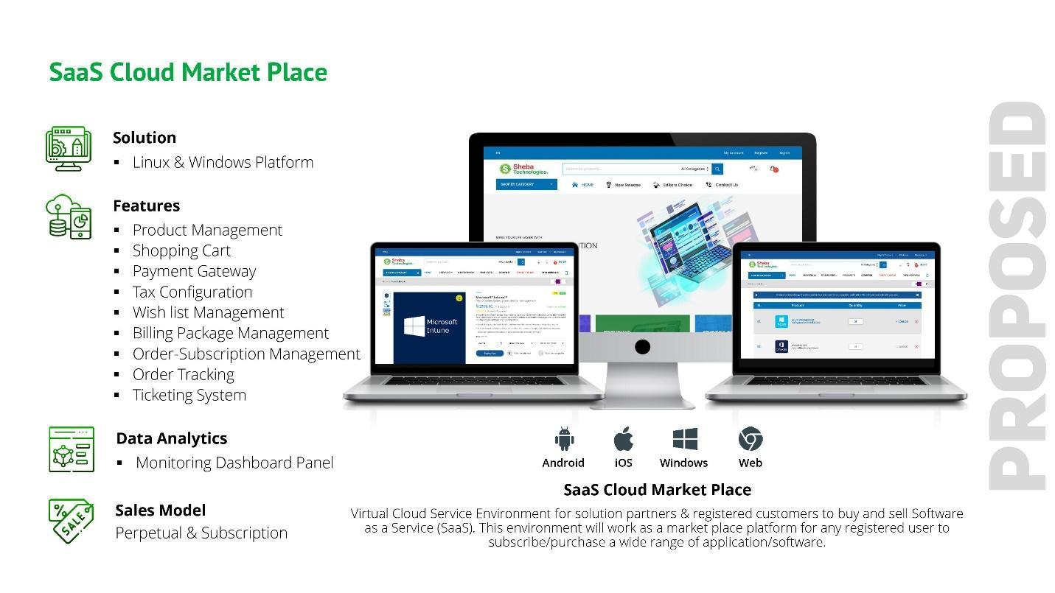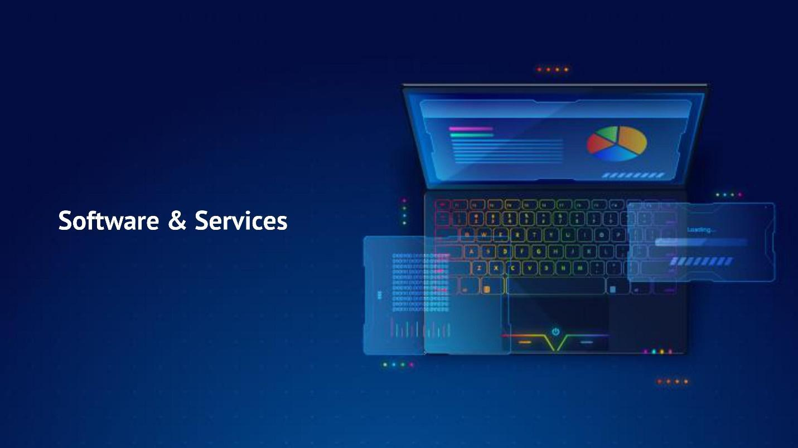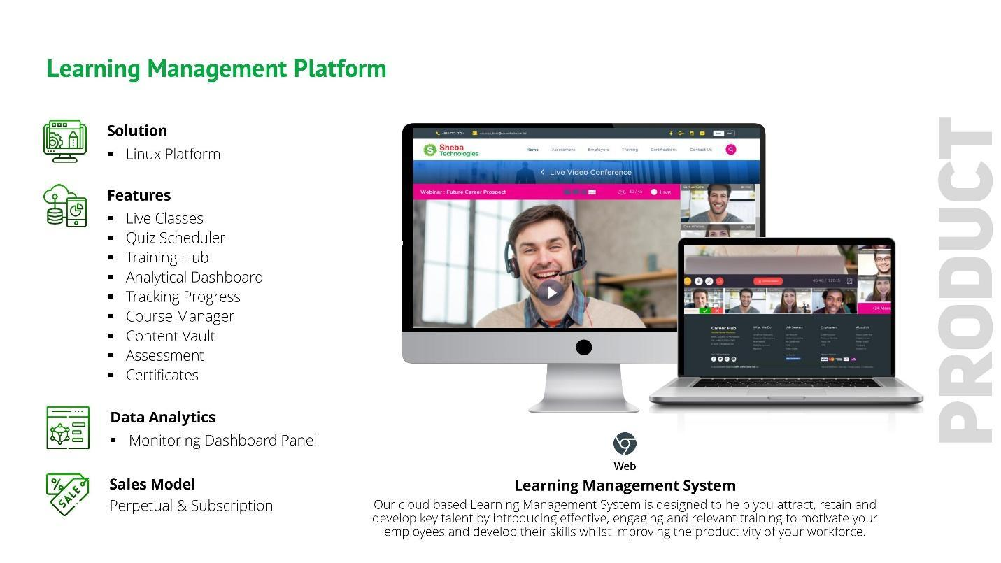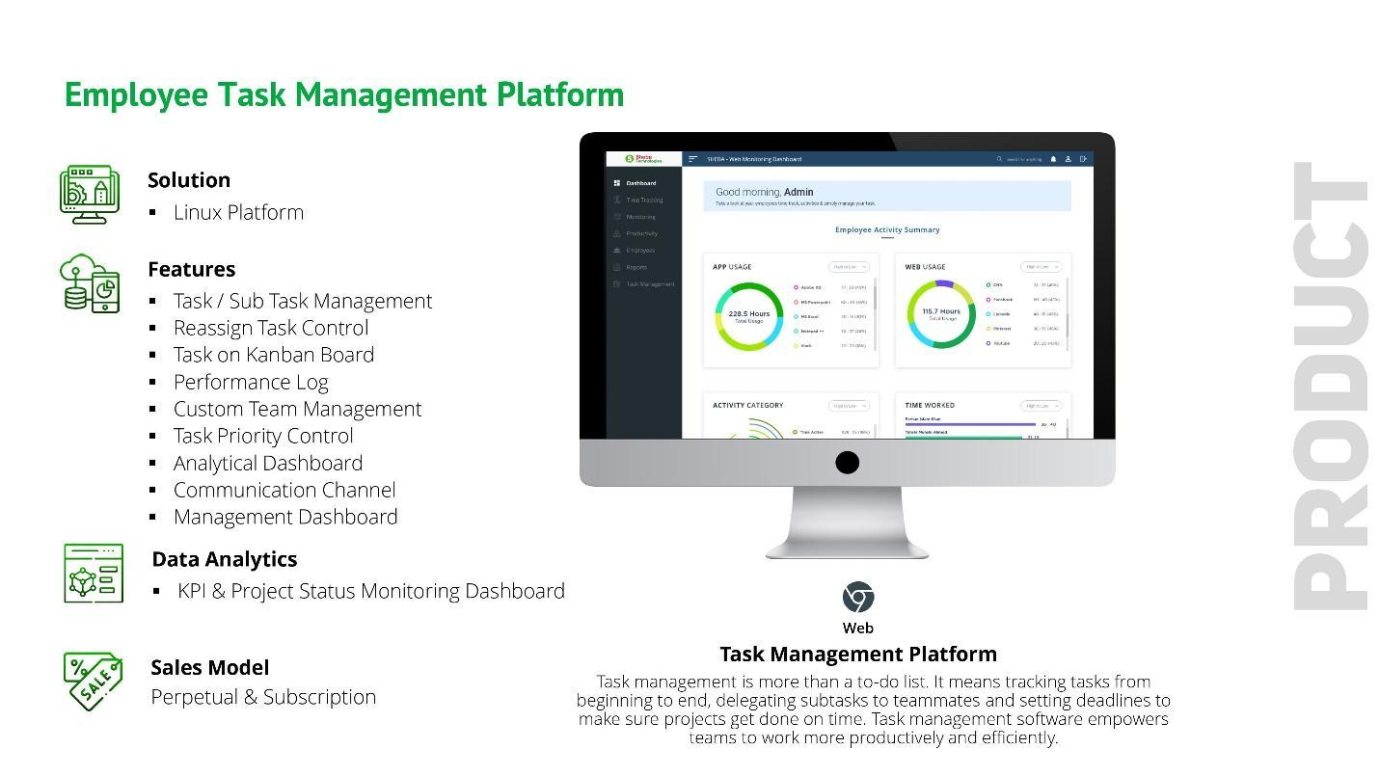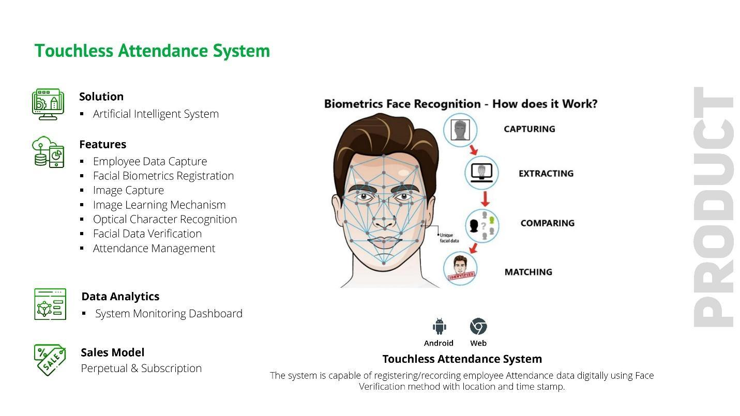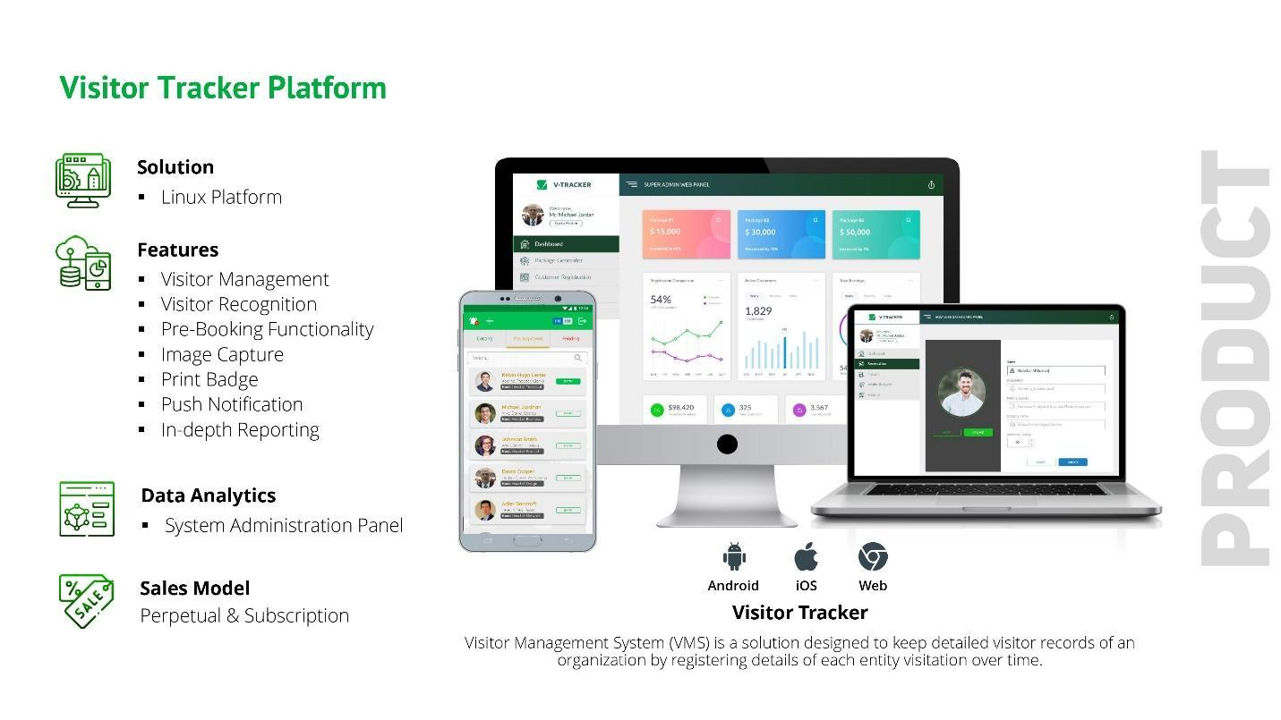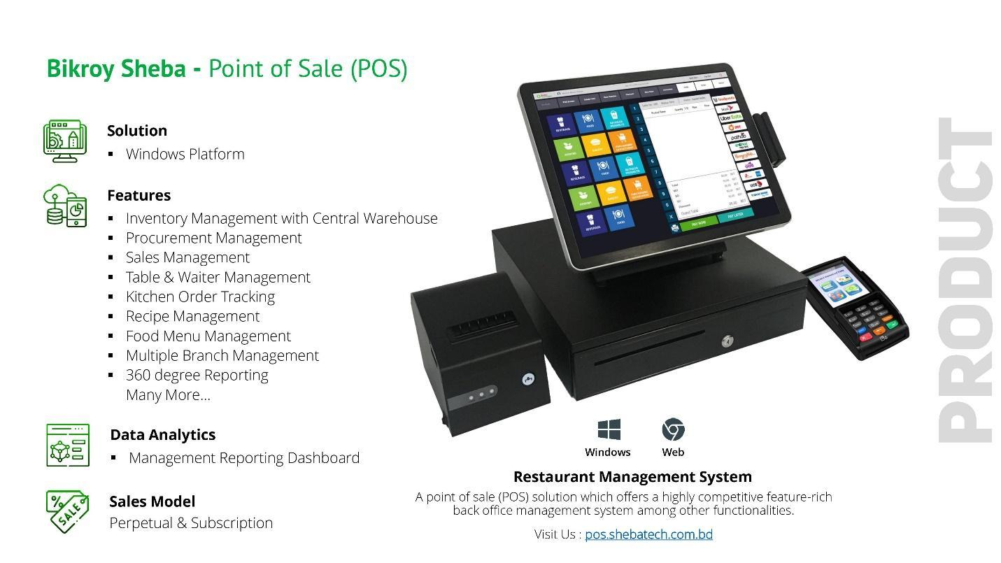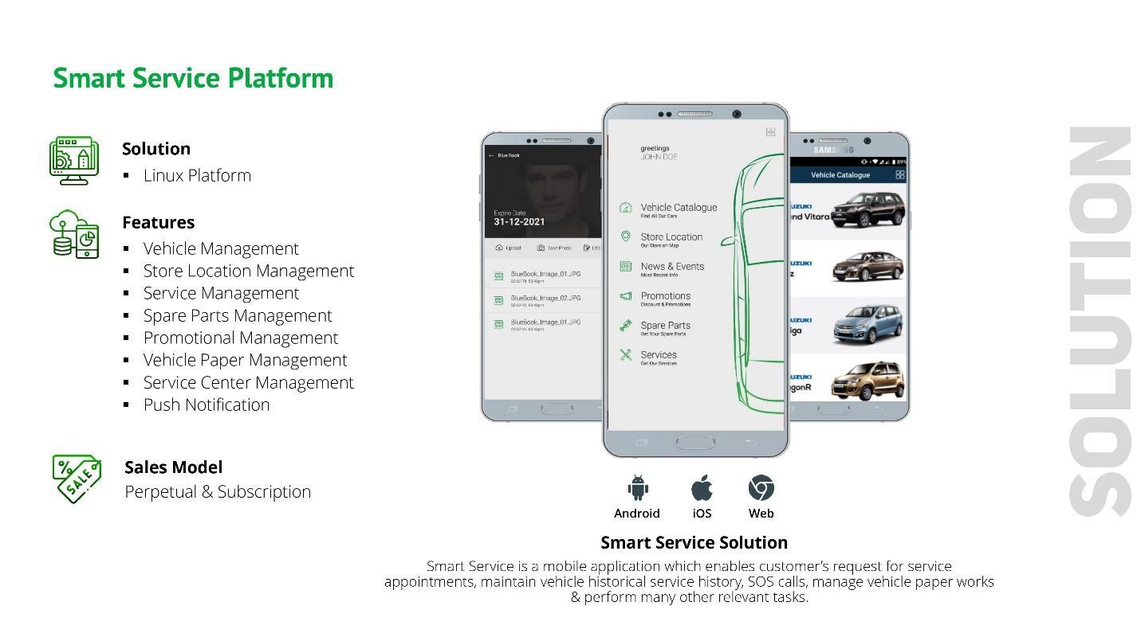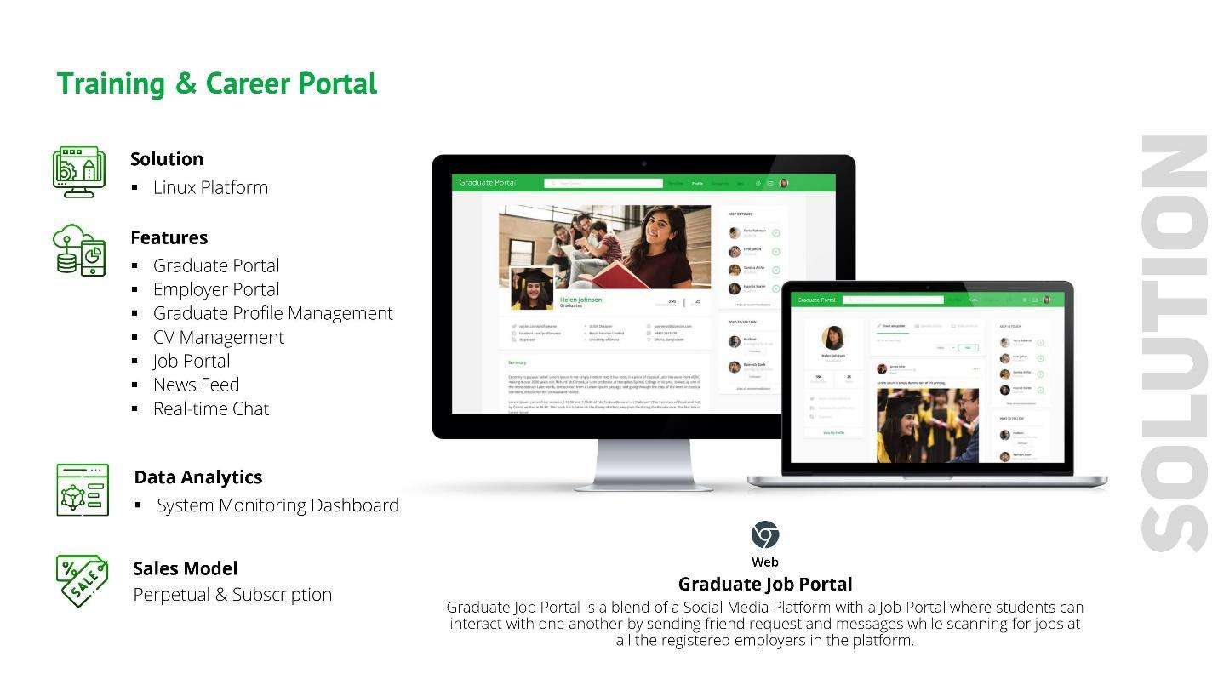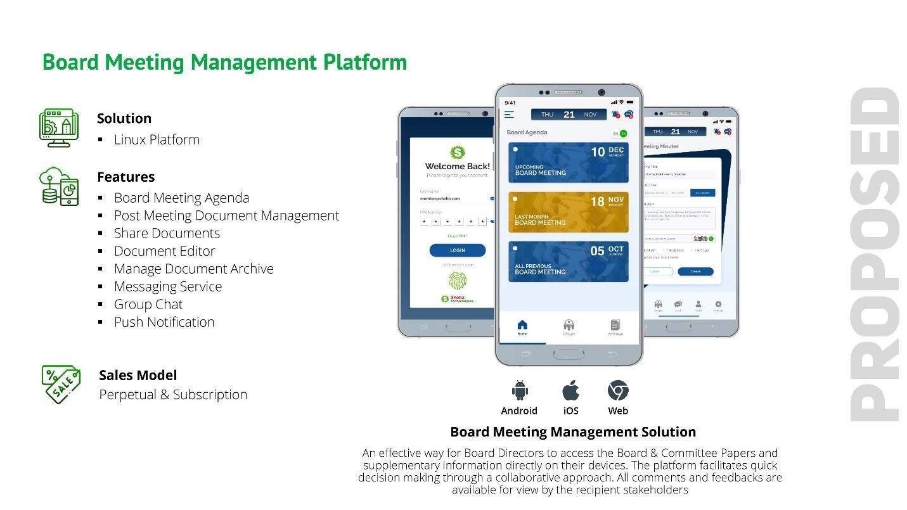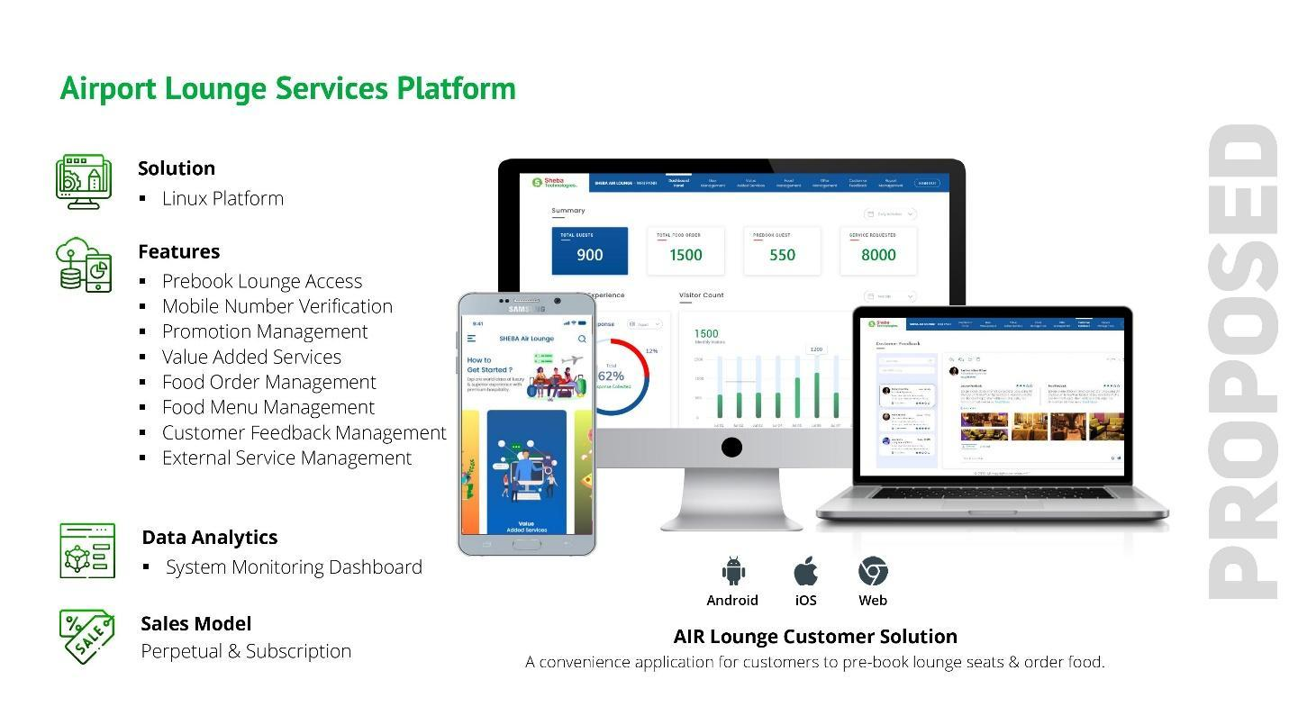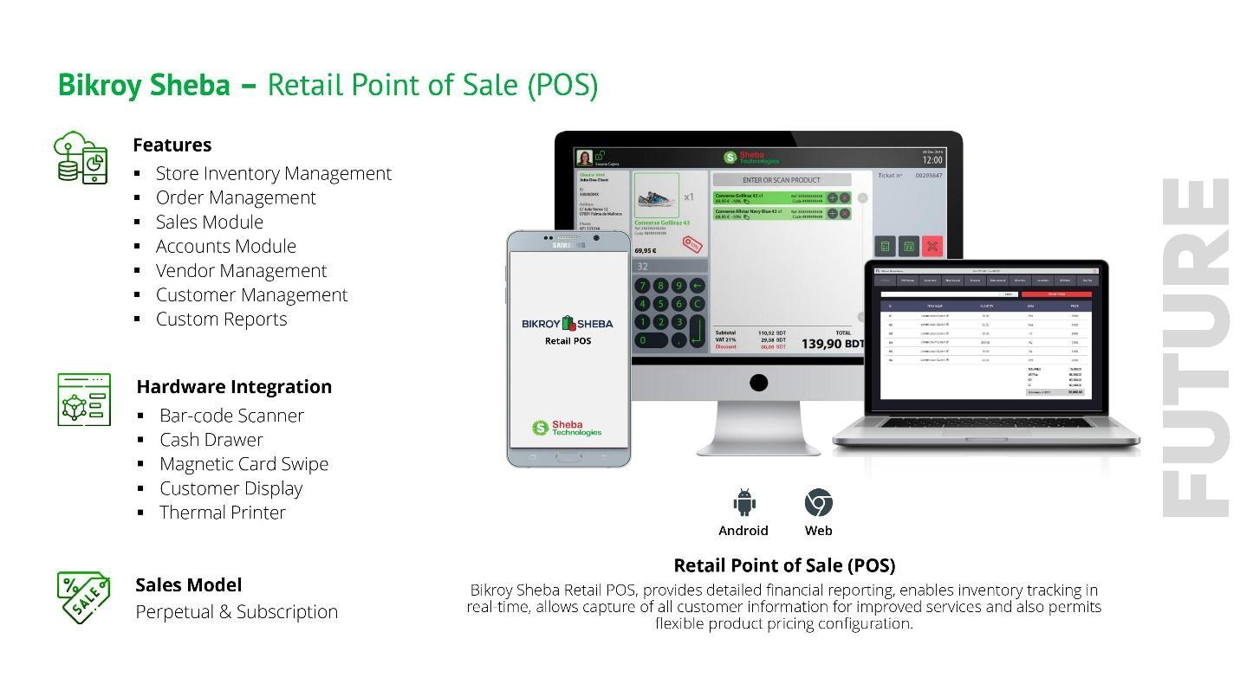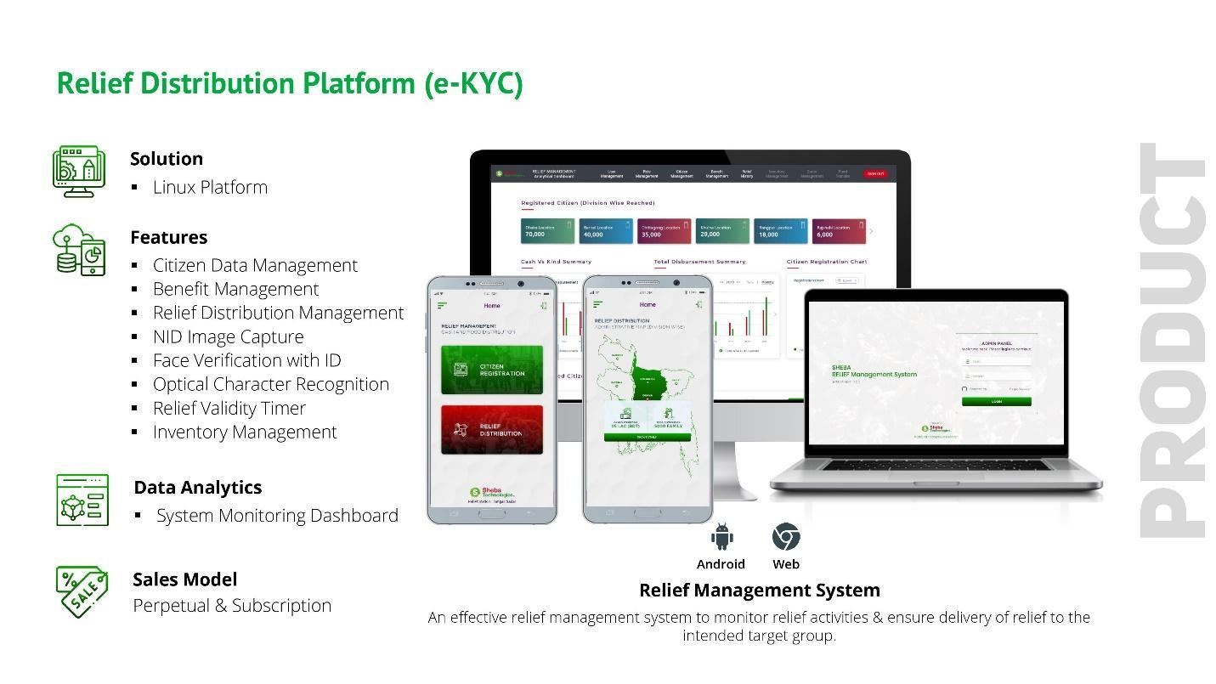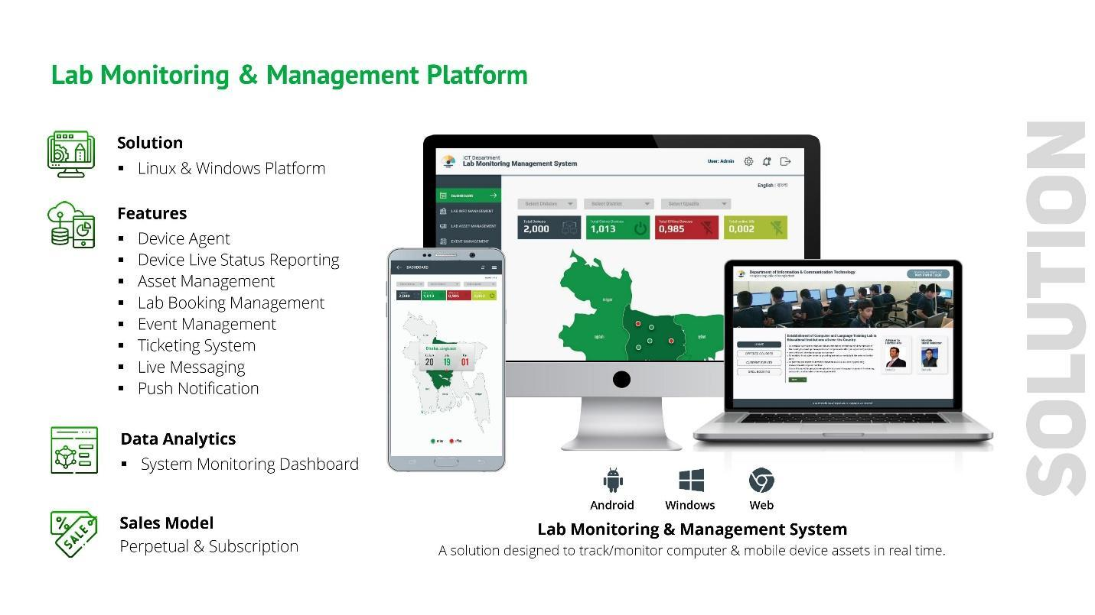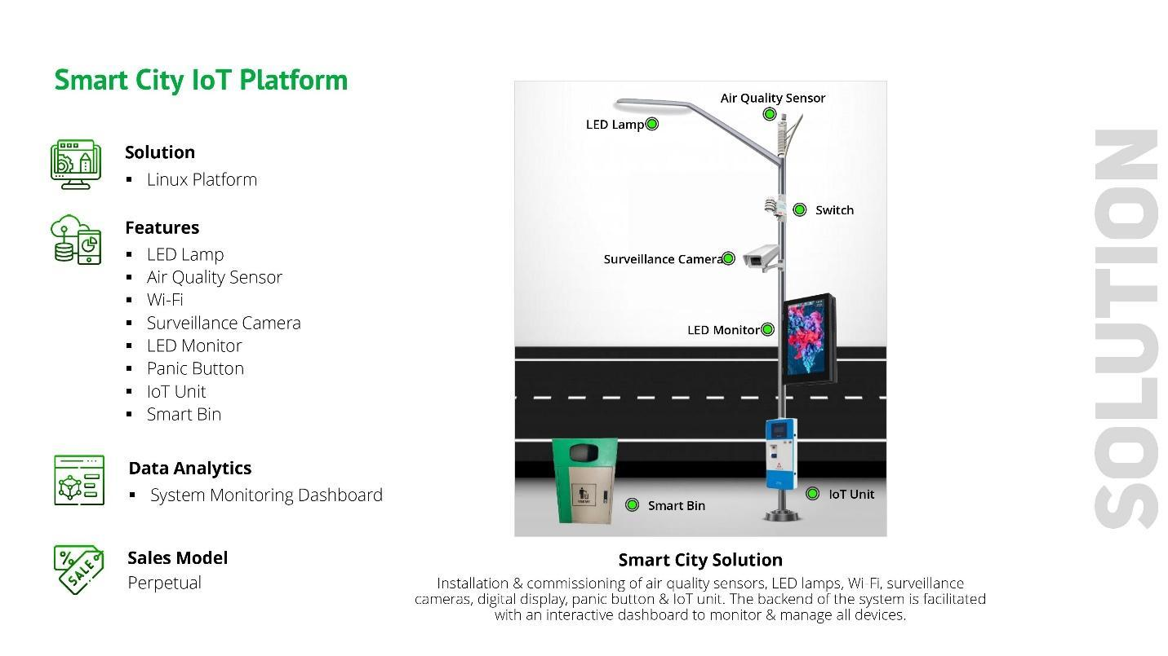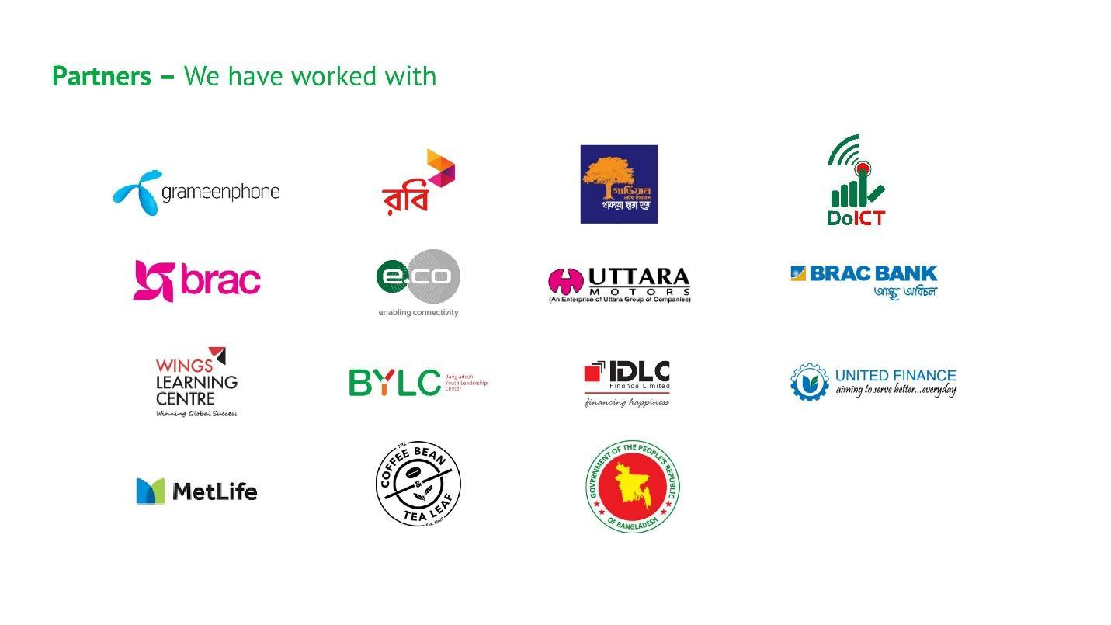

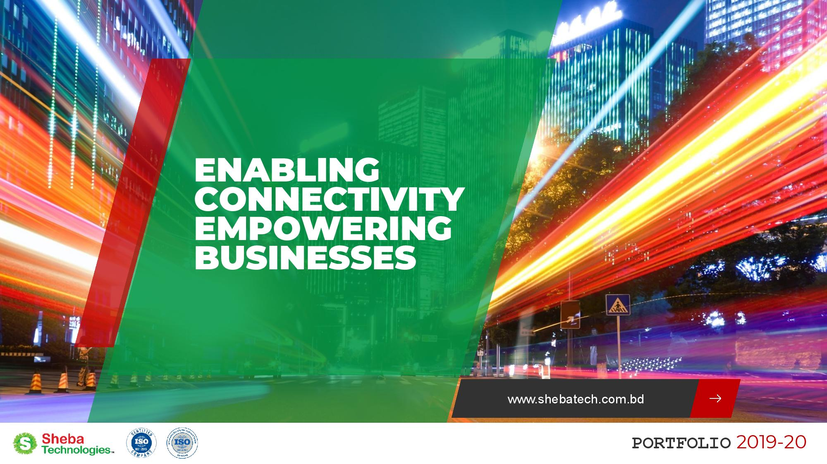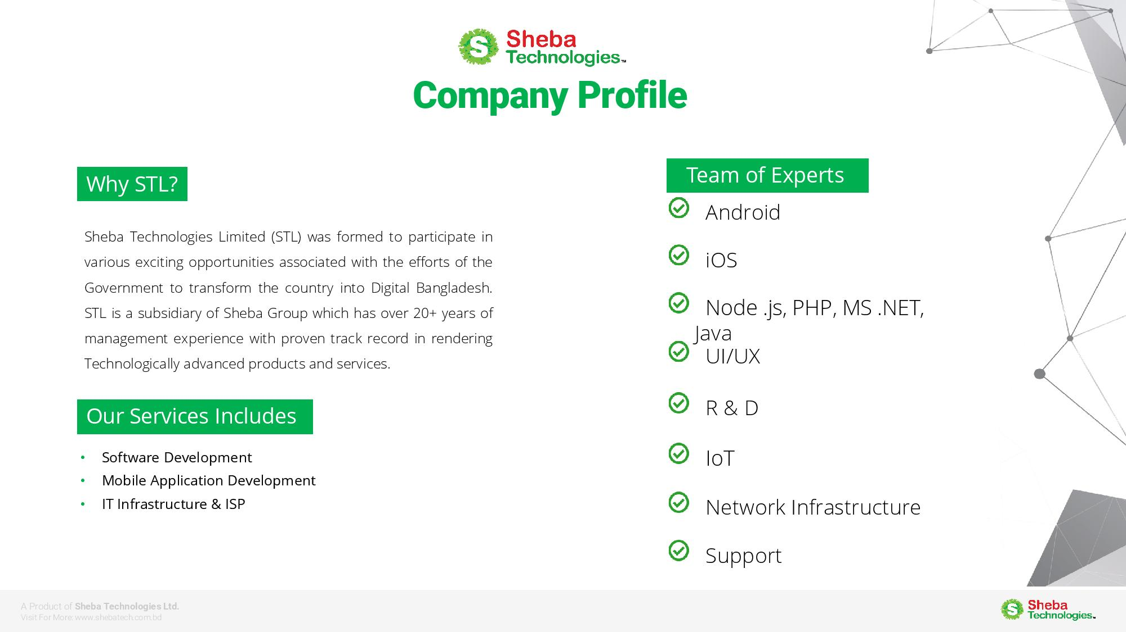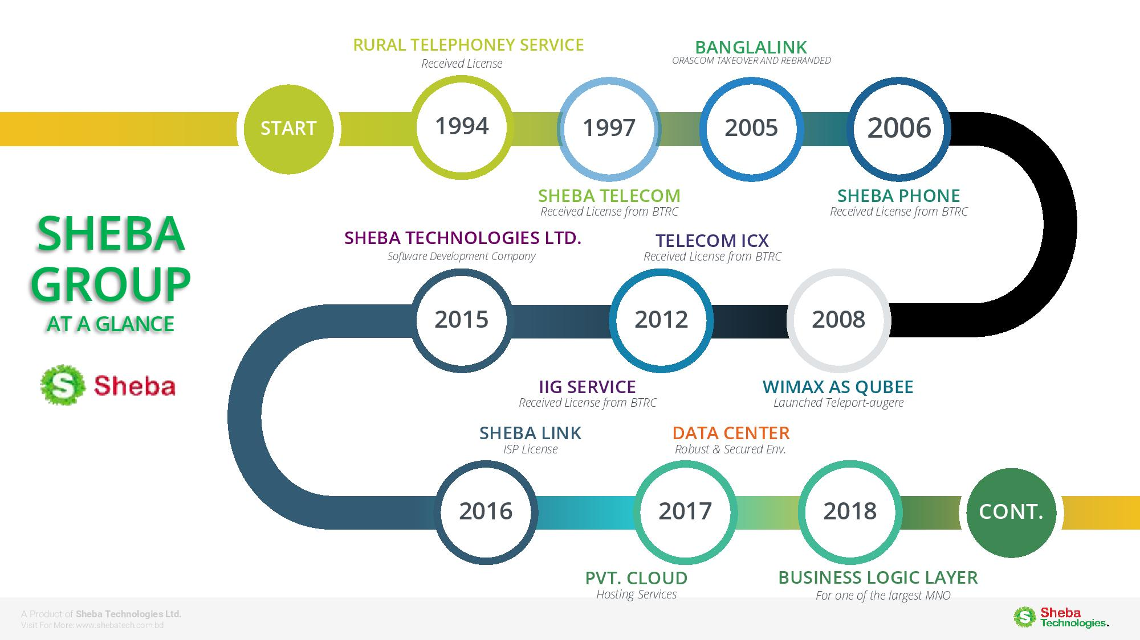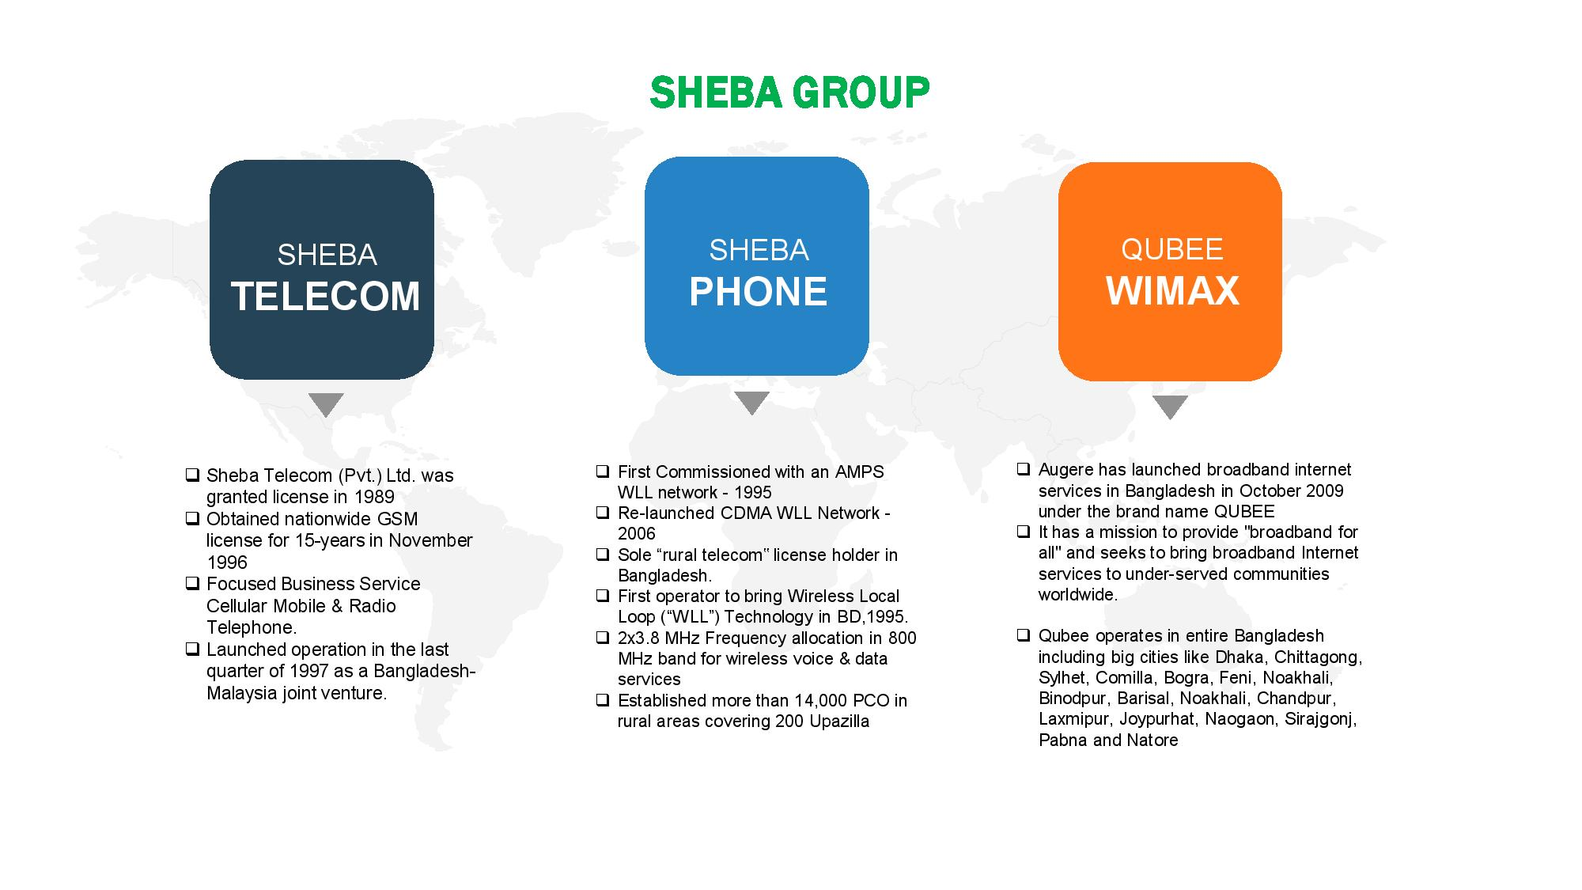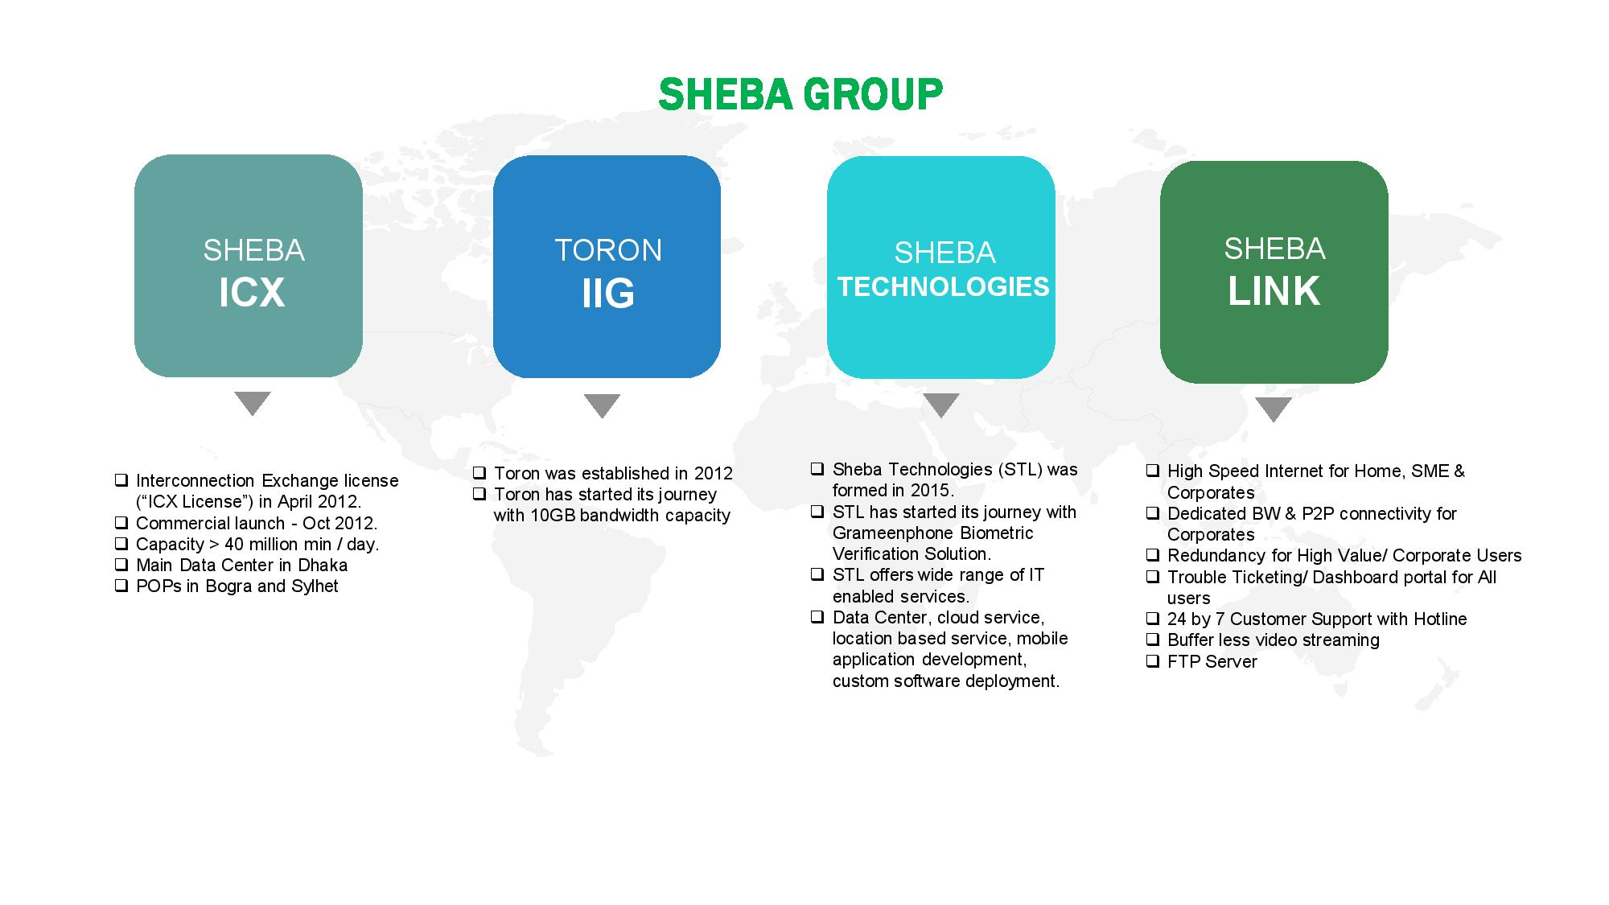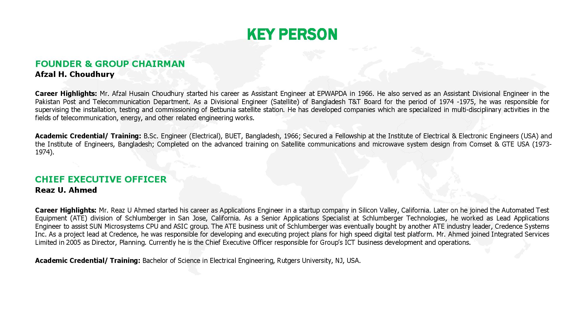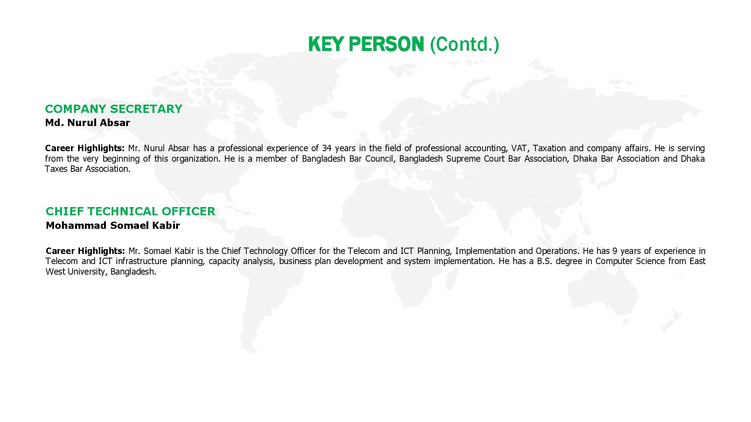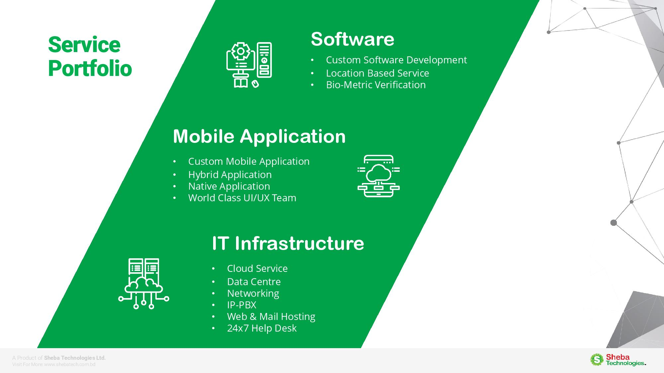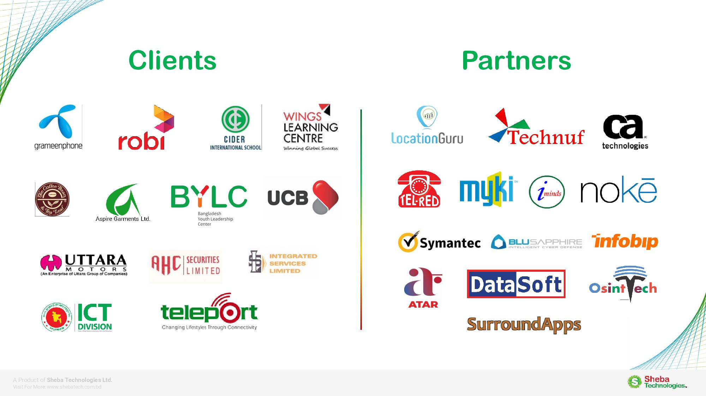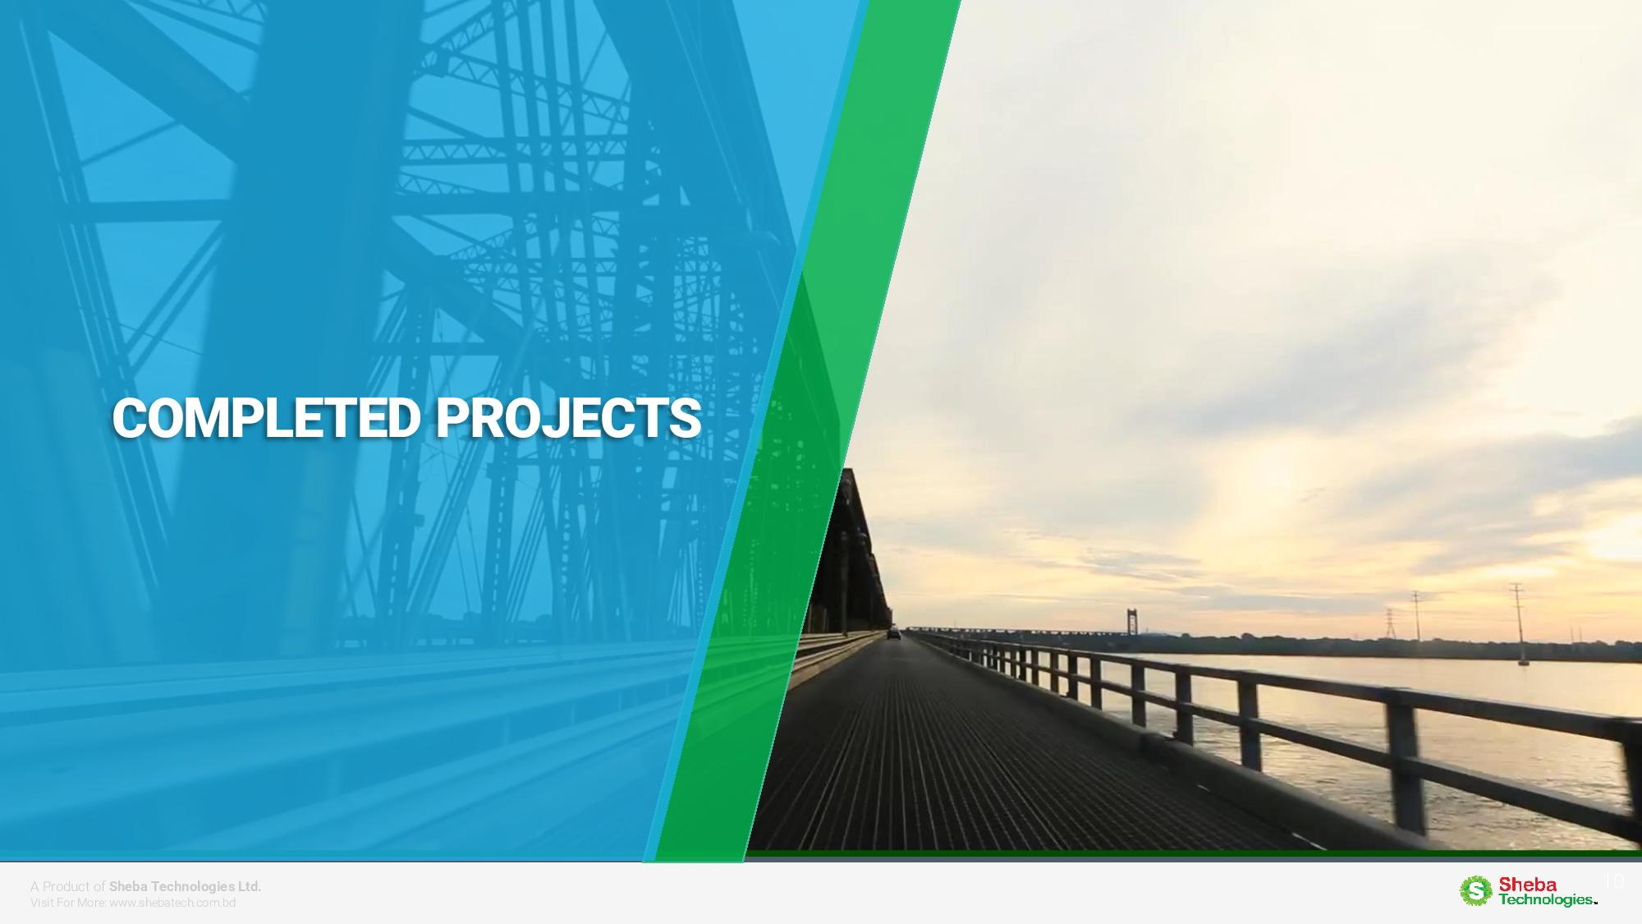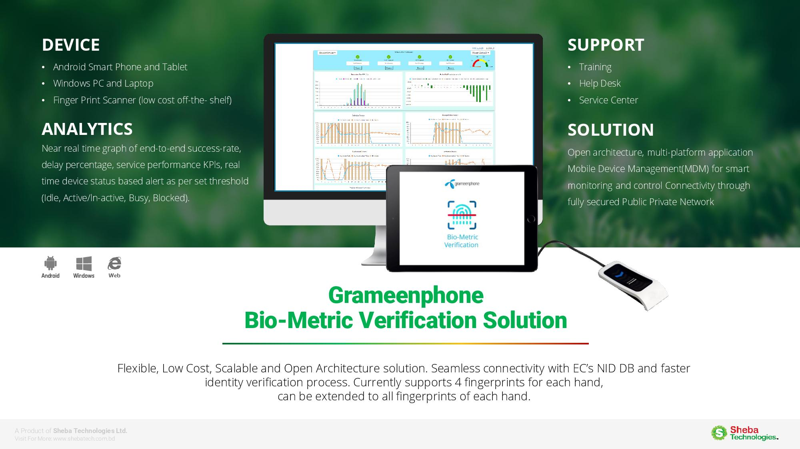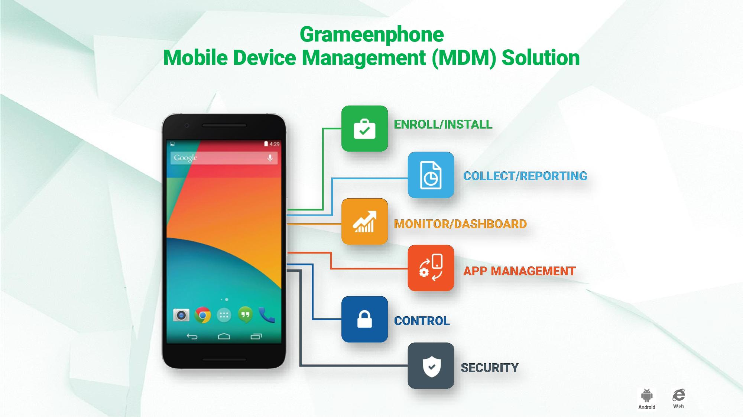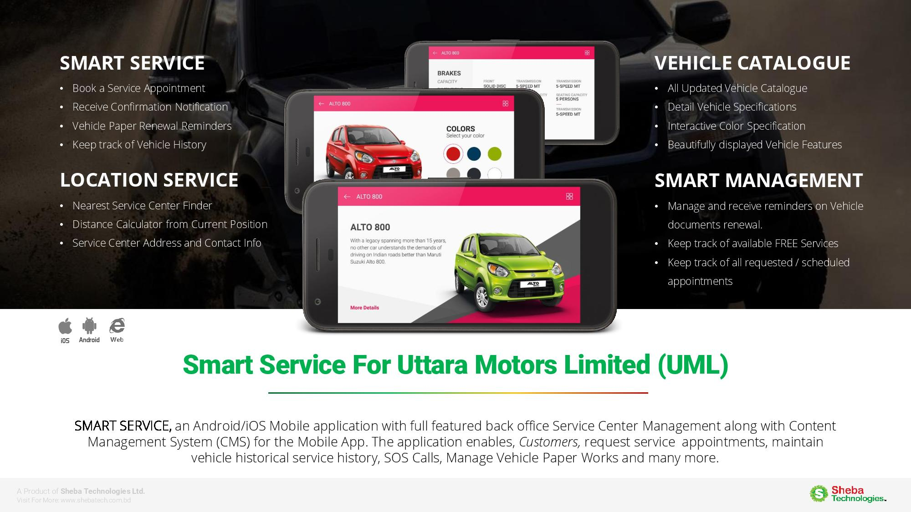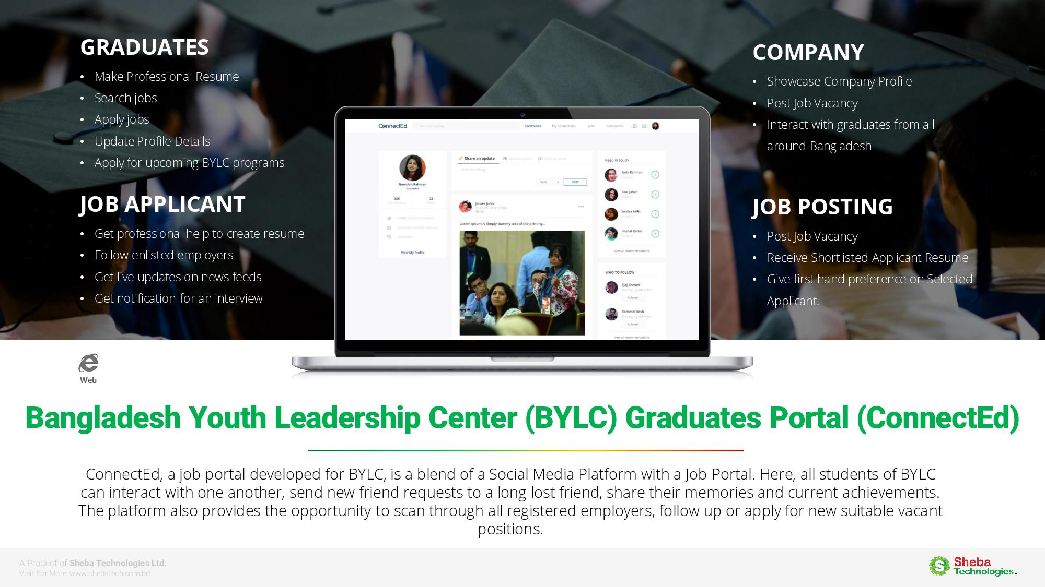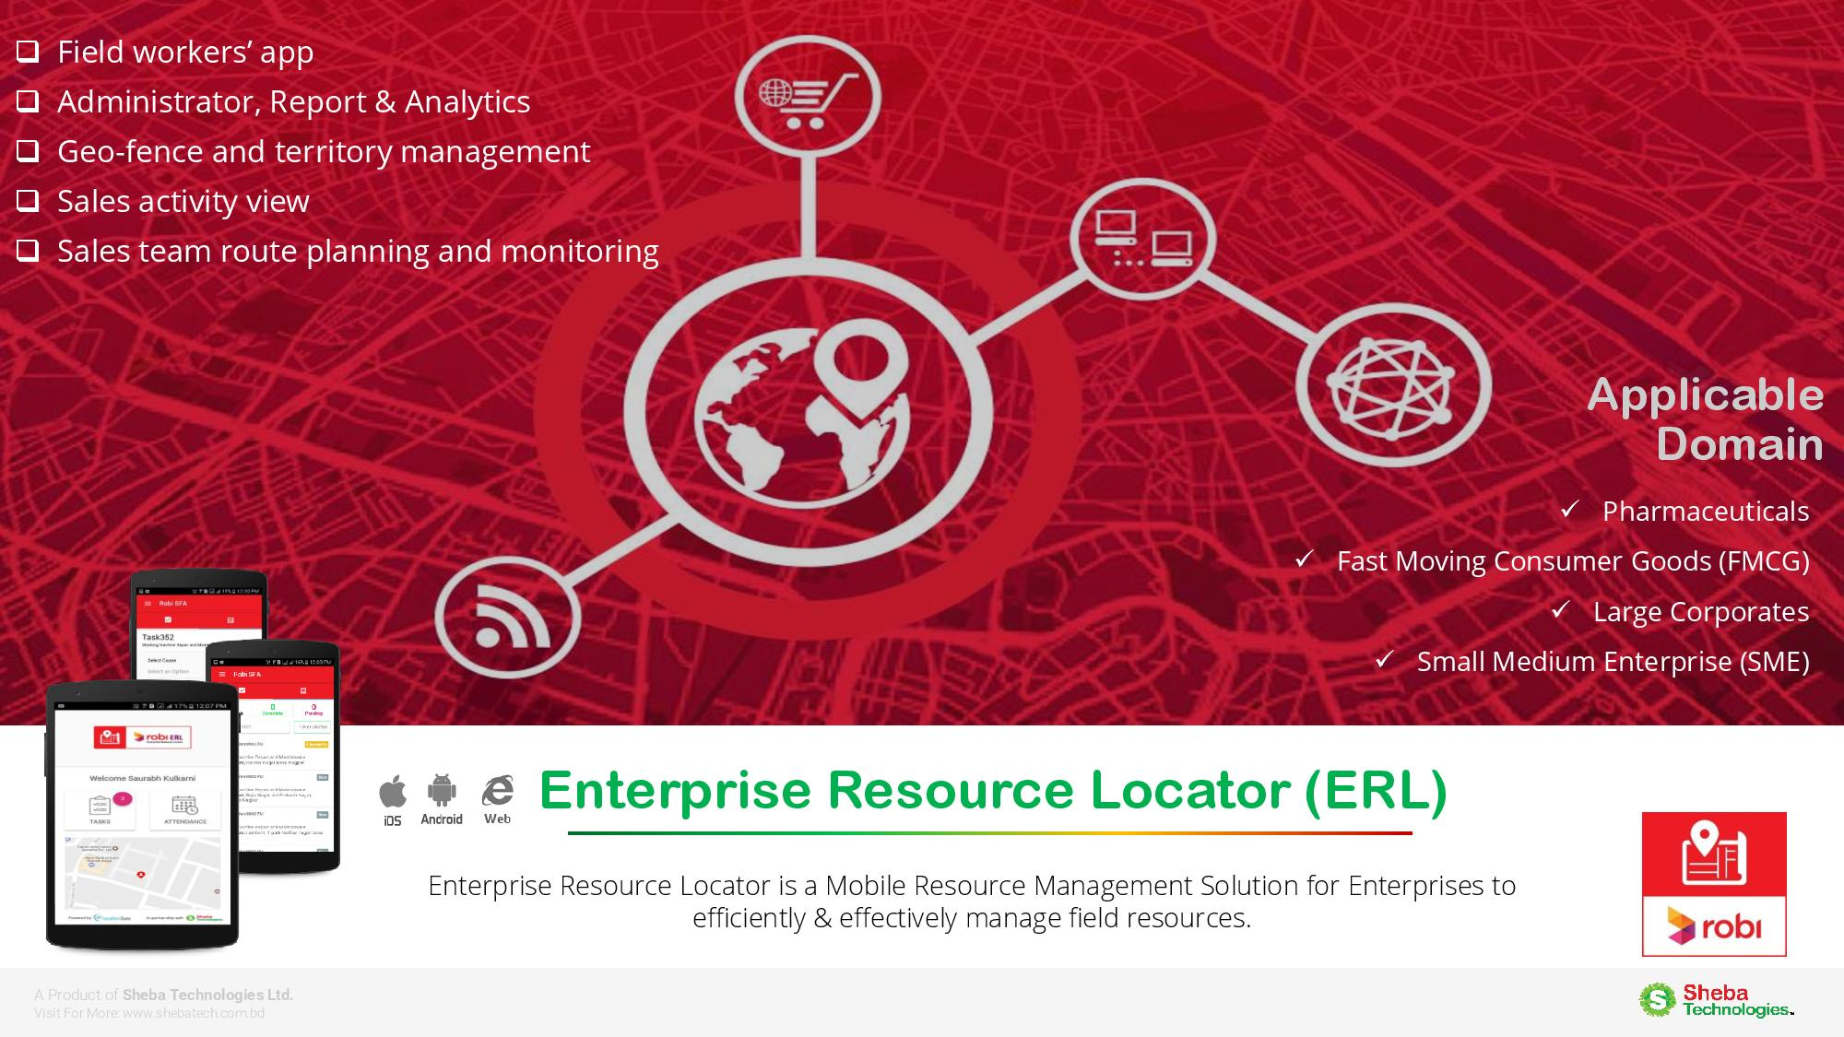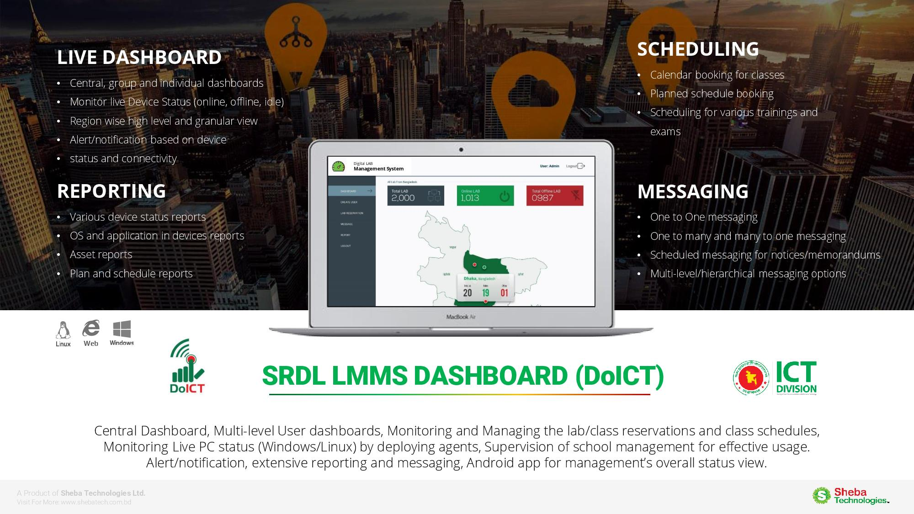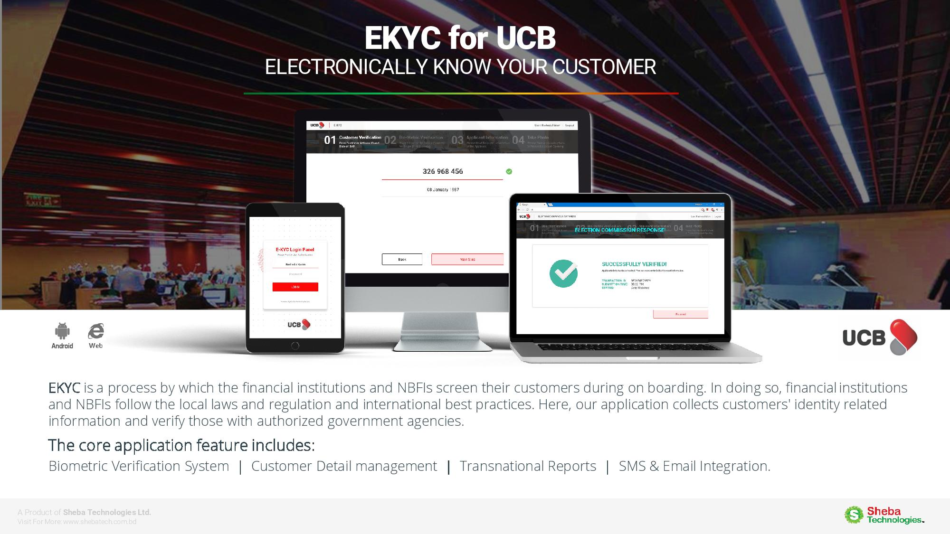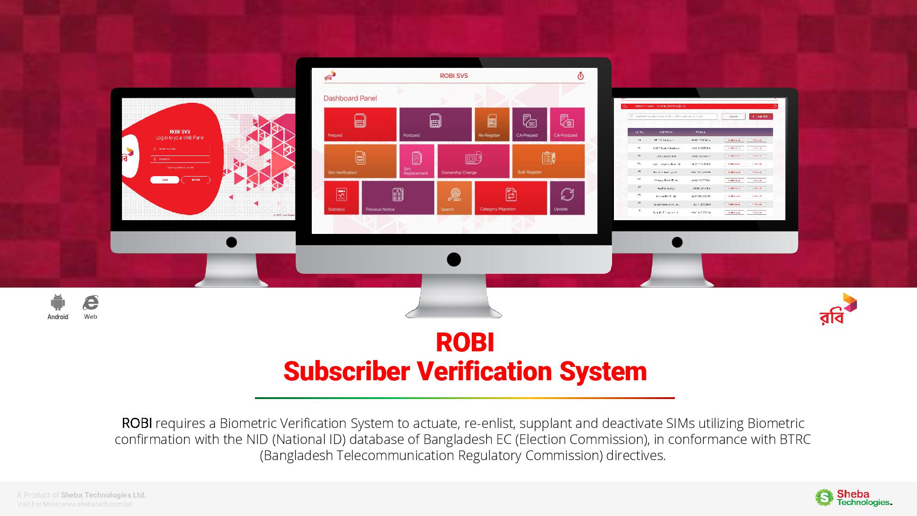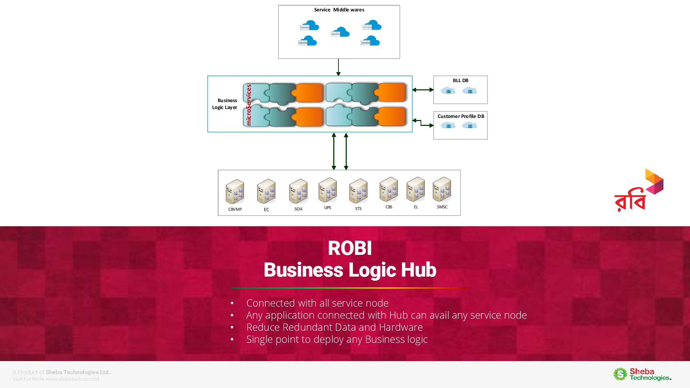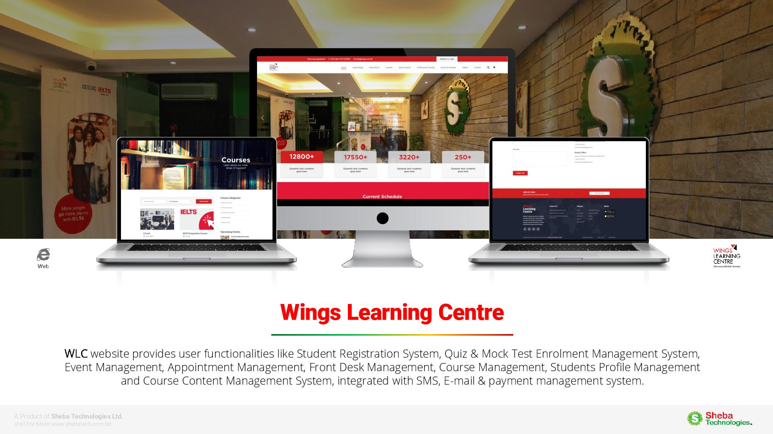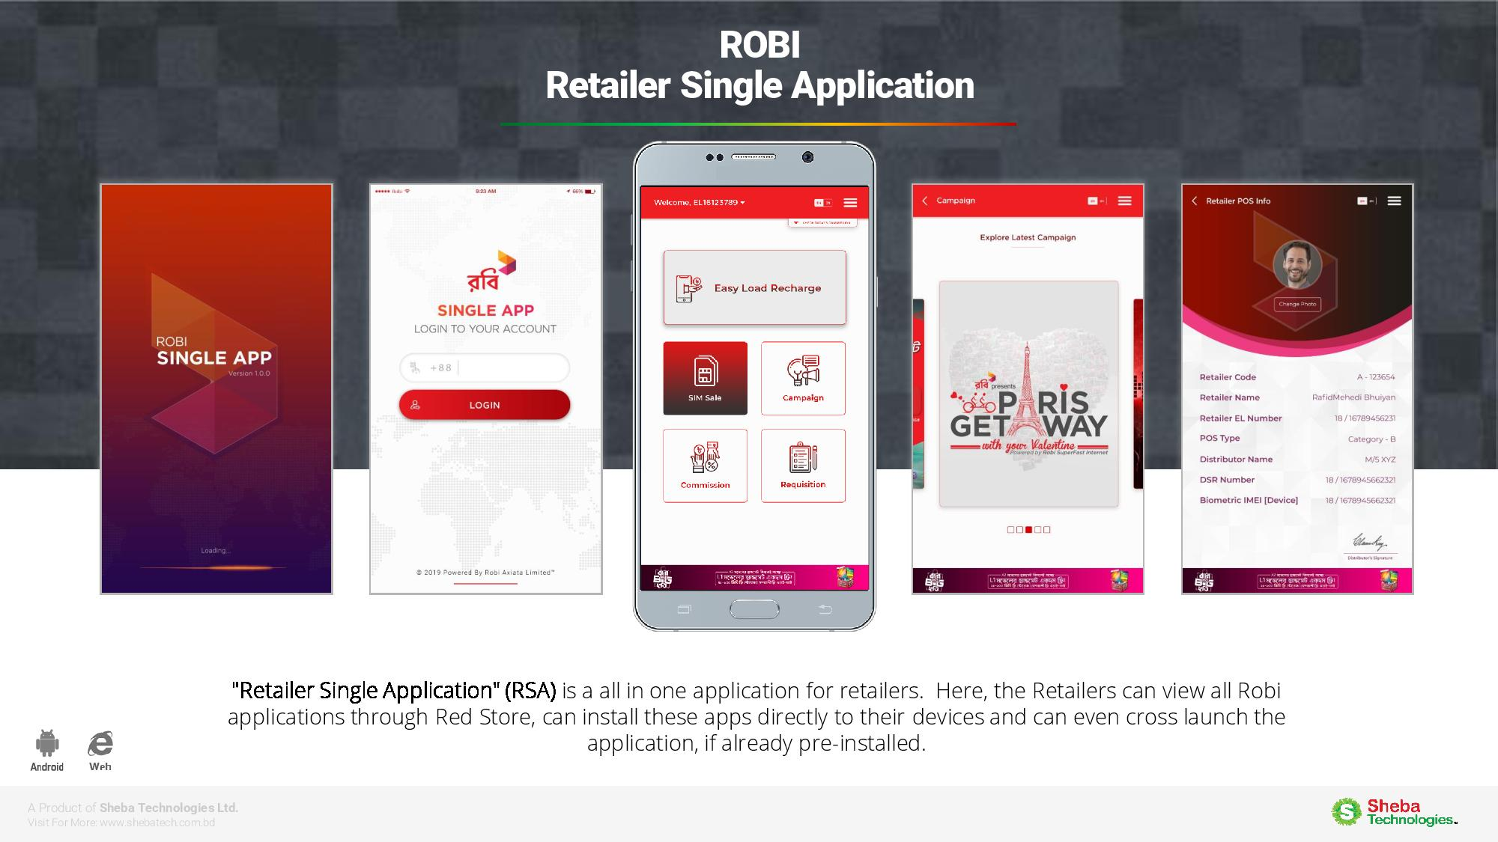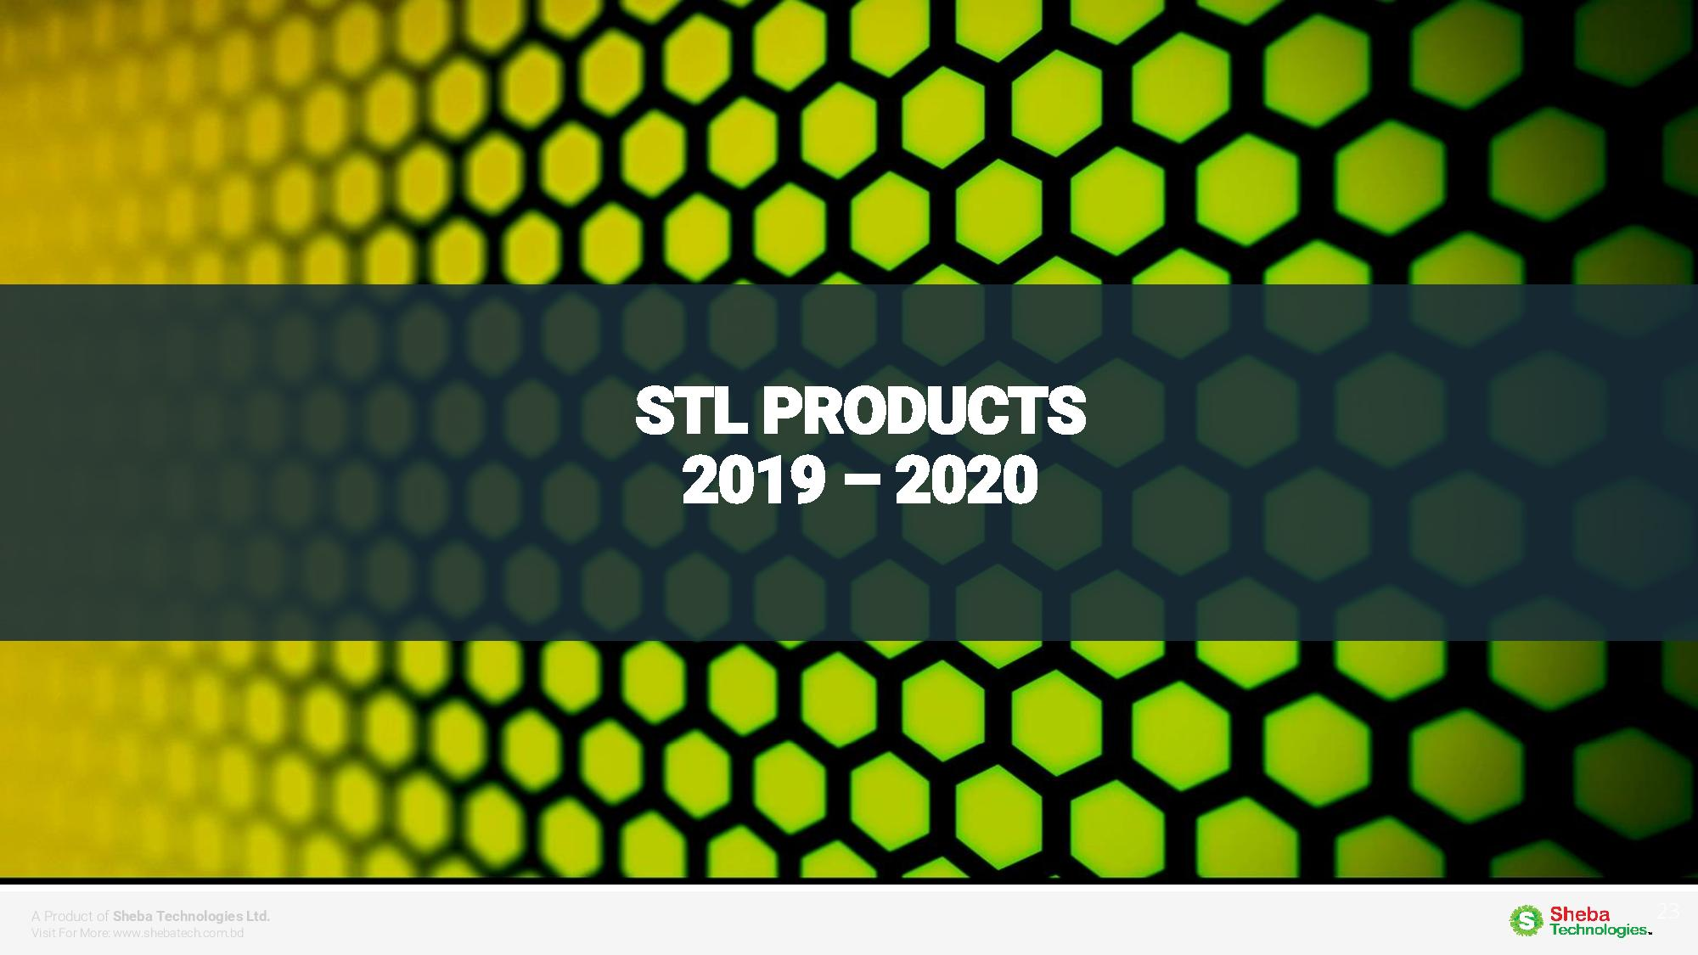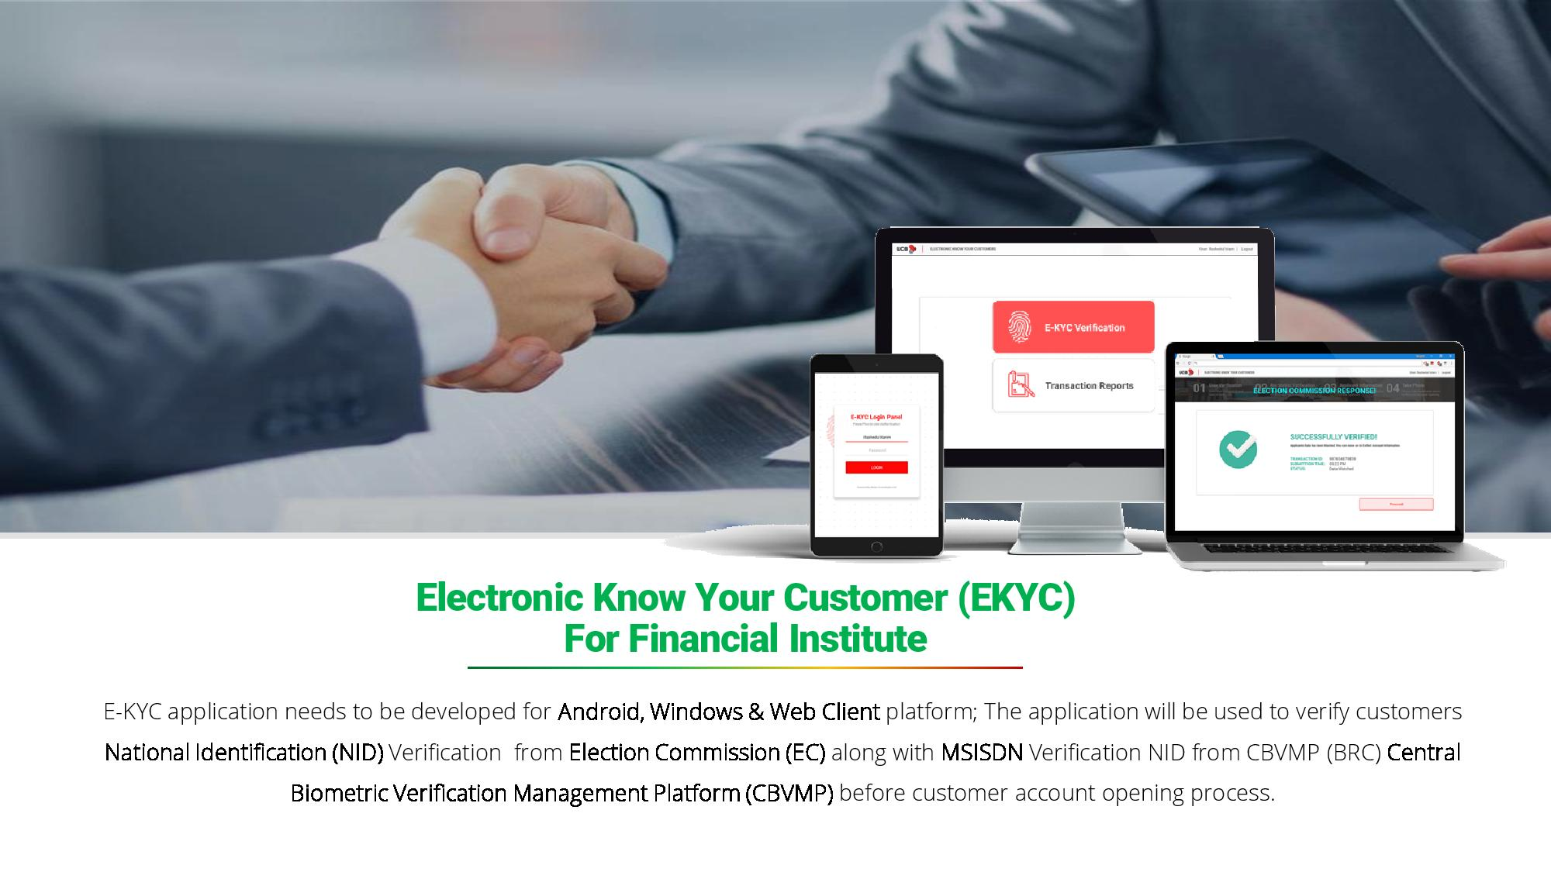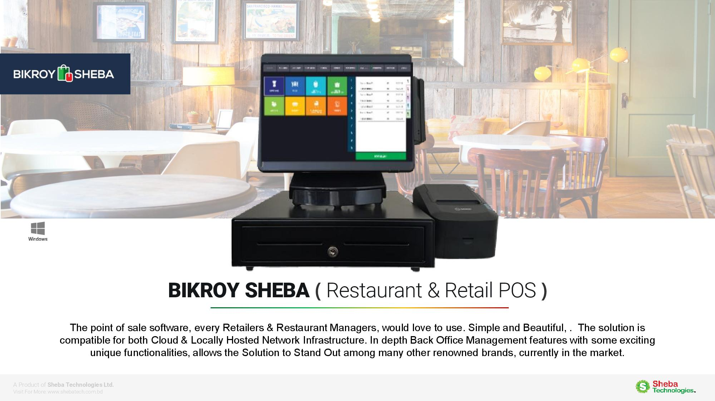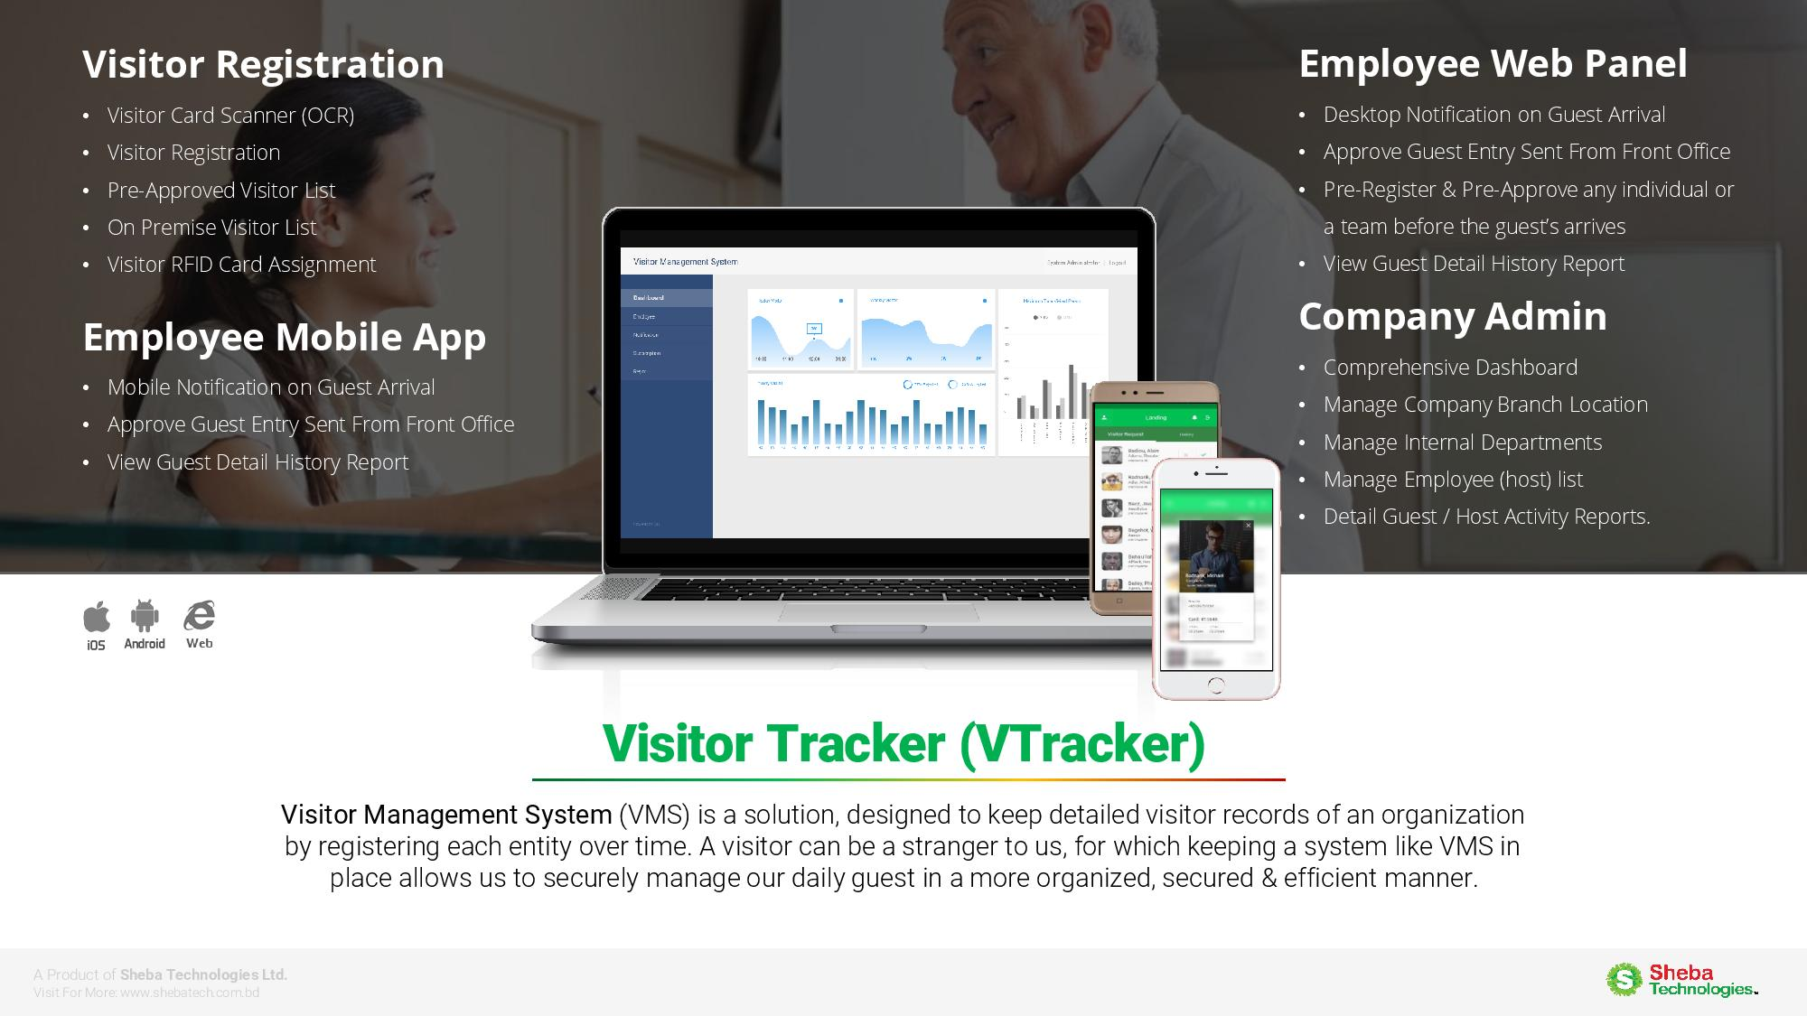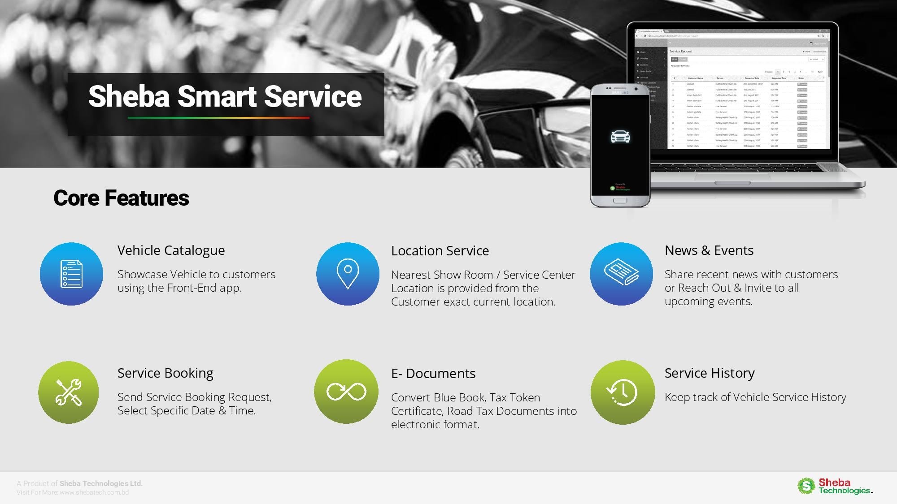

# 1.2 Wings Learning Center (WLC)

## 1.2.1 Company Background

Founded in 2001, WINGS is one of Bangladesh’s much reputed English and other language training institutions, AHC &CO. Ltd. (AHCCL)’s learning Unit and official test centre (BD001) being in Platinum Association with British Council Bangladesh to host the International English Language Testing System (IELTS) and other Academic and Professionals examinations. Besides all type of customized language programs, AHCCL is well known for exclusive training program of all types ranging from academic to corporate, soft skill to high tech ICT skills

## 1.2.2 WLC’s History

## 1.2.3 Products / Services

* IELTS One Stop Service.
* Diverse English Language Courses.
* Chinese Language & Culture.
* Schools Program/O’Level Tuition Program.
* Professional Skills Development Training.

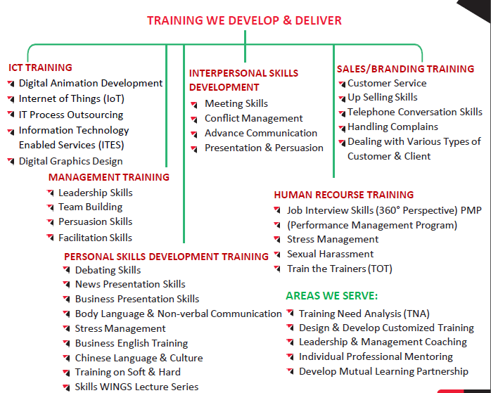

## 1.2.4 Trainer’s Profile

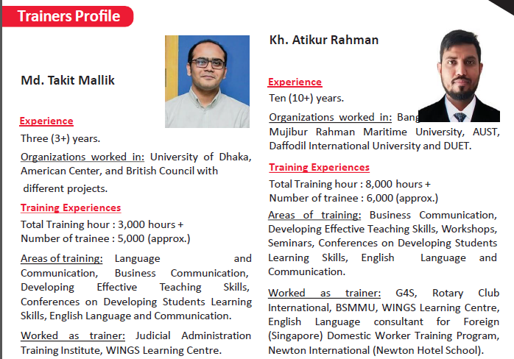

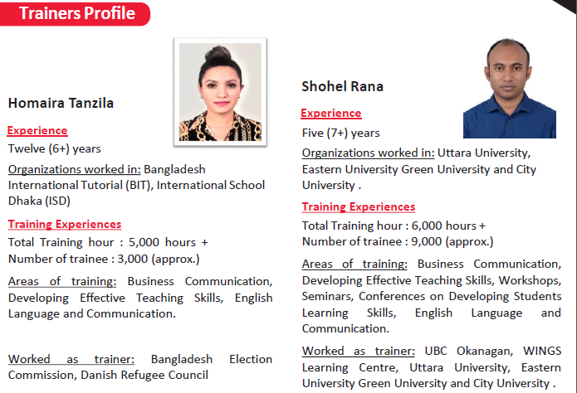

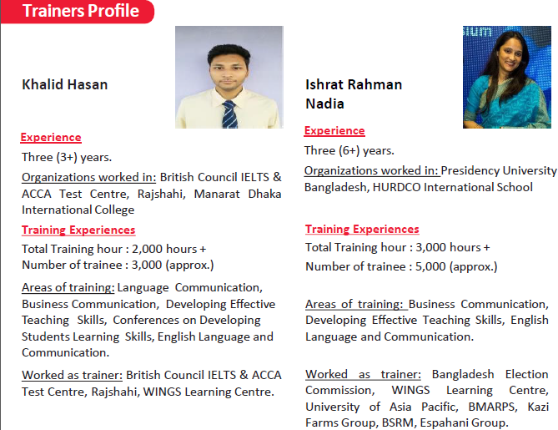

## 1.2.6 Management Profile

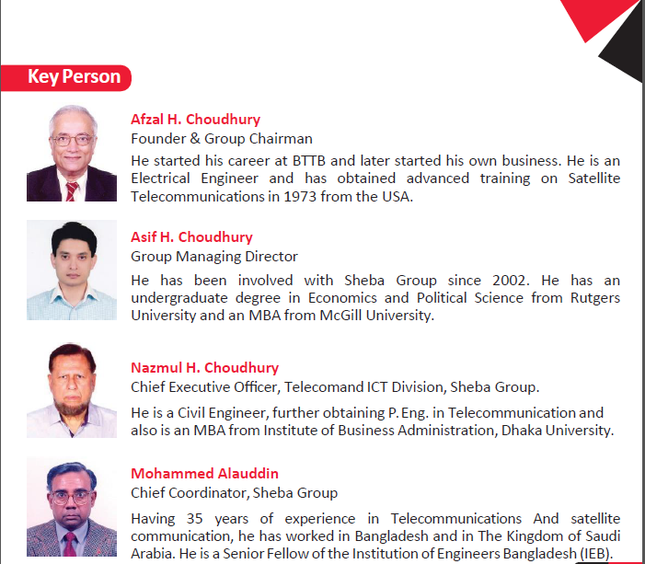

## 1.2.7 Brochure of WLC

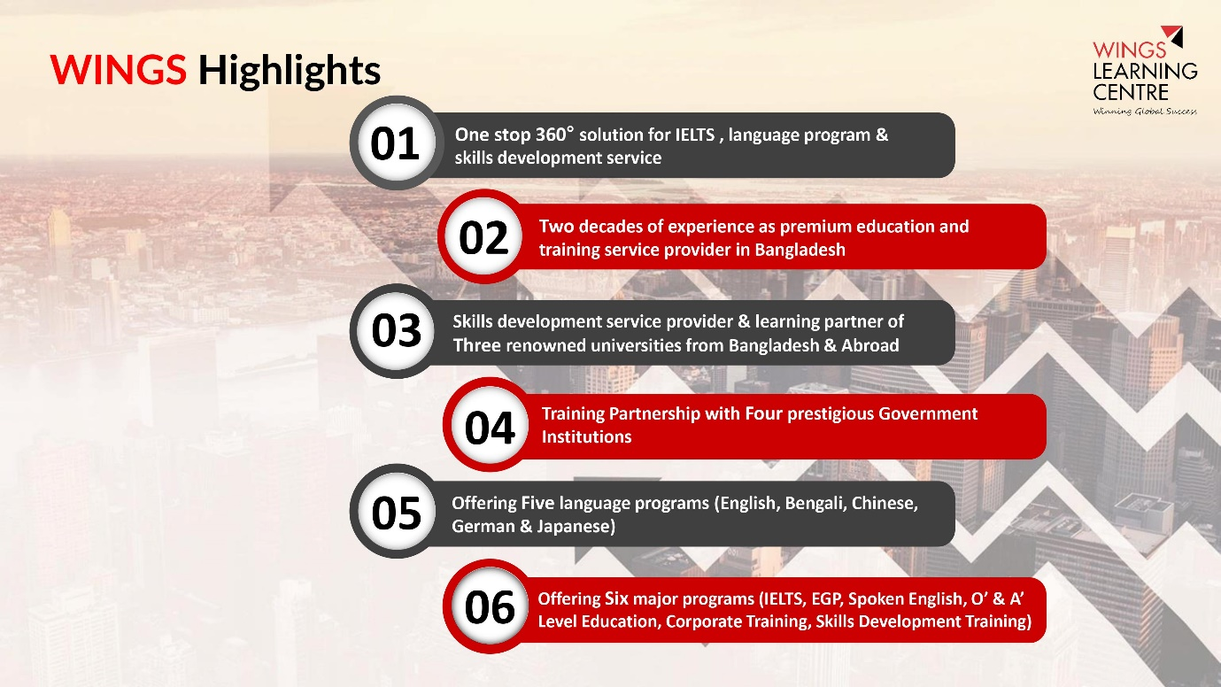

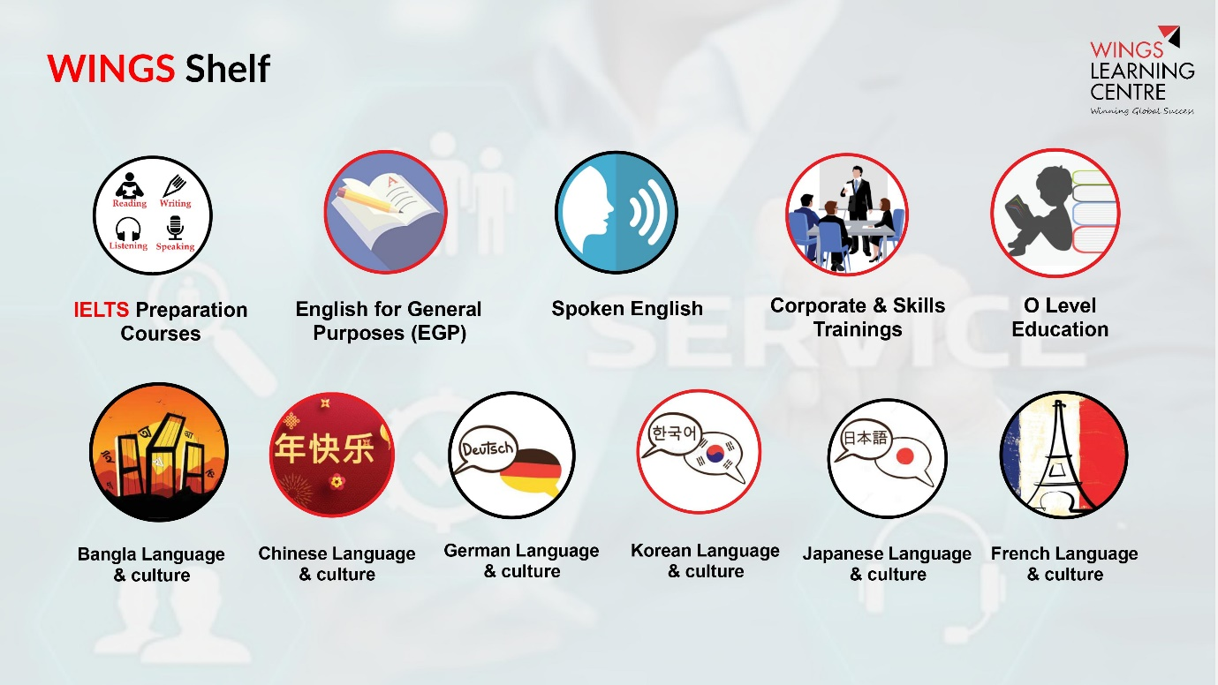

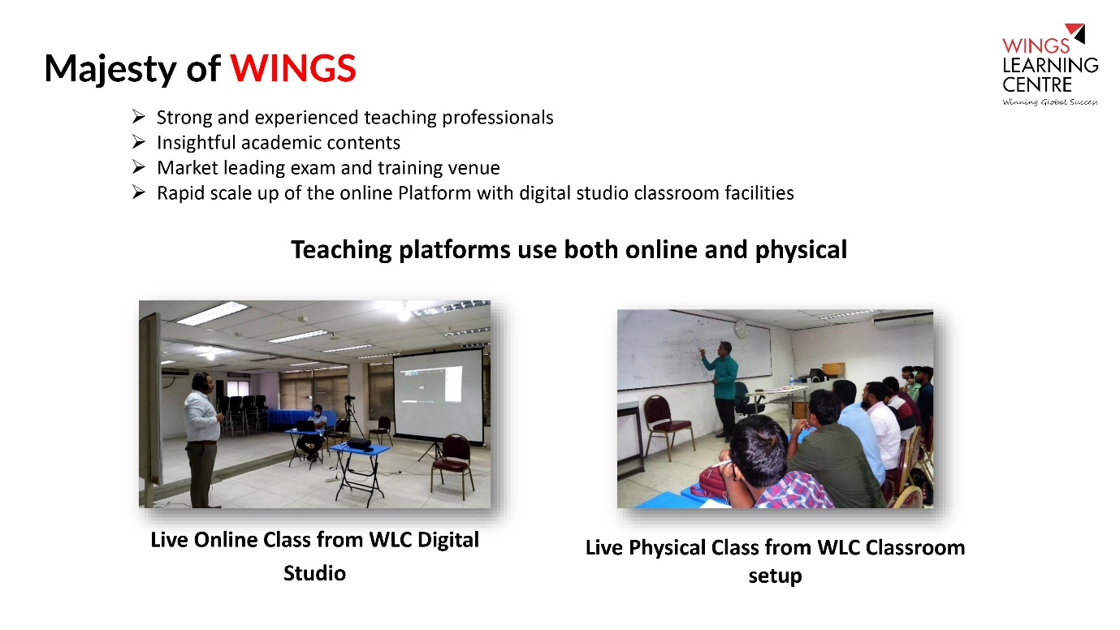

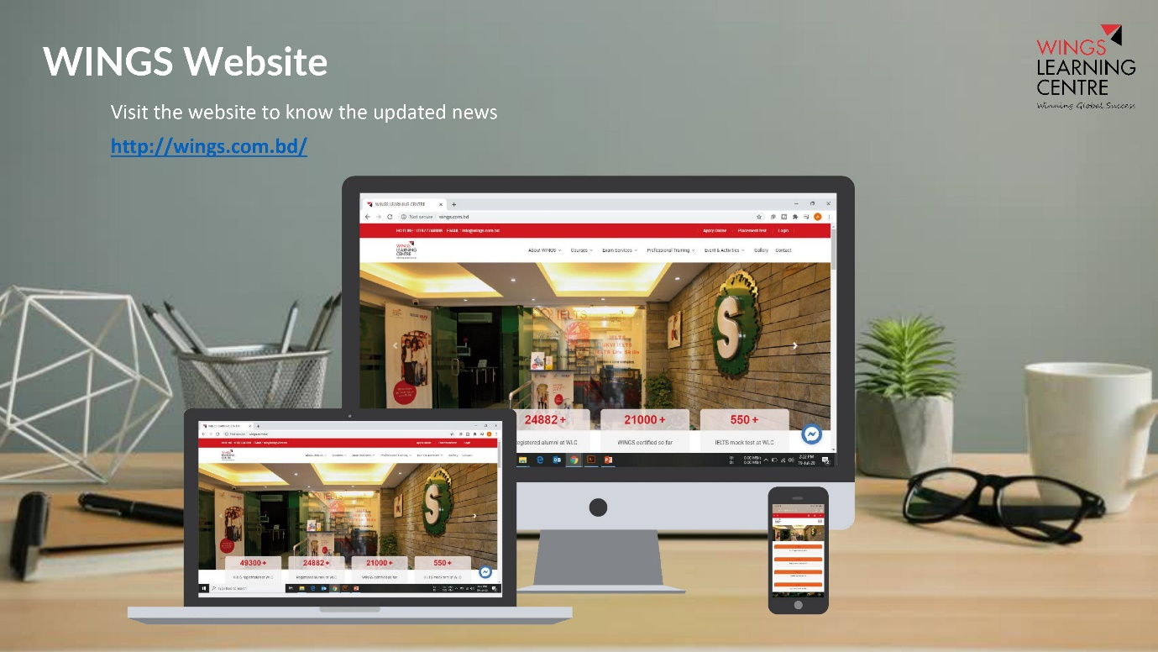

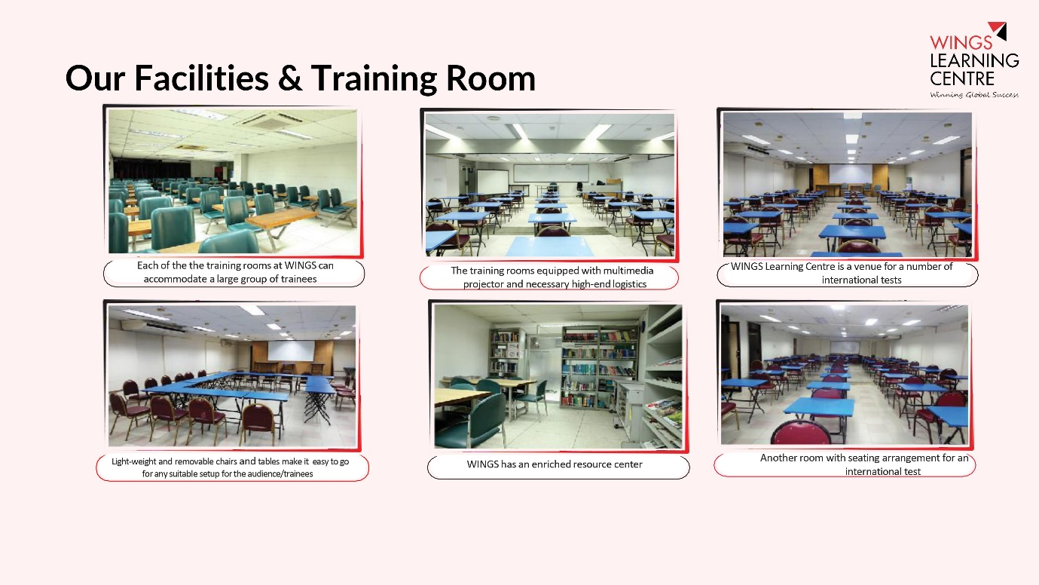

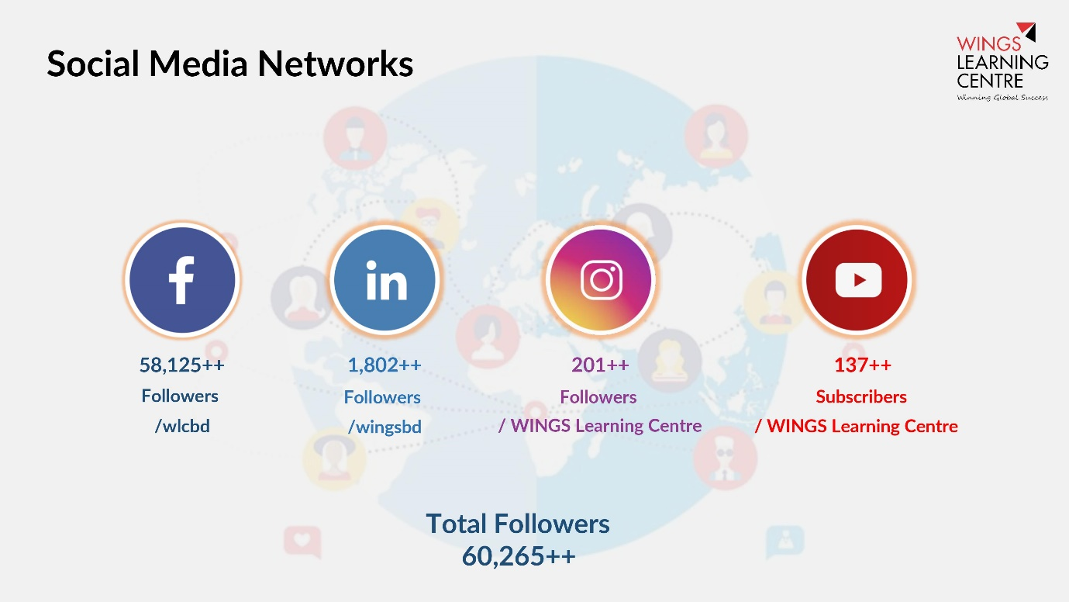

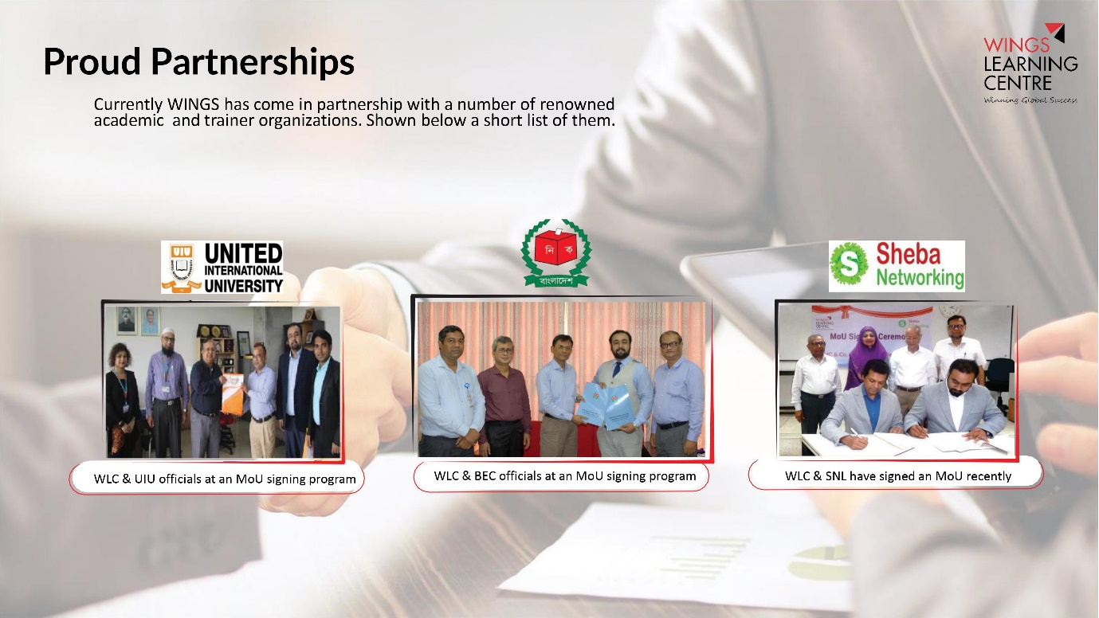

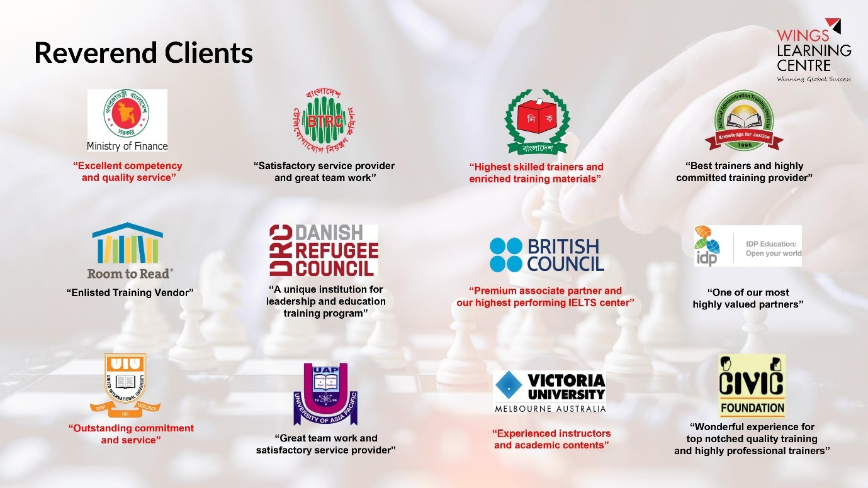

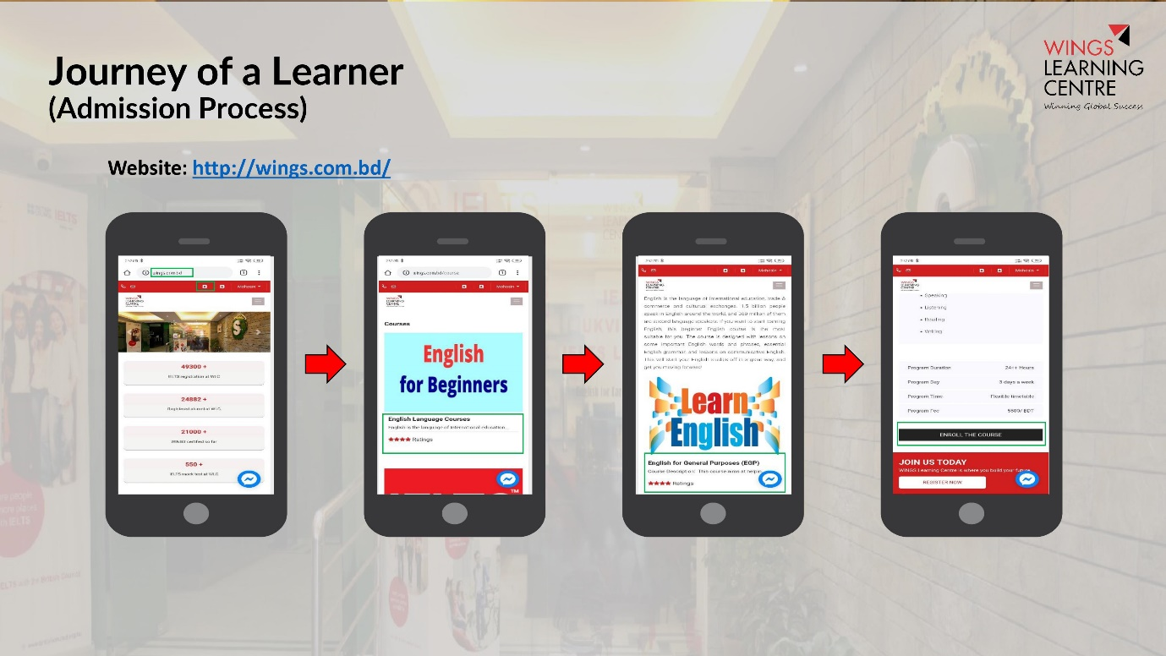

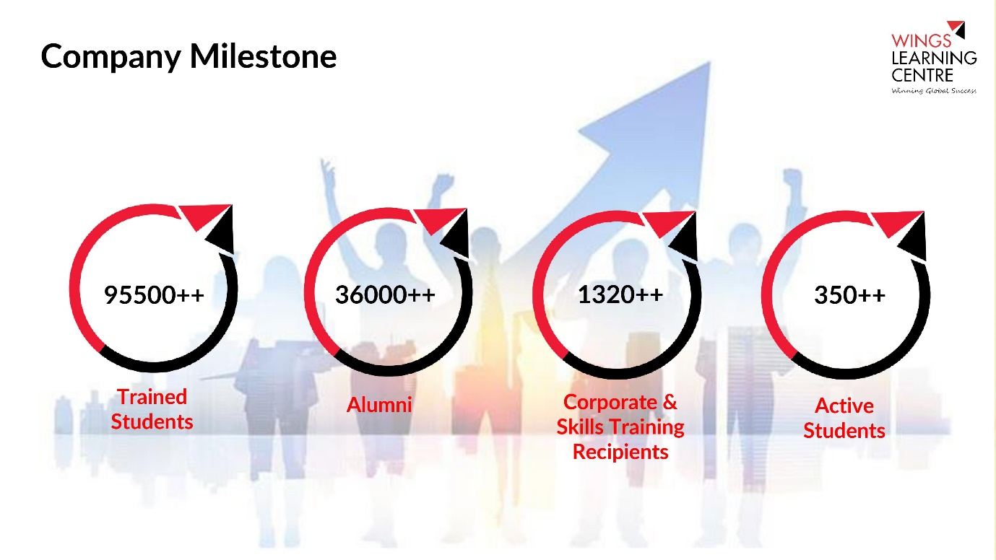

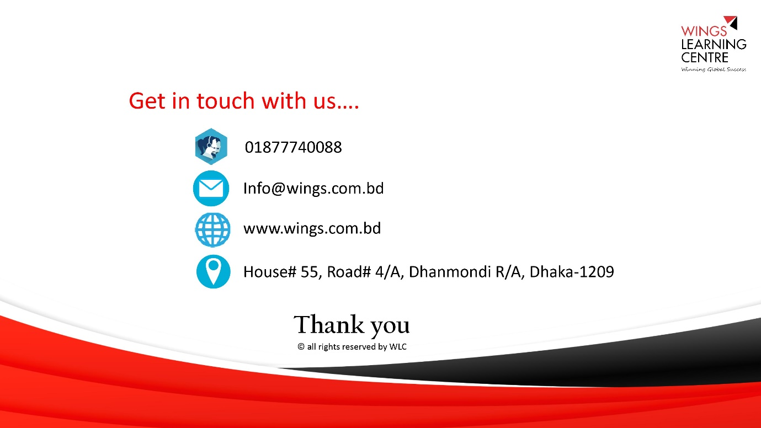

# 2.0 Section-2: Experiences of the Firm in Key Operating Areas

## 2.1. Sheba Technologies Ltd.

| **SL#** | **Software’s/Products Name** | **Clients Name & Address** |
| --- | --- | --- |
| 1 | EKYC Application | **Client Name:** Guardian Life Insurance  **Address:** Police Plaza Concord (13th Floor), Tower- 02,  Plot # 02, Road # 144, Gulshan Avenue, Dhaka- 1212. |
| 2 | EKYC, United Commercial Bank (POC) | **Client Name:** United Commercial Bank  **Address:** Bulus Center (Level - 3), Plot - CWS- (A)-1, Road No – 34, Gulshan Avenue, Dhaka-1212 |
| 3 | Bio-Metric Verification Solution (EKYC) | **Client Name:** GrameenPhone Limited  **Address:** GP House, Bashundhara, Baridhara, Dhaka 1229 |
| 4 | Robi Subscriber Verification System (EKYC) | **Client Name:** Robi Axiata Limited  **Address:** Robi Corporate Office, 53, Gulshan South Avenue, Gulshan-1, Dhaka-1212 |
| 5 | Mobile Device Management solution | **Client Name:** GrameenPhone Limited  **Address:** GP House, Bashundhara, Baridhara, Dhaka 1229 |
| 6 | Robi Single Application (Red Cube) | **Client Name:** Robi Axiata Limited  **Address:** Robi Corporate Office, 53, Gulshan South Avenue, Gulshan-1, Dhaka-1212 |
| 7 | Uttara Motors Smart Service | **Client Name:** Uttara Motors Ltd.  **Address:** H. No102, Uttara Center, Shaheed Tajuddin Ahmed Ave, Dhaka 1208 |
| 8 | BYLC Graduate Portal | **Client Name:** Bangladesh Youth Leadership Center (BYLC)  **Address:** Plot-3 Road No. 20, Block J Baridhara, Dhaka 1212 |
| 9 | Robi Enterprise Resource locator | **Client Name:** Robi Axiata Limited  **Address:** Robi Corporate Office, 53, Gulshan South Avenue, Gulshan-1, Dhaka-1212 |
| 10 | Restaurant Point of Sale | **Client Name: The** Coffee Bean & Tea Leaf  **Address:** House No 11/A, Road 117, Gulshan 2, Dhaka 1212 |
| 11 | T-Cash Mobile App For Trust Bank (POC) | **Client Name:** Trust Bank Ltd.  **Address:** Shadhinata Tower, Bir Srestha Shaheed Jahangir Gate, Dhaka Cantonment, Dhaka-1206 |
| 12 | Digital LAB Monitoring and Management Solution (POC) | **Client Name:** DoICT, Ministry of ICT  **Address:** ICT Tower, E-14/X, BCC Bhaban, Dhaka 1207 |

# 3.0 Section-3: Organizational Capability of the Firms

## 3.1. Sheba Technologies Ltd.

|  |  |
| --- | --- |
| **Name** | **Farhan Islam** |
| Designation | Cheif Operating Officer |
| Years of experience | 16 years + |
| Technology | IT Systems, Security, Architecture, Telecom Infrastructure, Datacom, Project Managment, Product Management |
| Degree | B.Sc. (Hons) in Computer Science, University of Portsmouth, United Kingdom |
| Short Description | **Farhan Islam** is working as a Product Manager for Sheba Technologies Limited. He has completed his B.Sc. (Hons) Computer Science from University of Portsmouth, United Kingdom. He has gathered extensive experience of over 16 + years in diversified fields of ICT as Software Developer, Technical Writer, Systems Analyst and Project Manager both in United Kingdom & in Bangladesh. Developed in-depth knowledge on Software development life cycle, help documentations & white papers for software developers. Recognized for translating technical information into easy to understand English. Committed to collaborate with Clients & Software development team in order to maintain smooth communication & also to provide defect free solutions. |
| Functional Area Expertise | Self/assisted on-boarding, data capture, identity verification, integration, system security, reporting, cross channel platform development, system architechture and mobile app development. |

|  |  |
| --- | --- |
| **Name** | **Somael Kabir** |
| **Designation** | **CTO** |
| **Years of experience** | **16 years +** |
| **Technology** | **IT Systems, Security, Architecture, Telecom Infrastructure, Datacom, Project Management** |
| **Certification** | **CEH,C|CISO,RHCVA,RHCEv5** |
| **Degree** | **B.Sc. in CSE, East West University** |
| **Short Description** | **16+ years of experience in managing telecom billing operations, ICT network, systems and databases. In-depth knowledge and experience in infrastructure planning, capacity analysis, system implementation. Handle regulatory and corporate affairs. Vendor management and business plan analysis.** |
| **Functional Area Expertise** | **Self/assisted on-boarding, data capture, identity verification, integration, system security, reporting, cross channel platform development, system architechture and mobile app development.** |
| **Name** | **Mujahidul Islam** |
| Designation | System Analyst |
| Years of experience | 10 years + |
| Database | Microsoft SQL Server 2000 to 2016, MSSQL DB Clustering, Oracle 10g, MySQL, Project |
| Reporting Tools | Microsoft BI (SSRS, SSIS), QlikView, Crystal Reports. |
| Language | PL/SQL, Database Programming |
| Degree | B.Sc. in CSE |
| Short Description | Worked on System Analysis and Design, Requirements analysis as well as ensure the synchronization of business process and system development in Renowned Groups, IT Enabled Firms. Developed interactive dashboards and reports in different Business Intelligence tools. Also worked in several RDBMS including DB programming and Administration. |
| Functional Area Expertise | Self/assisted on-boarding, data capture, identity verification, integration, system security, reporting, cross channel platform development, system architechture, database architechture, project management and mobile app development, cloud environments. |

|  |  |
| --- | --- |
| **Name** | **Md. Shafiqur Rahman** |
| Designation | Senior Software Developer |
| Years of experience | 10 years + |
| Language | PhP, ASP .NET |
| Scripting language | node js, Vue js, JavaScript, jquery |
| Database | Sql Server 2008, 2014, Oracle 10g, 12c, MySQL |
| Version control tool | TortoiseSVN, Git, TFS |
| Degree | M.Sc. in IT |
| Short Description | 10+ years of software development experience. Currently working as a Senior software engineer. Have more than 7 years of diversified experience in the field of ICT. Worked for Renowned ICT industry in Bangladesh. Extensive knowledge on Enterprise Appications, ERP, CRM System, Telecom Billing Solution. |
| Functional Area Expertise | Self/assisted on-boarding, data capture, identity verification, integration, system security, reporting, cross channel platform development, system architechture, database architechture, software development and mobile app development, cloud environments. |

|  |  |
| --- | --- |
| **Name** | **Tayab Khan** |
| Designation | Head of Infrastructure |
| Years of experience | 12 years + |
| Technology | IT Systems, Security, Architecture, Telecom Infrastructure, Datacom. |
| Degree | B.Sc. in CSE |
| Training | Cyber Security Concepts & Principles  RHCSA and RHCE  CCNA |
| Short Description | 12+ years of core IT, infrastructure and cyber security systems experience. |
| Functional Area Expertise | Infrastructure mapping, hardware sizing, systems support & security. |

|  |  |
| --- | --- |
| **Name** | **Tahsin Muhsin** |
| Designation | Assistant Manager, Business Operations (Documentation Specialist) |
| Years of experience | 6 years + |
| Technology | SRS, BRS & Technical documentation specialist. |
| Degree | BA Hons in Marketing, Cardiff Metropolitan University, Wales. |
| Short Description | 6 years of experience in technical documentation. |
| Functional Area Expertise | UAT, SRS, User Manual, Training & other documentation. |

|  |  |
| --- | --- |
| **Name** | **MD. Saiful Islam** |
| Designation | Sr. Executive, IT Services |
| Years of experience | 7 years + |
| Technology | IT Systems, Security, Architecture, Telecom Infrastructure, Datacom. |
| Degree | B.Sc. in CSE |
| Short Description | 7+ years of core IT, infrastructure and cyber security systems experience. |
| Functional Area Expertise | Infrastructure mapping, hardware sizing, systems support & security. |

|  |  |
| --- | --- |
| **Name** | **A.K.M Ariful Islam Shimul** |
| Designation | Lead Application Developer |
| Years of experience | 8 years + |
| Technology | IT Systems, Security, Architecture, BLL. |
| Degree | B.Sc. in CSE, MSC in CSE |
| Short Description | 8+ years of application development experience. |
| Functional Area Expertise | Mobile application development, platform development, security and architechture. |

|  |  |
| --- | --- |
| **Name** | **Rafid Mehedi Bhuiyan** |
| Designation | UI/UX Expert |
| Years of experience | 6 years + |
| Technology | UI, UX, Mock-up and prototype development. |
| Degree | MSC in ICT |
| Short Description | 6+ years of application UI/UX development experience. |
| Functional Area Expertise | UI/UX development, ituitive design and customer journey expert. |

|  |  |
| --- | --- |
| **Name** | **Saiful Islam Shojib** |
| Designation | Mobile App Developer |
| Years of experience | 7 years + |
| Language | PhP, ASP .NET, SWIFT, JAVA |
| Scripting language | node js, Vue js, JavaScript, jquery |
| Database | Sql Server 2008, 2014, Oracle 10g, 12c, MySQL |
| Version control tool | TortoiseSVN, Git, TFS |
| Degree | BSc. in CSE |
| Short Description | 7+ years of Android & IOS development experience. |
| Functional Area Expertise | IOS mobile application developer |

|  |  |
| --- | --- |
| **Name** | **Rakib Hasan** |
| Designation | Mobile App Developer |
| Years of experience | 3 years + |
| Language | SWIFT, JAVA |
| Degree | BSc. in CSE |
| Short Description | 3+ years of Android & IOS development experience. |
| Functional Area Expertise | Android mobile application development |

|  |  |
| --- | --- |
| **Name** | **Rezwanul Reaz** |
| Designation | Software Developer Developer |
| Years of experience | 7 years + |
| Language | PhP, ASP .NET |
| Scripting language | node js, Vue js, JavaScript, jquery |
| Database | Sql Server 2008, 2014, Oracle 10g, 12c, MySQL |
| Version control tool | TortoiseSVN, Git, TFS |
| Degree | BSC. in CSE |
| Short Description | 7+ years of software development experience. |
| Functional Area Expertise | Software platform development, system security & integration. |

|  |  |
| --- | --- |
| **Name** | **Fahima Chowdhury** |
| Designation | Software Developer Developer |
| Years of experience | 4 years + |
| Language | PhP, ASP .NET |
| Scripting language | node js, Vue js, JavaScript, jquery |
| Database | Sql Server 2008, 2014, Oracle 10g, 12c, MySQL |
| Version control tool | TortoiseSVN, Git, TFS |
| Degree | BSC. in CSE |
| Short Description | 4+ years of software development experience. |
| Functional Area Expertise | Software development, backend dashboard, MIS, testing and QA. |

|  |  |
| --- | --- |
| **Name** | **Nipun Ferdous** |
| Designation | Tester & QA |
| Years of experience | 2 years + |
| Degree | BSC. in CSE |
| Short Description | 2 years of software application testing experience and QA experience. |
| Functional Area Expertise | Testing, QA and documentation. |

|  |  |
| --- | --- |
| **Name** | **Salman Kabir Shuvo** |
| Designation | UI/UX Expert |
| Years of experience | 3 years + |
| Technology | UI, UX, Mock-up and prototype development. |
| Degree | BSc in CSE |
| Short Description | 3+ years of application UI/UX development experience. |
| Functional Area Expertise | UI/UX development, visuals & application graphics. |

|  |  |
| --- | --- |
| **Name** | **MD Jeshad** |
| Designation | Tester & QA |
| Years of experience | 3 years + |
| Technology | Testing, QA & documentation |
| Degree | BSc in CSE |
| Short Description | 3+ years of application UI/UX development experience. |
| Functional Area Expertise | Testing, QA and documentation. |

|  |  |
| --- | --- |
| **Name** | **Tajid Hasan** |
| Designation | Senior ICT Engineer |
| Years of experience | 10 years + |
| Technology | IT Systems, Security, Architecture, Telecom Infrastructure, Datacom. |
| Degree | B.Sc. in CSE |
| Training | Cyber Security Concepts & Principles  RHCSA and RHCE  CCNA |
| Short Description | 10+ years of core IT, infrastructure and cyber security systems experience. |
| Functional Area Expertise | Infrastructure mapping, systems support & security specialist. |

|  |  |
| --- | --- |
| **Name** | **SNA Nilim** |
| Designation | Software Developer |
| Years of experience | 4 years + |
| Technology | Machine Learning, AI & R&D |
| Degree | BBA, MBA |
| Short Description | 4+ years of in machine learning, AI and R&D |
| Functional Area Expertise | Machine Learning, AI & R&D |

|  |  |
| --- | --- |
| **Name** | **Iqbal Khan** |
| Designation | Mobile App Developer |
| Years of experience | 4 years + |
| Language | SWIFT, JAVA |
| Degree | BSc. in CSE |
| Short Description | 4+ years of Android development experience. |
| Functional Area Expertise | Android mobile application development and integration specialist. |

# 4.0 Section-4: Logistics Resources of the Firm

## 4.1. Sheba Technologies Ltd.

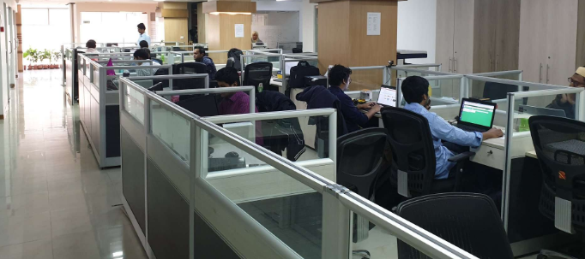The work center of Sheba Technologies Limited offers excellent environment with all modern facilities of hardware, software and networking. The total floor space is over 5000 sft and is equipped with a wide array of hardware including sophisticated and powerful PCs, Laptops, Laser Printers, Scanners and color printers. STL is fully equipped to provide all necessary logistic support for various Software development, training and consultancy project activities. It has all sorts of modern and up-to date computers and peripheral equipment.

### 4.1.2 Efficient Logistic & Equipment

STL uses modern IT equipment, servers and peripherals to accomplish its business activities which are designed to fulfill the needs of Internal and External Clients efficiently. The hardware consists of:

|  |  |  |
| --- | --- | --- |
| SL | Items | Quantity |
| 1 | Desktop PC | 40 |
| 2 | Laptop (Core i3, i5, i7) | 35 |
| 3 | Brother LaserJet Network Printer (Color) | 1 |
| 4 | HP Laserjet Network Printer | 3 |
| 5 | Scanner | 3 |
| 6 | Multi Media Projector | 2 |
| 7 | IP Telephone/ SIP Phone (AASTRA/ HUAWEI) | 15 |

### 4.1.3 Facilities

Well-organized corporate office **–** Sheba Technologies Limited is maintaining a well-organized registered office at Khawaja Tower (8th Floor), 95 Mohakhali C/A, Dhaka, with all modern and state of the art office facilities and Data Center It's total personnel force amounts to more than 40.

Ample floor space –

|  |  |  |
| --- | --- | --- |
| **Sl. No.** | **Description** | **Sq. ft.** |
| 1 | Conference Room | 250 |
| 2 | Data Center | 1200 |
| 3 | Office and others | 4,350 |
| **Total Floor Space** | | **5,800** |

### 4.1.4 Skill set

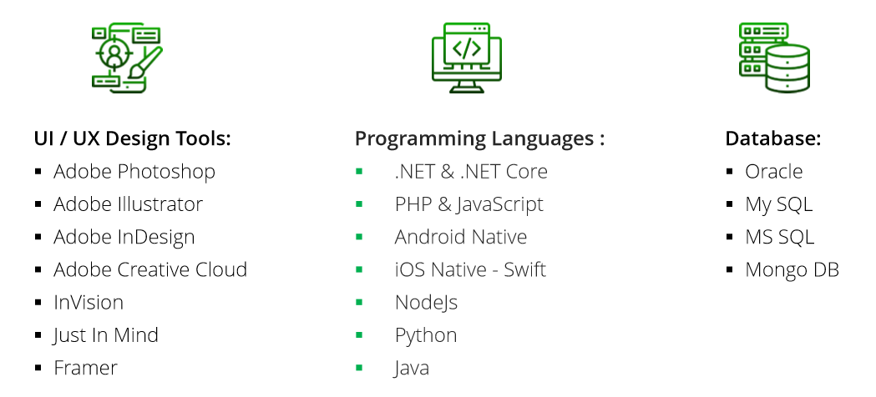

### 4.1.5 Work Centre With Modern Facilities

The work center of Sheba Technologies Limited offers excellent environment with all modern facilities of hardware, software and networking. The total floor space is approximately 5000 sft and is equipped with a wide array of hardware including sophisticated and powerful PCs, Laptops, Laser Printers, Scanners and color printers. STL is fully equipped to provide all necessary logistic support for various Software development, training and consultancy project activities. It has all sorts of modern and up-to date computers and peripheral equipment.

STL Ltd. has a well-organized registered Head office at House no. 55 (3rd floor), Road no. 4/A, Dhanmondi, Dhaka with all modern office facilities.

## 4.2. WINGS Learning Center. (WLC)

Wings Learning Center. (WLC) is equipped with large facilities at Dhaka Office.

### 4.2.1 Training Equipment

WLC uses modern IT equipment, servers and peripherals to accomplish its business activities which are designed to fulfill the needs of Internal and External Clients efficiently. The hardware consists of:

|  |  |  |
| --- | --- | --- |
| SL | Items | Quantity |
| 1 | Desktop PC | 20 |
| 2 | Laptop (Core i3, i5, i7) | 10 |
| 3 | Brother LaserJet Network Printer (Color) | 1 |
| 4 | HP Laserjet Network Printer | 2 |
| 5 | Scanner | 2 |
| 6 | Multi Media Projector | 2 |
| 7 | IP Telephone/ SIP Phone (AASTRA/ HUAWEI) | 5 |

### 4.2.2 Training Facilities

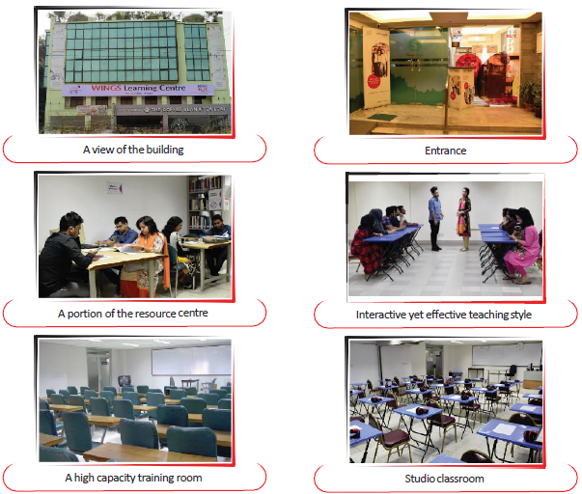

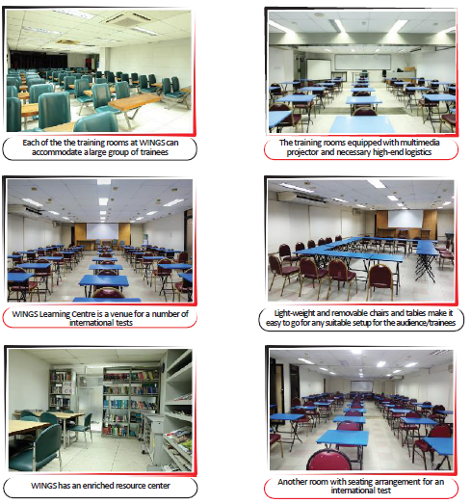

One of the sister concerns of STL, AHC & Co. has State of the ART training rooms with the following facilities:

* Fully furnished air-conditioned training room that can accommodate up to 40 participants
* A large conference room that can accommodate up to 20 participants
* A fully-fledged center having state of the art computer and wifi internet facilities
* Overhead Multimedia projector and suitable audiovisual equipment
* Facilitator/Moderator/Rapporteur/Receptionist/ Attendants services
* Computerized Study Materials

# 5.0 Section-5: STL Work Experience

|  |
| --- |
| **BRAC Online Career Hub**  To address the rising unemployment rate amongst the youth in Bangladesh, SDP wants to propose the development of a web and mobile platform that will serve as a medium for the learners to gain employability skills online to ultimately get employment. The end goal of the platform is to provide its learners necessary skills to get job opportunities/entrepreneurship support within the platform. For this reason, the platform will have features such as career counselling, skills training, and job posting capability.   * Relevant Work Order attached below. |
|  |
| **Grameenphone Mobile Device Management (MDM)**  Sheba Technologies Ltd. has developed the Mobile Device Management (MDM) solution for Grameen Phone.  **Features**  The solution provides full system administrative functionalities, list of which is provided below:   * Web control and usage policies * App whitelisting/blacklisting * Password and encryption enforcement * Remote wipes and locking * Mobile device inventory and tracking * App passwords, and custom application containers * Wi-Fi, Bluetooth and update control * App distribution or volume purchasing * Relevant Work Order attached below. |
|  |
| **Implementation & Development of EKYC Solution for IDLC Finance Ltd.**  Sheba Technologies Limited has provided fully functional EKYC solution to IDLC Finance Limited supported by Web Application and Mobile application both.  Primary Functionalities:   * Client NID verification & Identification; * Administration Dashboard; * Audit Trial; * Application Security; * Relevant Work Order attached below. |
| **United Finance Limited**  The EKYC Solution developed for United Finance will be based on Android and Web-based platforms. The solution will allow both Self verification of Customer along with Assisted Customer verification functionality. For Self-verification of Customer, users can use these two platforms to verify themselves digitally and will receive SMS notification once the verification process has been completed successfully. For Assisted Customer Verification, UFL or its nominated agents will assist the customer to directly get verified using the system. A separate backend web panel will be there for the process admin to maintain settings of the system.   * Relevant Work Order attached below. |
| **Guadian Life Insuarance**  The EKYC Solution developed for GLIL will be based on Android, IOS and Web-based platforms. Customers can use all three platforms to on-board themselves digitally and will receive SMS and Email notification once the onboarding process has been completed successfully. It is essential to note that the on-onboarding parent app is a part of a larger GLIL ‘Parent Application’ which will call for the KYC application and will provide the system with the customer phone number and email ID (optional) through which customers will get on-boarding notification. A separate backend web application will be there for the system admin to monitor the system.   * Relevant Work Order attached below. |
| **Robi Subscriber Verification System**  The solution will comprise of Web Based WIC App, an Android App, Web Portal/Back End for the Web APP, Central Control Management Panel, SVS Middleware, Business Logic Layer, Analytical Dashboard and Management Dashboard.   * Relevant Work Order attached below. |
| **BRAC BANK – SME Collection Dashboard**  SME Dashboard for BRAC Bank is designed to provide a detailed overview of the loan activities for small & medium enterprises**.**   * This application will improve business collection and recovery efforts. * Help RO’s on-the-go to monitor their loan accounts in real time. * Allows RO’s to manage/input key details about their accounts. * Allows BDM to get an overview of the real-time RO performance under them. * Allows TM’s to get an overview of the BDM’s under them as well as an RO’s account details in real-time. * Option to generate various real-time reports as required. * Relevant Work Order attached below. |
| **BRAC Artificial Insemination: ERP SOFTWARE** |
| **Project: Dashboard for Lab Monitoring Activities of Sheikh Russel Digital Labs** |

# 6.0 Section-6: Availability of Technical Experts for Performing the Assignment

|  |  |  |  |  |  |  |  |  |  |  |  |
| --- | --- | --- | --- | --- | --- | --- | --- | --- | --- | --- | --- |
|  | | Recent Photo of the Individual | |  | | | | | | | |
| 1 | | PROPOSED POSITION FOR  THIS PROJECT | | **Chief Operating Officer** | | | | | | | |
| 2 | | NAME OF PERSON | | **Farhan Islam** | | | | | | | |
| 3 | | DATE OF BIRTH | | 19-11-1982 | | | | | | | |
| 4 | | NATIONALITY | | Bangladeshi | | | | | | | |
| 5 | | MEMBERSHIP IN PROFESSIONALSOCIETIES | | *N/A* | | | | | | | |
| 6 | | EDUCATION: | | *BSc. Computer Science,*  *University of Portsmouth, United Kingdom* | | | | | | | |
| 7 | | OTHER TRAINING | | N/A | | | | | | | |
| 8 | | LANGUAGES & DEGREE OF  PROFICIENCY | | Language | | | Speaking | | Reading | Writing | |
|  | | *English* | | | *Fluent* | | *Excellent* | *Excellent* | |
| 9 | | COUNTRIES OF WORK EXPERIENCE | | Bangladesh | | | | | | | |
| 10 | | | EMPLOYMENT RECORD |  | | | | | | | |
|  | | **EMPLOYER: 1**  **Sheba Technologies Ltd.**  <http://www.shebatech.com.bd/>  8th Floor, Khawaja Tower, 95 Mohakhali C/A, Dhaka-1212.  Position Held: **Head of Business Operations**  **Duties and Responsibilities:**   * Report to CEO on Business Development & Operations; * Collect reports on upcoming project opportunities; * Lead Technical Documentation Team; * Lead Software Quality Assurance & Software Testing Group; * Lead Business Analysts; * Taken Responsibility as Head of Software Engineering Process Group (SEPG); * Provide and support the implementation of business solutions by building relationships and partnerships with key stakeholders; identifying business needs; determining and carrying out necessary processes and practices; monitoring progress and results; recognizing and capitalizing on improvement opportunities; and adapting to competing demands, organizational changes and new responsibilities; * Monitor Project schedules, milestone completions, track all phases of the project lifecycle; * Manage Project team regularly to review project deliverables and deadlines; * Manage existing products and its upcoming feature roadmap; | | | | FROM:  **2020** | | | TO:  **Ongoing** | | |
|  | **EMPLOYER: 2**  **Sheba Technologies Ltd.**  <http://www.shebatech.com.bd/>  8th Floor, Khawaja Tower, 95 Mohakhali C/A, Dhaka-1212.  Position Held: **Senior Business Analyst**  **Duties and Responsibilities:**   * Lead UI/UX Team; * Support and align efforts to meet customer and business needs; * Manage customer relationships and expectations by developing a communication process; * Capture and clearly document business and systems requirements; * Lead or participate in multiple projects by completing and updating project documentation; managing project scope; adjusting schedules when necessary; determining daily priorities; ensuring efficient and on-time delivery of project tasks and milestones; following proper escalation paths; and managing customer and supplier relationships; * Provide project level analysis – producing required project analysis documentation (business requirements, scope matrix, use cases, sequence diagrams, future state proposals, UAT plan); * Analyze Customer Business Requirements and present them with Non-Functional Prototypes to allow them to visualize and experience the solution to be; * Create and maintain issue logs, meeting minutes, meeting schedules, project summaries and updates; * Create and maintain project schedules by developing project plans and specifications, estimating time and resources, monitoring milestone completion, tracking all phases of the project lifecycle, providing timely reporting of issues that impact project progress, coordinating actions and resolving conflicts; * Develop and execute test plans; * Support system conversions, upgrades, enhancements; * Oversee the design of new products, assisting with market trends in order to guide the design team; | | | | FROM:  **2019** | | | TO:  **2020** | | |
|  | **EMPLOYER: 3**  **Sheba Technologies Ltd.**  <http://www.shebatech.com.bd/>  8th Floor, Khawaja Tower, 95 Mohakhali C/A, Dhaka-1212.  Position Held: **Product Manager**  **Duties and Responsibilities:**   * Lead the product development process, including user research, prototyping, and business case generation while working very closely with the Technical Team; * Develop and implement product strategies consistent with company vision; * Collect and analyze feedback from customers, stakeholders and other teams to shape requirements, features and end products; * Work with senior management to create product plans and road maps; * Produce and review product requirement documents (PRD); * Ensure products release as per “Go to Market” (G2M) Strategy; * Managing the product through the delivery process, including managing key vendors / partners and influencing internal stakeholders; * Monitoring product key performance indicators and continuously improving operational delivery to maximize performance; * Preparing and conducting PoC (Proof of Concept), UAT (User Acceptance Test), User Manual, operation and quality control processes; * Continuously communicate with customers and end users to meet their expectation and minimize gap; * Recommending the nature and scope of present and future product lines by reviewing product specifications and requirements; appraising new product ideas and/or product or packaging changes; * Assessing market competition by comparing the company's product to competitors' products; * Providing source data for product line communications by defining product marketing communication objectives; * Obtaining product market share by working with sales to develop product sales strategies; * Providing information for management by preparing short-term and long-term product sales forecasts and special reports and analyses; answering questions and requests; * Facilitating inventory turnover and product availability by reviewing and adjusting inventory levels and production schedules; * Bringing new products to market by analyzing proposed product requirements and product development programs; preparing return-on-investment analyses; establishing time schedules with development; * Introduces and markets new products by developing time-integrated plans with sales, advertising, and production; * Determines product pricing by utilizing market research data; reviewing production and sales costs; anticipating volume; costing special and customized orders;   **EMPLOYER: 4**  FROM To  **2010 2016**  **SkyHigh Communications, HK Limited**  Position Held: **Partner & Chief Business Development Manager**  **Duties and Responsibilities:**   * Reaching out to interconnect with variety of other telecomm carrier’s worldwide; * Negotiating Voice Traffic Wholesale Rates as per destination and caller prefix; * Keeping Local Capacity Suppliers available at all times with numerous **E1** capacity; * Reviewing and Analyzing Call Success Rates along with Average Call durations every hour; * Troubleshooting any issues that might arise while Routing VOIP traffic from Customer To Supplier To Soft switch (VOS3000); * Maintain Monthly Traffic Revenue Accounts and Clearing Payments to all stakeholders.   FROM To **2009 2010**  **EMPLOYER: 5**  **Bangladesh Internet Press Ltd. (BIPL), Bangladesh**.  Position Held: **Manager Key Accounts & Client Relationship**  **Duties and Responsibilities:**   * Use variety of resources to scan through Prospective Tenders & create relationship with the client’s high-end authorities to find & gather in depth project related information; * Schedule & Plan Tender Participation techniques and brief in-house team member to work accordingly; * Actively participate in preparing Technical & Financial Proposal; * Work as a bridge between existing Clients and our Development Team to ensure all Projects related work are well documented & maintained as per CMMI (Level 3) standards; * Assist HR Department to scan through applicants in order to employ consultants for upcoming projects & also for any replacement in the ongoing projects; * Work closely together with the Managing Director & the top-level management officials to identify future prospects of the Company.   FROM To **2004 2005**  **EMPLOYER: 6**  **Apollo Fire detectors Limited, United Kingdom**  Position Held: **Technical Maintenance Engineer**  **Duties and Responsibilities:**   * In charge of providing maintenance support to the shop floor which consists of a wide variety of machines in the production line of fire detectors; * Also engaged partially in charge of Health and Safety from the electrical section, as to perform PAT test to make sure that all the items in use are safe to handle.   FROM To **2002 2003**  **EMPLOYER: 7**  **iCubed Technologies Ltd. United Kingdom**  Position Held: **Industrial Placement Engineer**  **Duties and Responsibilities:**   * iCubed Technologies mainly focuses on providing solutions for real time control systems in commerce and industry; * Involved in Software development, Web Applications development, Embedded Applications Testing, User Interfaces Design and Documentation. | | | | FROM:  **2016** | | | TO:  **2019** | | |

CERTIFICATION

I, the undersigned, certify that (i) I was not a former employee of the Client immediately before the submission of this proposal, and (ii) to the best of my knowledge and belief, this biodata correctly describes myself, my qualifications, and my experience. I understand that any wilful misstatement described herein may lead to my disqualification or dismissal, if engaged.  
I have been employed by **Sheba Technologies Ltd.** continuously for the last Sixty five (65) months as regular full time staff. Indicate “Yes” or “No” in the boxes below:

|  |  |  |  |  |  |  |  |  |  |  |  |  |  |  |  |
| --- | --- | --- | --- | --- | --- | --- | --- | --- | --- | --- | --- | --- | --- | --- | --- |
|  |  |  | **YES** |  |  |  | **NO** |  |  |  |  |  |  |  |  |

|  |  |
| --- | --- |
| Signature |  |
| Date of Signing | **19-12-2021**  Day / Month / Year |

|  |  |  |  |  |  |  |
| --- | --- | --- | --- | --- | --- | --- |
|  | Recent Photo of the Individual |  | | | | |
| 1 | PROPOSED POSITION FOR THIS PROJECT | **Technical Project Manager** | | | | |
| 2 | NAME OF PERSON | **Md. Sadi Arman** | | | | |
| 3 | DATE OF BIRTH | 04-02-1994 | | | | |
| 4 | NATIONALITY | Bangladeshi | | | | |
| 5 | MEMBERSHIP IN PROFESSIONALSOCIETIES | *N/A* | | | | |
| 6 | EDUCATION: | *M.Sc. in IT (2021)* | | | | |
| 7 | OTHER TRAINING | Project Management Professional; | | | | |
| 8 | LANGUAGES & DEGREE OF  PROFICIENCY | Language | Speaking | | Reading | Writing |
|  | *English* | *Native* | | *Native* | *Native* |
| 9 | COUNTRIES OF WORK EXPERIENCE | Bangladesh | | | | |
| 10 | EMPLOYMENT RECORD |  | | | | |
|  | **EMPLOYER: 1**  **Sheba Technologies Ltd.**  <http://www.shebatech.com.bd/>  8th Floor, Khawaja Tower, 95 Mohakhali C/A, Dhaka-1212.  Position Held: **Technical Project Manager**  **Duties and Responsibilities:**   * Establish and implement training processes. * Analyse, plan and develop requirements. * Assign and oversee the daily tasks of technical personnel. * Hold regular technical team meetings. * Determine and define clear deliverables, roles and responsibilities for staff members required, etc. | | | FROM:  **2021** | TO:  **Present** | |
|  | **EMPLOYER: 2**  **Nano Information Technology**  <http://www.nanoit.biz/>  Cha-88/1/B, North Badda (2nd & 3rd Floor), Badda, Dhaka, 1212, Dhaka  Position Held: **IT Project Manager**  **Duties and Responsibilities:**   * Perform Requirement analysis, * Risk Management analysis, * Compile Software Requirement Specification and other essential documents based on relevance, * Design Activity, Wireframe, user story, etc. * Initiate Project (Agile/Waterfall methodologies), * Lead team of developer and tester towards project completion, * SQA when required, * Deliver Projects to stakeholders and many more. | | | FROM:  **2019** | TO:  **2021** | |
|  |  | | |  |  | |

CERTIFICATION

I, the undersigned, certify that (i) I was not a former employee of the Client immediately before the submission of this proposal, and (ii) to the best of my knowledge and belief, this biodata correctly describes myself, my qualifications, and my experience. I understand that any wilful mis-statement described herein may lead to my disqualification or dismissal, if engaged.

I have been employed by **Sheba Technologies Ltd.** continuously for the last Thirty One (31) months as regular full time staff. Indicate “Yes” or “No” in the boxes below:

|  |  |  |  |  |  |  |  |  |  |  |  |  |  |  |  |
| --- | --- | --- | --- | --- | --- | --- | --- | --- | --- | --- | --- | --- | --- | --- | --- |
|  |  |  | **YES** |  |  |  | **NO** |  |  |  |  |  |  |  |  |

|  |  |
| --- | --- |
| Signature |  |
| Date of Signing | **19-12-2021**  Day / Month / Year |

|  |  |  |  |  |  |  |
| --- | --- | --- | --- | --- | --- | --- |
|  | Recent Photo of the Individual |  | | | | |
| 1 | PROPOSED POSITION FOR  THIS PROJECT | Senior System Analyst | | | | |
| 2 | NAME OF PERSON | **SUMAYA MAHBUB** | | | | |
| 3 | DATE OF BIRTH | June 26, 1989 | | | | |
| 4 | NATIONALITY | Bangladeshi | | | | |
| 5 | MEMBERSHIP IN PROFESSIONAL SOCIETIES | *Certified Scrum Master* | | | | |
| 6 | EDUCATION: | *B.Sc. in CSE, East West University* | | | | |
| 7 | OTHER TRAINING | * Work smarter not harder, Coursera * Business Writing, Coursera * Effective Problem Solving and Decision Making, Coursera * Internet of Things (IOT), BRAC IT Services Limited * CBAP, BRAC IT Services Limited * Oracle Procurement Cloud Implementation, BRAC IT Services Limited * Oracle Financial CloudImplementation, , BRAC IT Services Limited | | | | |
| 8 | LANGUAGES & DEGREE OF PROFICIENCY | Language | | Speaking | Reading | Writing |
|  | *English* | | *Fluent* | *Excellent* | *Excellent* |
| 9 | COUNTRIES OF WORK EXPERIENCE | Bangladesh | | | | |
| 10 | EMPLOYMENT RECORD |  | | | | |
|  | **EMPLOYER: 1**  **BRAC IT Services Limited**  Company Location: House 115, Road 5, Block B, Niketon, Gulshan, Dhaka.  Position Held: **Business Analysis**  **Duties and Responsibilities:**  Analyzing applications, find out solution considering the risk of the projects. Prepare flow diagrams,  business analysis documents. Define scope, take vetting by clients. Share user experience, challenges  of using the as is system/process to the cross functional team through documentation, and knowledge  sharing sessions. Work effectively and efficiently to build a quality product through appropriate  software development processes. | | FROM:  **June 15, 2015** | | TO:  **October, 2021** | |
|  | **EMPLOYER: 2**  **Transcom group**  Position Held: **Sadiatec Limited**  Company Location : House 2, Road 3, Sector 7, Uttara, Dhaka  **Duties and Responsibilities:**   * UI Designing, Database maintenance, Software support, marketing | | FROM:  **September 1, 2013** | | TO:  **June 10, 2015** | |

CERTIFICATION

I, the undersigned, certify that (i) I was not a former employee of the Client immediately before the submission of this proposal, and (ii) to the best of my knowledge and belief, this bio-data correctly describes myself, my qualifications, and my experience. I understand that any wilful misstatement described herein may lead to my disqualification or dismissal, if engaged.

I have been employed by **Sheba Technologies Ltd.** as regular full time staff. Indicate “Yes” or “No” in the boxes below:

|  |  |  |  |  |  |  |  |  |  |  |  |  |  |  |  |
| --- | --- | --- | --- | --- | --- | --- | --- | --- | --- | --- | --- | --- | --- | --- | --- |
|  |  |  |  |  |  |  |  |  |  |  |  |  |  |  |  |

|  |  |
| --- | --- |
| Signature |  |
| Date of Signing | **19-12-2021**  Day / Month / Year |

|  |  |  |  |  |  |  |
| --- | --- | --- | --- | --- | --- | --- |
|  | Recent Photo of the Individual |  | | | | |
| 1 | PROPOSED POSITION FOR  THIS PROJECT | **Senior Software Architect** | | | | |
| 2 | NAME OF PERSON | **MD. SHAFIQUR RAHMAN** | | | | |
| 3 | DATE OF BIRTH | 01-07-1989 | | | | |
| 4 | NATIONALITY | Bangladeshi | | | | |
| 5 | MEMBERSHIP IN PROFESSIONALSOCIETIES | *N/A* | | | | |
| 6 | EDUCATION: | *Masters in Information Technology, University of Dhaka, 2016.* | | | | |
| 7 | OTHER TRAINING | CCNA  Linux | | | | |
| 8 | LANGUAGES & DEGREE OF  PROFICIENCY | Language | | Speaking | Reading | Writing |
|  | *English* | | *Fluent* | *Excellent* | *Excellent* |
| 9 | COUNTRIES OF WORK EXPERIENCE | Bangladesh | | | | |
| 10 | EMPLOYMENT RECORD |  | | | | |
|  | **EMPLOYER: 1**  **Sheba Technologies Ltd.**  <http://www.shebatech.com.bd/>  8th Floor, Khawaja Tower, 95 Mohakhali C/A, Dhaka-1212.  Position Held: **Senior Developer (Software Development)**  **Duties and Responsibilities:**   * Design / Architect software solutions * Supervise and conduct development activities of a software life cycle | | FROM:  **Nov, 2017** | | TO:  **Present** | |
|  | **EMPLOYER: 2**  **2RA Technologies Ltd**  Position Held: **Assistant Manager (Development)**  **Duties and Responsibilities:**   * Developed online VISA tracking system. * Electricity production and consumption monitoring system. | | FROM:  **April, 2014** | | TO:  **Nov, 2017** | |
|  | **EMPLOYER: 3**  **Noman Group of Industries**  Dhaka, Bangladesh.  Position Held: **Senior Programmer**  **Duties and Responsibilities:**   * Developed HR & Payroll Software. * Developed Inventory Management Software. * Developed Production Management Software. * Developed Requisition to Procurement Management Software. * Developed Ticketing Software. | | FROM:  **Sep, 2009** | | TO:  **April, 2014** | |

CERTIFICATION

I, the undersigned, certify that (i) I was not a former employee of the Client immediately before the submission of this proposal, and (ii) to the best of my knowledge and belief, this biodata correctly describes myself, my qualifications, and my experience. I understand that any wilful misstatement described herein may lead to my disqualification or dismissal, if engaged.

I have been employed by **Sheba Technologies Ltd.** continuously for the last fifty one (51) months as regular full time staff. Indicate “Yes” or “No” in the boxes below:

|  |  |  |  |  |  |  |  |  |  |  |  |  |  |  |  |
| --- | --- | --- | --- | --- | --- | --- | --- | --- | --- | --- | --- | --- | --- | --- | --- |
|  |  |  | **YES** |  |  |  | **NO** |  |  |  |  |  |  |  |  |

|  |  |
| --- | --- |
| Signature |  |
| Date of Signing | **19-12-2021**  Day / Month / Year |

|  |  |  |  |  |  |  |
| --- | --- | --- | --- | --- | --- | --- |
|  | Recent Photo of the Individual |  | | | | |
| 1 | PROPOSED POSITION FOR  THIS PROJECT | **Database Administrator (DBA)** | | | | |
| 2 | NAME OF PERSON | **A.K.M Ariful Islam Shimul** | | | | |
| 3 | DATE OF BIRTH | 07-01-1983 | | | | |
| 4 | NATIONALITY | Bangladeshi | | | | |
| 5 | MEMBERSHIP IN PROFESSIONALSOCIETIES | *N/A* | | | | |
| 6 | EDUCATION: | *M.Sc. in CSE, Jagannath University (2019)* | | | | |
| 7 | OTHER TRAINING | J2EE (ESAD) ​  Computer Operations, Ministry of Social Welfare  Hardware Application, Ministry of Social Welfare | | | | |
| 8 | LANGUAGES & DEGREE OF  PROFICIENCY | Language | | Speaking | Reading | Writing |
|  | *English* | | *Fluent* | *Excellent* | *Excellent* |
| 9 | COUNTRIES OF WORK EXPERIENCE | Bangladesh | | | | |
| 10 | EMPLOYMENT RECORD |  | | | | |
|  | **EMPLOYER: 1**  **Sheba Technologies Ltd.**  <http://www.shebatech.com.bd/>  8th Floor, Khawaja Tower, 95 Mohakhali C/A, Dhaka-1212.  Position Held: **Lead Application Developer**  **Duties and Responsibilities:**   * Directly supervises others. Provide mentoring, coaching, performance feedback for direct reports or others in the application development area. * Develops, modifies and maintains application software that supports internal and external business processes of Greenheck that may be complex or sensitive in nature. * Ensure quality standards are met for all development including internal, offshore and outsourced development initiatives. * Sr. Member of Business Logic Layer team of ​Redon​ Project (Robi) and Lead of the Data Migration Team. | | FROM:  **Feb, 2019** | | TO:  **Present** | |
|  | **EMPLOYER: 2**  **Institute of Information and**  **Communication Technology (IICT), BUET**  Position Held: **Senior Programmer (Project)**  **Duties and Responsibilities:**   * Design & Develop Online Admission System for National University. * Design & Develop Karnaphuli Gas Marketing System * Design & Develop Karnaphuli Gas Online Billing System. * Database Design & Support for CEGIS for Karnaphuli Gas GIS System | | FROM:  **Sept, 2013** | | TO:  **Jan, 2019** | |
|  | **EMPLOYER: 3**  **IBCS-PRIMAX SOFTWARE LTD.**  Dhaka, Bangladesh.  Position Held: **Programmer**  **Duties and Responsibilities:**   * Training for Novice Software Developer. * Development & Reporting for Independent University Accounting System. * Development & Reporting Walton HRMS. * Development & Reporting Excel Enterprise Resource Planning (ERP). | | FROM:  **Oct, 2012** | | TO:  **Sept, 2013** | |

CERTIFICATION

I, the undersigned, certify that (i) I was not a former employee of the Client immediately before the submission of this proposal, and (ii) to the best of my knowledge and belief, this biodata correctly describes myself, my qualifications, and my experience. I understand that any wilful mis-statement described herein may lead to my disqualification or dismissal, if engaged.

I have been employed by **Sheba Technologies Ltd.** continuously for the last forty three () month43

|  |  |  |  |  |  |  |  |  |  |  |  |  |  |  |  |
| --- | --- | --- | --- | --- | --- | --- | --- | --- | --- | --- | --- | --- | --- | --- | --- |
|  |  |  | **YES** |  |  |  | **NO** |  |  |  |  |  |  |  |  |

|  |  |
| --- | --- |
| Signature |  |
| Date of Signing | **19-12-2021**  Day / Month / Year |

|  |  |  |  |  |  |  |
| --- | --- | --- | --- | --- | --- | --- |
|  | Recent Photo of the Individual | *here]* | | | | |
| 1 | PROPOSED POSITION FOR  THIS PROJECT | **Sr. Programmer** | | | | |
| 2 | NAME OF PERSON | **Md. Rejwanul Reaz** | | | | |
| 3 | DATE OF BIRTH | August 22, 1986 | | | | |
| 4 | NATIONALITY | Bangladeshi | | | | |
| 5 | MEMBERSHIP IN PROFESSIONALSOCIETIES | *N/A* | | | | |
| 6 | EDUCATION: | *M.Sc. in CSE, Daffodil International University (Progressing)*  *B.Sc. in CSE, Daffodil International University(2009)* | | | | |
| 7 | OTHER TRAINING | *N/A* | | | | |
| 8 | LANGUAGES & DEGREE OF  PROFICIENCY | Language | | Speaking | Reading | Writing |
|  | *English* | | *Fluent* | *Excellent* | *Excellent* |
| 9 | COUNTRIES OF WORK EXPERIENCE | Bangladesh | | | | |
| 10 | EMPLOYMENT RECORD |  | | | | |
|  | **EMPLOYER: 1**  **Sheba Technologies Ltd.**  <http://www.shebatech.com.bd/>  8th Floor, Khawaja Tower, 95 Mohakhali C/A, Dhaka-1212.  Position Held: **Sr. Application Developer**  **Duties and Responsibilities:**  Software Architecture Design, Process Analysis, Development. Review Code with debug and testing. | | FROM:  **Dec, 2019** | | TO:  **Present** | |
|  | **EMPLOYER: 2**  **Cygnus Innovation Ltd.**  (Financial Software Experts.)  House: C-39,Road:06, Block-c,  Niketon,Gulshan-1,  Dhaka-1212.  www.cygnusinnovation.com  Position Held: **Sr. Software Engineer**  **Duties and Responsibilities:**  Programming & Develop Web Application (Asset Management System Developing, Vehicle Management & Monitoring , ERP, Merchant Banking Back Office Application) software architecture design, review code with debug, testing, prepare test reports, reporting, bugs & errors prevent, Android Application Design & Development etc. | | FROM:  **April, 2012** | | TO:  **Dec, 2019** | |
|  | **EMPLOYER: 3**  **Cluster BD**  HAK Tower (1st floor), 3/C Karwan bazzar, Dhaka.  Position Held: **Junior Programme**  **Duties and Responsibilities:**  User Interface Designing ,Programming & Develop the Application (Desktop Application Development),Review Code with debug and testing. Prepare Test Reports. | | FROM:  **Sep, 2018** | | TO:  **Oct, 2009** | |

CERTIFICATION

I, the undersigned, certify that (i) I was not a former employee of the Client immediately before the submission of this proposal, and iii) to the best of my knowledge and belief, this biodata correctly describes myself, my qualifications, and my experience. I understand that any wilful mis-statement described herein may lead to my disqualification or dismissal, if engaged.

I have been employed by **Sheba Technologies Ltd.** continuously for the last twenty seven (27) months as regular full time staff. Indicate “Yes” or “No” in the boxes below.

|  |  |  |  |  |  |  |  |  |  |  |  |  |  |  |  |
| --- | --- | --- | --- | --- | --- | --- | --- | --- | --- | --- | --- | --- | --- | --- | --- |
|  |  |  | **YES** |  |  |  | **NO** |  |  |  |  |  |  |  |  |

|  |  |
| --- | --- |
| Signature |  |
| Date of Signing | **19-12-2021**  Day / Month / Year |

|  |  |  |  |  |  |  |
| --- | --- | --- | --- | --- | --- | --- |
|  | Recent Photo of the Individual |  | | | | |
| 1 | PROPOSED POSITION FOR  THIS PROJECT | **Software Engineer** | | | | |
| 2 | NAME OF PERSON | **Fahima Chowdhury** | | | | |
| 3 | DATE OF BIRTH | 01-09-1992 | | | | |
| 4 | NATIONALITY | Bangladeshi | | | | |
| 5 | MEMBERSHIP IN PROFESSIONALSOCIETIES | *N/A* | | | | |
| 6 | EDUCATION: | *Masters in Computer Science*  *United International University* | | | | |
| 7 | OTHER TRAINING | Professional Application Development with ASP.NET MVC  Web Development in ASP.Net  Web Programming | | | | |
|  |  |  | | | | |
| 8 | LANGUAGES & DEGREE OF  PROFICIENCY | Language | | Speaking | Reading | Writing |
|  | *English* | | *Fluent* | *Excellent* | *Excellent* |
| 9 | COUNTRIES OF WORK EXPERIENCE | Bangladesh | | | | |
| 10 | EMPLOYMENT RECORD |  | | | | |
|  | **EMPLOYER: 1**  **Sheba Technologies Ltd.**  <http://www.shebatech.com.bd/>  8th Floor, Khawaja Tower, 95 Mohakhali C/A, Dhaka-1212.  Position Held: **Software Engineer**  **Duties and Responsibilities:**   * Software Development | | FROM:  **March, 2016** | | TO:  **Present** | |
|  | **EMPLOYER: 2**  **ICT Alliance**  12 Kawran Bazar C/A, Dhaka-1215, Bangladesh  Position Held: **Software Developer**  **Duties and Responsibilities:**   * Developing the Front End and Back End in ASP.Net Training the end user over Skype or Team Viewer | | FROM:  **2014** | | TO:  **2016** | |

CERTIFICATION

I, the undersigned, certify that (i) I was not a former employee of the Client immediately before the submission of this proposal, and (ii) to the best of my knowledge and belief, this biodata correctly describes myself, my qualifications, and my experience. I understand that any wilful mis-statement described herein may lead to my disqualification or dismissal, if engaged.

I have been employed by **Sheba Technologies Ltd.** continuously for the last fifty nine (59) months as regular full time staff. Indicate “Yes” or “No” in the boxes below:

|  |  |  |  |  |  |  |  |  |  |  |  |  |  |  |  |
| --- | --- | --- | --- | --- | --- | --- | --- | --- | --- | --- | --- | --- | --- | --- | --- |
|  |  |  | **YES** |  |  |  | **NO** |  |  |  |  |  |  |  |  |

|  |  |
| --- | --- |
| Signature |  |
| Date of Signing | **19-12-2021**  Day / Month / Year |

|  |  |  |  |  |  |  |
| --- | --- | --- | --- | --- | --- | --- |
|  | Recent Photo of the Individual |  | | | | |
| 1 | PROPOSED POSITION FOR  THIS PROJECT | **Business Analyst** | | | | |
| 2 | NAME OF PERSON | **Nipun Ferdous** | | | | |
| 3 | DATE OF BIRTH | 10-09-1995 | | | | |
| 4 | NATIONALITY | Bangladeshi | | | | |
| 5 | MEMBERSHIP IN PROFESSIONALSOCIETIES | *N/A* | | | | |
| 6 | EDUCATION: | *B.Sc. in CS, BRAC University (2019)* | | | | |
| 7 | OTHER TRAINING | N/A | | | | |
| 8 | LANGUAGES & DEGREE OF  PROFICIENCY | Language | | Speaking | Reading | Writing |
|  | *English* | | *Fluent* | *Excellent* | *Excellent* |
| 9 | COUNTRIES OF WORK EXPERIENCE | Bangladesh | | | | |
| 10 | EMPLOYMENT RECORD |  | | | | |
|  | **EMPLOYER: 1**  **Sheba Technologies Ltd.**  <http://www.shebatech.com.bd/>  8th Floor, Khawaja Tower, 95 Mohakhali C/A, Dhaka-1212.  Position Held: **Junior Business Analyst**  **Duties and Responsibilities:**   * Project Requirement Elicitation; * Feature Analysis; * Technical Diagramming; * Prepare Technical Documentation; * Software Testing * Maintain Q/A report * Prepare Test cases * Prepare Bug reports | | FROM:  **Jan, 2019** | | TO:  **Present** | |

CERTIFICATION

I, the undersigned, certify that (i) I was not a former employee of the Client immediately before the submission of this proposal, and (ii) to the best of my knowledge and belief, this biodata correctly describes myself, my qualifications, and my experience. I understand that any wilful mis-statement described herein may lead to my disqualification or dismissal, if engaged.

I have been employed by **Sheba Technologies Ltd.** continuously for more than thirty two (32) months as regular full time staff. Indicate “Yes” or “No” in the boxes below:

|  |  |  |  |  |  |  |  |  |  |  |  |  |  |  |  |
| --- | --- | --- | --- | --- | --- | --- | --- | --- | --- | --- | --- | --- | --- | --- | --- |
|  |  |  | **YES** |  |  |  | **NO** |  |  |  |  |  |  |  |  |

|  |  |
| --- | --- |
| Signature |  |
| Date of Signing | **19-12-2021**  Day / Month / Year |

|  |  |  |  |  |  |  |
| --- | --- | --- | --- | --- | --- | --- |
|  | Recent Photo of the Individual |  | | | | |
| 1 | PROPOSED POSITION FOR  THIS PROJECT | **Head of IT Infrastructure** | | | | |
| 2 | NAME OF PERSON | **TAYAB KHAN** | | | | |
| 3 | DATE OF BIRTH | 25-11-1985 | | | | |
| 4 | NATIONALITY | Bangladeshi | | | | |
| 5 | MEMBERSHIP IN PROFESSIONALSOCIETIES | *N/A* | | | | |
| 6 | EDUCATION: | *Masters in Computer Science, Dept of CSE.(2014)*  *Jahangirnagar University* | | | | |
| 7 | OTHER TRAINING | Microsoft Certified Professional(MCP)  CCNA  Linux  Red hat Linux System and Network Administrating  Certified from Department of Youth Development  CCNP Security (Cisco Certified Network Professional Security)  JNCIA-JUNOS (Juniper Network Certified Internet Associate)  CNSS Certified Network Security Specialist | | | | |
| 8 | LANGUAGES & DEGREE OF  PROFICIENCY | Language | | Speaking | Reading | Writing |
|  | *English* | | *Fluent* | *Excellent* | *Excellent* |
| 9 | COUNTRIES OF WORK EXPERIENCE | Bangladesh | | | | |
| 10 | EMPLOYMENT RECORD |  | | | | |
|  | **EMPLOYER: 1**  **Sheba Technologies Ltd.**  <http://www.shebatech.com.bd/>  8th Floor, Khawaja Tower, 95 Mohakhali C/A, Dhaka-1212.  Position Held: **Head of System, Network and Infrastructure**  **Duties and Responsibilities:**   * Plan and design secure IT infrastructure of ISP, IIG and ICX. * Lead overall Sheba Group Technical team especially System, Network and Infrastructure Team * Deploy ICT Policy and Strategic Planning. Check current environment of the latest technology and also adopt those technologies. | | FROM:  **2018** | | TO:  **2020** | |
|  | **EMPLOYER: 2**  **Earth Telecom and Race Online Ltd.**  Position Held: **Head of System and Cloud**  **Duties and Responsibilities:**   * Lead overall system server and cloud implementation team. * Lead IPTSP Team Plan and design secure IT infrastructure * Train Technical team especially System & Network Team of ISP, IPTSP and Cloud Team. * Deploy ICT Policy and Strategic Planning. * Check current environment of the latest technology and also adopt those technologies. | | FROM:  **2015** | | TO:  **2017** | |
|  | **EMPLOYER: 3**  **Paradise Group, Exabyte and P.Tech**  Dhaka, Bangladesh.  Position Held: **CTO (Chief Technical Officer), DGM**  **Duties and Responsibilities:**   * Lead overall Paradise Group Technical team especially System & Network Team of IIG and ISP. * Deploy ICT Policy and Strategic Planning. Check current environment of the latest technology and also adopt those technologies. | | FROM:  **2012** | | TO:  **2014** | |

CERTIFICATION

I, the undersigned, certify that (i) I was not a former employee of the Client immediately before the submission of this proposal, and (ii) to the best of my knowledge and belief, this biodata correctly describes myself, my qualifications, and my experience. I understand that any wilful mis-statement described herein may lead to my disqualification or dismissal, if engaged.

I have been employed by **Sheba Technologies Ltd.** continuously for the last fifty one (51) months as regular full time staff. Indicate “Yes” or “No” in the boxes below:

|  |  |  |  |  |  |  |  |  |  |  |  |  |  |  |  |
| --- | --- | --- | --- | --- | --- | --- | --- | --- | --- | --- | --- | --- | --- | --- | --- |
|  |  |  | **YES** |  |  |  | **NO** |  |  |  |  |  |  |  |  |

|  |  |
| --- | --- |
| Signature |  |
| Date of Signing | **19-12-2021**  Day / Month / Year |

|  |  |  |  |  |  |  |
| --- | --- | --- | --- | --- | --- | --- |
|  | Recent Photo of the Individual |  | | | | |
| 1 | PROPOSED POSITION FOR  THIS PROJECT | **Sr. Engineer, IT Services** | | | | |
| 2 | NAME OF PERSON | **MD. SAIFUL ISLAM** | | | | |
| 3 | DATE OF BIRTH | 28-12-1990 | | | | |
| 4 | NATIONALITY | Bangladeshi | | | | |
| 5 | MEMBERSHIP IN PROFESSIONALSOCIETIES | *N/A* | | | | |
| 6 | EDUCATION: | *B.Sc in Computer Science & Engineering (CSE) University of Liberal Arts Bangladesh* | | | | |
| 7 | OTHER TRAINING | Cyber Security Concepts & Principles  RHCSA and RHCE  CCNA | | | | |
| 8 | LANGUAGES & DEGREE OF  PROFICIENCY | Language | | Speaking | Reading | Writing |
|  | *English* | | *Fluent* | *Excellent* | *Excellent* |
| 9 | COUNTRIES OF WORK EXPERIENCE | Bangladesh | | | | |
| 10 | EMPLOYMENT RECORD |  | | | | |
|  | **EMPLOYER: 1**  **Sheba Technologies Ltd.**  <http://www.shebatech.com.bd/>  8th Floor, Khawaja Tower, 95 Mohakhali C/A, Dhaka-1212.  Position Held: **Sr. Engineer, IT Services**  **Duties and Responsibilities:**   * System Design, Architecture, Capacity Sizing * Python, PHP, .Net Core, JAVA application deployment and Maintenance. * Solution Design and Deployment in various projects like eKYC, BlueBox, Redshift, Data-Hub, DoICT. * System Deployment and Maintenance: Web, Radius, Database, DNS, Rack-Tables, IPLog and WHM/cPanel * Virtualization and Storage with Clustering and High Availability: NFS Storage, Proxmox VE * VMs management-Backup and Restore, Live Migration, Resource Planning. * Load Balancer: Software based Ha-Proxy Load Balancer. * Monitoring System: Nagios (NMS) and Cacti (MRTG) and Ticketing System: OsTicket. * Spam Filter and eMail Gateway: MailScanner and Proxmox Mail Gateway. * Operation Iredmail mail server and ensure security from viruses, spam, phishing, malware, other attacks and security vulnerabilities * SLA, Preparation of RCA for Major Incidents and SSL Implementation. * Infrastructure Hardening in accordance with standards and project/operational requirements. * Security and Firewall: nDPI and pfSense. * IIG and ISP network operations: Link Aggregation, Routing-BGP, OSPF, GGC, Firewall ACL and Policies. * System and Network Services Check, Monitoring and Support 24x7 & SDC management. | | FROM:  **July, 2018** | | TO:  **Present** | |
|  | **EMPLOYER: 2**  **Sheba Technologies Ltd.**  <http://www.shebatech.com.bd/>  8th Floor, Khawaja Tower, 95 Mohakhali C/A, Dhaka-1212.  Position Held: **Engineer, ICT Planning and Development**  **Duties and Responsibilities:**   * Task plan on daily basis and Team Management * Developing and publish management required Group IT policy, SLA, IT Handbook. * Dealing with Top IT Vendors for IT Related Procurement, Price Negotiation & PO Releasing. * L3 Support in various Telecom projects like GP BlueBox, Robi LBS. * Technical handbook modify & update. * RND Systems, Services and Various Processes for new & existing projects. * Infrastructure (System and Network) and hardware planning, architecture, commissioning, deployment, configuration and management. | | FROM:  **2016** | | TO:  **2018** | |
|  | **EMPLOYER: 3**  **Sheba Technologies Ltd.**  [**http://www.shebatech.com.bd/**](http://www.shebatech.com.bd/)  8th Floor, Khawaja Tower, 95 Mohakhali C/A, Dhaka-1212.  Position Held**: Executive, ICT Operations & Support**  **Duties and Responsibilities:**   * Vendor Management. * Administration of LAN/WAN Network, Cabling, Network Sharing & Channeling. * Administration of Access Point, Routers and Switches. * Mikrotik Router Management (Bandwidth, Static, DHCP, IPsec, IPIP & PPTP VPN). * Mikrotik Hotspot setup with radius server and user manager. * Manage end user support to group of Branch Offices on physically or Remote Access. * Linux/Windows systems installation, configuration and troubleshooting * MS office & email client configure and troubleshooting. | | FROM:  **Jan, 2015** | | TO:  **March, 2016** | |

CERTIFICATION

I, the undersigned, certify that (i) I was not a former employee of the Client immediately before the submission of this proposal, and (ii) to the best of my knowledge and belief, this biodata correctly describes myself, my qualifications, and my experience. I understand that any wilful mis-statement described herein may lead to my disqualification or dismissal, if engaged.

I have been employed by **Sheba Technologies Ltd.** continuously for the last more than five (5) years as regular full time staff. Indicate “Yes” or “No” in the boxes below:

|  |  |  |  |  |  |  |  |  |  |  |  |  |  |  |  |
| --- | --- | --- | --- | --- | --- | --- | --- | --- | --- | --- | --- | --- | --- | --- | --- |
|  |  |  | **YES** |  |  |  | **NO** |  |  |  |  |  |  |  |  |

|  |  |
| --- | --- |
| Signature |  |
| Date of Signing | **19-12-2021**  Day / Month / Year |

|  |  |  |  |  |  |  |
| --- | --- | --- | --- | --- | --- | --- |
|  | Recent Photo of the Individual |  | | | | |
| 1 | PROPOSED POSITION FOR  THIS PROJECT | **UI/UX Designer** | | | | |
| 2 | NAME OF PERSON | **A.M. Rafat Rahman** | | | | |
| 3 | DATE OF BIRTH | 07-04-1996 | | | | |
| 4 | NATIONALITY | Bangladeshi | | | | |
| 5 | MEMBERSHIP IN PROFESSIONALSOCIETIES | *N/A* | | | | |
| 6 | EDUCATION: | *Bachelor of Science (B. Sc.) in Computer Science and Engineering (2017)* | | | | |
| 7 | OTHER TRAINING | N/A | | | | |
| 8 | LANGUAGES & DEGREE OF  PROFICIENCY | Language | | Speaking | Reading | Writing |
|  |  | *English* | | *Fluent* | *Excellent* | *Excellent* |
| 9 | COUNTRIES OF WORK EXPERIENCE | Bangladesh | | | | |
| 10 | EMPLOYMENT RECORD |  | | | | |
|  | **EMPLOYER: 1**  **Sheba Technologies Ltd.**  <http://www.shebatech.com.bd/>  8th Floor, Khawaja Tower, 95 Mohakhali C/A, Dhaka-1212.  Position Held: **UI/UX Designer**  **Duties and Responsibilities:**   * *Story Boarding, User Guide, Brand Guide* * *Mobile and Desktop application interface designing* * *Brand Template Guide building, Prototyping,* * *Social Posts create* * *Website & web application QA.* * *Mobile App UI, icons, wireframing* * All Website, web application and Mobile Apps UI create * *Sketch, Wireframing* * *UI template, Prototyping, Interaction Video* * *Realistic view, User Experience Collection* * *User Presentation, Demonstration All Website, web application and Mobile Apps UI create* | | FROM:  **Jul, 2021** | | TO:  **Present** | |
|  | **EMPLOYER: 2**  **Akij Group, IT Department**  [**www.akij.net**](http://www.akij.net)  Position Held: **UI/UX Designer**  **Duties and Responsibilities:**   * *Story Boarding, User Guide, Brand Guide* * *All website re-branding, User Experience check,* * *Mobile and Desktop application interface designing* * *Brand Template Guide building, Prototyping,* * *Social Posts create, IT Newsletter design.* * *Website & web application QA.* * *Mobile App UI, icons, wireframing* * All Website, web application and Mobile Apps UI create * *Content Collection, Sketch, Wireframing* * *UI template, Prototyping, Interaction Video* * *Realistic view, User Experience Collection* * *Website Monitoring, Modification Analysis* * *User Presentation, Demonstration All Website, web application and Mobile Apps UI create* | | FROM:  **Feb, 2018** | | TO:  **Jun, 2021** | |
|  | **EMPLOYER: 3**  **Freelancer**  [**www.freelancer.com**](http://www.freelancer.com)  Remote.  Position Held: **Front End Designer**  **Duties and Responsibilities:**   * *Website template design, Logo, Brochure design* * *HTML, CSS, Bootstrap template development* * *Story Boarding, User Guide, Brand Guide* * *Mobile and Desktop application interface designing* * *Brand Template Guide building, Prototyping,* * *Social Posts create, IT Newsletter design.* | | FROM:  **Feb, 2014** | | TO:  **Feb, 2018** | |

CERTIFICATION

I, the undersigned, certify that (i) I was not a former employee of the Client immediately before the submission of this proposal, and (ii) to the best of my knowledge and belief, this biodata correctly describes myself, my qualifications, and my experience. I understand that any wilful mis-statement described herein may lead to my disqualification or dismissal, if engaged.

I have been employed by **Sheba Technologies Ltd.** continuously for the last four (4) months as regular full time staff. Indicate “Yes” or “No” in the boxes below:

|  |  |  |  |  |  |  |  |  |  |  |  |  |  |  |  |
| --- | --- | --- | --- | --- | --- | --- | --- | --- | --- | --- | --- | --- | --- | --- | --- |
|  |  |  | **YES** |  |  |  | **NO** |  |  |  |  |  |  |  |  |

|  |  |
| --- | --- |
| Signature |  |
| Date of Signing | **19-12-2021**  Day / Month / Year |

|  |  |  |  |  |  |  |
| --- | --- | --- | --- | --- | --- | --- |
|  | Recent Photo of the Individual | *Azfar* | | | | |
| 1 | PROPOSED POSITION FOR  THIS PROJECT | **Technical Documentation Expert** | | | | |
| 2 | NAME OF PERSON | **Ajfar Uddin Ahmed Chowdhury** | | | | |
| 3 | DATE OF BIRTH | 14-03-1993 | | | | |
| 4 | NATIONALITY | Bangladeshi | | | | |
| 5 | MEMBERSHIP IN PROFESSIONALSOCIETIES | *N/A* | | | | |
| 6 | EDUCATION: | *Bachelor of Science (B. Sc.) in Computer Science(2020)*  *Daffodil Institute of IT, Dhaka, Bangladesh* | | | | |
| 7 | OTHER TRAINING | N/A | | | | |
| 8 | LANGUAGES & DEGREE OF  PROFICIENCY | Language | | Speaking | Reading | Writing |
|  |  | *English* | | *Fluent* | *Excellent* | *Excellent* |
| 9 | COUNTRIES OF WORK EXPERIENCE | Bangladesh | | | | |
| 10 | EMPLOYMENT RECORD |  | | | | |
|  | **EMPLOYER: 1**  **Sheba Technologies Ltd.**  <http://www.shebatech.com.bd/>  8th Floor, Khawaja Tower, 95 Mohakhali C/A, Dhaka-1212.  Position Held: **Junior Business Analyst**  **Duties and Responsibilities:**   * Project Requirement Elicitation; * Feature Analysis; * Technical Diagramming; * Prepare Technical Documentation; | | FROM:  **Feb, 2021** | | TO:  **Present** | |

CERTIFICATION

I, the undersigned, certify that (i) I was not a former employee of the Client immediately before the submission of this proposal, and (ii) to the best of my knowledge and belief, this biodata correctly describes myself, my qualifications, and my experience. I understand that any wilful mis-statement described herein may lead to my disqualification or dismissal, if engaged.

I have been employed by **Sheba Technologies Ltd.** continuously for the last thirty eight (8) months as regular full time staff. Indicate “Yes” or “No” in the boxes below:

|  |  |  |  |  |  |  |  |  |  |  |  |  |  |  |  |
| --- | --- | --- | --- | --- | --- | --- | --- | --- | --- | --- | --- | --- | --- | --- | --- |
|  |  |  | **YES** |  |  |  | **NO** |  |  |  |  |  |  |  |  |

|  |  |
| --- | --- |
| Signature |  |
| Date of Signing | **19-12-2021**  Day / Month / Year |

|  |  |  |  |  |  |  |
| --- | --- | --- | --- | --- | --- | --- |
|  | Recent Photo of the Individual |  | | | | |
| 1 | PROPOSED POSITION FOR  THIS PROJECT | **Jr. Software Engineer** | | | | |
| 2 | NAME OF PERSON | **Abdullah Hel Azmain** | | | | |
| 3 | DATE OF BIRTH | 28-07-1999 | | | | |
| 4 | NATIONALITY | Bangladeshi | | | | |
| 5 | MEMBERSHIP IN PROFESSIONALSOCIETIES | *N/A* | | | | |
| 6 | EDUCATION: | *Bachelor of Science (B. Sc.) in Computer Science and Engineering (2020)*  *American International University, Bangladesh* | | | | |
| 7 | OTHER TRAINING | N/A | | | | |
| 8 | LANGUAGES & DEGREE OF  PROFICIENCY | Language | | Speaking | Reading | Writing |
|  |  | *English* | | *Fluent* | *Excellent* | *Excellent* |
| 9 | COUNTRIES OF WORK EXPERIENCE | Bangladesh | | | | |
| 10 | EMPLOYMENT RECORD |  | | | | |
|  | **EMPLOYER: 1**  **Sheba Technologies Ltd.**  <http://www.shebatech.com.bd/>  8th Floor, Khawaja Tower, 95 Mohakhali C/A, Dhaka-1212.  Position Held: **Software Engineer**  **Duties and Responsibilities:**  Software Frontend Design, Development. Review Code with debug and testing. | | FROM:  **May, 2021** | | TO:  **Present** | |
|  |  | |  | |  | |

CERTIFICATION

I, the undersigned, certify that (i) I was not a former employee of the Client immediately before the submission of this proposal, and (ii) to the best of my knowledge and belief, this biodata correctly describes myself, my qualifications, and my experience. I understand that any wilful mis-statement described herein may lead to my disqualification or dismissal, if engaged.

I have been employed by **Sheba Technologies Ltd.** continuously for the last six (6) months as regular full time staff. Indicate “Yes” or “No” in the boxes below:

|  |  |  |  |  |  |  |  |  |  |  |  |  |  |  |  |
| --- | --- | --- | --- | --- | --- | --- | --- | --- | --- | --- | --- | --- | --- | --- | --- |
|  |  |  | **YES** |  |  |  | **NO** |  |  |  |  |  |  |  |  |

|  |  |
| --- | --- |
| Signature |  |
| Date of Signing | **19-12-2021**  Day / Month / Year |

|  |  |  |  |  |  |  |
| --- | --- | --- | --- | --- | --- | --- |
|  | Recent Photo of the Individual |  | | | | |
| 1 | PROPOSED POSITION FOR  THIS PROJECT | **App Developer** | | | | |
| 2 | NAME OF PERSON | **Rokibul Hasan** | | | | |
| 3 | DATE OF BIRTH | 21-07-1995 | | | | |
| 4 | NATIONALITY | Bangladeshi | | | | |
| 5 | MEMBERSHIP IN PROFESSIONALSOCIETIES | *N/A* | | | | |
| 6 | EDUCATION: | *B.Sc. in CSE (2017)* | | | | |
| 7 | OTHER TRAINING | Mobile Application Development (Android) | | | | |
| 8 | LANGUAGES & DEGREE OF  PROFICIENCY | Language | Speaking | | Reading | Writing |
|  | *English* | *Fluent* | | *Excellent* | *Excellent* |
| 9 | COUNTRIES OF WORK EXPERIENCE | Bangladesh | | | | |
| 10 | EMPLOYMENT RECORD | | | | | |
|  | **EMPLOYER: 1**  **Sheba Technologies Ltd.**  <http://www.shebatech.com.bd/>  8th Floor, Khawaja Tower, 95 Mohakhali C/A, Dhaka-1212.  Position Held: **Junior Android Developer**  **Duties and Responsibilities:**   * Design and Develop functions of Android Applications | | | FROM:  **2017** | TO:  **Present** | |
|  | **EMPLOYER: 2**  **Sheba Technologies Ltd.**  http://www.shebatech.com.bd/  8th Floor, Khawaja Tower, 95 Mohakhali C/A, Dhaka-1212.  Position Held: **Android Developer Intern**  **Duties and Responsibilities:**   * Design and Develop functions of Android Applications | | | FROM:  **July, 2017** | TO:  **Sep, 2017** | |

CERTIFICATION

I, the undersigned, certify that (i) I was not a former employee of the Client immediately before the submission of this proposal, and (ii) to the best of my knowledge and belief, this biodata correctly describes myself, my qualifications, and my experience. I understand that any wilful mis-statement described herein may lead to my disqualification or dismissal, if engaged.

I have been employed by **Sheba Technologies Ltd.** continuously for the last Thirty One (31) months as regular full time staff. Indicate “Yes” or “No” in the boxes below:

|  |  |  |  |  |  |  |  |  |  |  |  |  |  |  |  |
| --- | --- | --- | --- | --- | --- | --- | --- | --- | --- | --- | --- | --- | --- | --- | --- |
|  |  |  | **YES** |  |  |  | **NO** |  |  |  |  |  |  |  |  |

|  |  |
| --- | --- |
| Signature |  |
| Date of Signing | **19-12-2021**  Day / Month / Year |

|  |  |  |  |  |  |  |  |
| --- | --- | --- | --- | --- | --- | --- | --- |
|  | Recent Photo of the Individual |  | | | | | |
| 1 | PROPOSED POSITION FOR  THIS PROJECT | **SQA Engineer** | | | | | |
| 2 | NAME OF PERSON | **Md. Jeshad** | | | | | |
| 3 | DATE OF BIRTH | 31-03-1997 | | | | | |
| 4 | NATIONALITY | Bangladeshi | | | | | |
| 5 | MEMBERSHIP IN PROFESSIONALSOCIETIES | *N/A* | | | | | |
| 6 | EDUCATION: | *Bachelor of Science (B. Sc.) in Computer Science and Engineering (2019)*  *ULAB (University of Liberal Arts Bangladesh)* | | | | | |
| 7 | OTHER TRAINING | N/A | | | | | |
| 8 | LANGUAGES & DEGREE OF  PROFICIENCY | Language | | | Speaking | Reading | Writing |
|  | *English* | *Fluent* | | | *Excellent* | *Excellent* |
| 9 | COUNTRIES OF WORK EXPERIENCE | Bangladesh | | | | | |
| 10 | EMPLOYMENT RECORD |  | | | | | |
|  | **EMPLOYER: 1**  **Sheba Technologies Ltd.**  <http://www.shebatech.com.bd/>  8th Floor, Khawaja Tower, 95 Mohakhali C/A, Dhaka-1212.  Position Held: **SQA Engineer**  **Duties and Responsibilities:**   * As a Software Testing Engineer, responsible for Product Development, Design and Execute software testing to improve the quality and reduce operational risk of the developed application, prepare Test Plan, Test Case and UAT execution.   ***Project Name:***  **BRAC Task management platform** - It’s a task tracking platform that is built on the concept of JIRA. After preparing the Test Plan & Test Cases based on SRS, called a meeting based on MoM for confirmed the UI/UX design from both parties.  **BRAC AI – ERP** – It’s an Artificial Insemination ERP project. I’m responsible for the SQA manual testing lead.  **SRMS** – Sheba Relief Management Solution which is a relief management solution waiting for Govt. approval.  **DNCC** – Dhaka North City Corporations Attendance Solution waiting for Government approval.  **SRDL** - Sheikh Rasel Digital LAB which is a BD Govt. project for school lab monitoring.  **E-KYC** – Electronics Know Your Customer is an automatic face verification customer On-boarding IOS, Android & Web app solutions forUFL, MetLife & many more companies.   * Research for new products, Business Network Development, Business Analysis and strategy planning. * Prepare user manual, conduct end users training, ensure effective software maintenance and change requirement management, Training and customer support. * Organizational papers documentation (Business Strategy Presentation, SLA, MoU, BRS etc.). | | | FROM:  **March, 2019** | | TO:  **Present** | |

CERTIFICATION

I, the undersigned, certify that (i) I was not a former employee of the Client immediately before the submission of this proposal, and (ii) to the best of my knowledge and belief, this biodata correctly describes myself, my qualifications, and my experience. I understand that any wilful mis-statement described herein may lead to my disqualification or dismissal, if engaged.



I have been employed by **Sheba Technologies Ltd.** continuously for the last thirty two (32) months as regular full time staff. Indicate “Yes” or “No” in the boxes below:

|  |  |  |  |  |  |  |  |  |  |  |  |  |  |  |  |
| --- | --- | --- | --- | --- | --- | --- | --- | --- | --- | --- | --- | --- | --- | --- | --- |
|  |  |  | **YES** |  |  |  | **NO** |  |  |  |  |  |  |  |  |

|  |  |
| --- | --- |
| Signature |  |
| Date of Signing | **19-12-2021**  Day / Month / Year |

|  |  |  |  |  |  |  |
| --- | --- | --- | --- | --- | --- | --- |
|  | Recent Photo of the Individual |  | | | | |
| 1 | PROPOSED POSITION FOR  THIS PROJECT | **Software Quality Assurance Engineer** | | | | |
| 2 | NAME OF PERSON | **Nafisa Haque** | | | | |
| 3 | DATE OF BIRTH | 02-11-1993 | | | | |
| 4 | NATIONALITY | Bangladeshi | | | | |
| 5 | MEMBERSHIP IN PROFESSIONALSOCIETIES | *N/A* | | | | |
| 6 | EDUCATION: | *Masters of Science (MSc.) in Computer Science and Engineering (2017)*  *Daffodil International University, Bangladesh* | | | | |
| 7 | OTHER TRAINING | N/A | | | | |
| 8 | LANGUAGES & DEGREE OF  PROFICIENCY | Language | | Speaking | Reading | Writing |
|  | *English* | | *Fluent* | *Excellent* | *Excellent* |
| 9 | COUNTRIES OF WORK EXPERIENCE | Bangladesh | | | | |
| 10 | EMPLOYMENT RECORD |  | | | | |
|  | **EMPLOYER: 1**  **Sheba Technologies Ltd.**  <http://www.shebatech.com.bd/>  8th Floor, Khawaja Tower, 95 Mohakhali C/A, Dhaka-1212.  Position Held: **Software Quality Assurance Engineer**  **Duties and Responsibilities:**  Software Testing. | | FROM:  **March, 2021** | | TO:  **Present** | |
|  |  | |  | |  | |
|  |  | |  | |  | |

CERTIFICATION

I, the undersigned, certify that (i) I was not a former employee of the Client immediately before the submission of this proposal, and (ii) to the best of my knowledge and belief, this biodata correctly describes myself, my qualifications, and my experience. I understand that any wilful mis-statement described herein may lead to my disqualification or dismissal, if engaged.

I have been employed by **Sheba Technologies Ltd.** continuously for the last six (6) months as regular full time staff. Indicate “Yes” or “No” in the boxes below:

|  |  |  |  |  |  |  |  |  |  |  |  |  |  |  |  |
| --- | --- | --- | --- | --- | --- | --- | --- | --- | --- | --- | --- | --- | --- | --- | --- |
|  |  |  | **YES** |  |  |  | **NO** |  |  |  |  |  |  |  |  |

|  |  |
| --- | --- |
| Signature |  |
| Date of Signing | **19-12-2021**  Day / Month / Year |

|  |  |  |  |  |  |  |
| --- | --- | --- | --- | --- | --- | --- |
|  | Recent Photo of the Individual |  | | | | |
| 1 | PROPOSED POSITION FOR  THIS PROJECT | **Trainer**: Project Manager | | | | |
| 2 | NAME OF PERSON | **Mujahidul Islam** | | | | |
| 3 | DATE OF BIRTH | 26-08-1989 | | | | |
| 4 | NATIONALITY | Bangladeshi | | | | |
| 5 | MEMBERSHIP IN PROFESSIONALSOCIETIES | *N/A* | | | | |
| 6 | EDUCATION: | *B.Sc. in CSE, Military Institute of Science and Technology(2010)* | | | | |
| 7 | OTHER TRAINING | Basics of C.F of PHP  Networking Basics | | | | |
| 8 | LANGUAGES & DEGREE OF  PROFICIENCY | Language | | Speaking | Reading | Writing |
|  | *English* | | *Fluent* | *Excellent* | *Excellent* |
| 9 | COUNTRIES OF WORK EXPERIENCE | Bangladesh | | | | |
| 10 | EMPLOYMENT RECORD |  | | | | |
|  | **EMPLOYER: 1**  **Sheba Technologies Ltd.**  <http://www.shebatech.com.bd/>  8th Floor, Khawaja Tower, 95 Mohakhali C/A, Dhaka-1212.  Position Held: **Technical Project Manager / Senior System Analyst**  **Duties and Responsibilities:**   * Practitioner in Project Management, Monitor and ensure end to end Project from Analysis phase to Deployment phase. * Performing as Technical PM and Analyst for critical and major accounts of Private and Govt sector Customers to ensure successful delivery of Projects, especially for services with Telecom operators. * Creating Project Plans and Track as well. * Requirements analysis as well as ensure the synchronization of business process owners and Development Team. * Preparing Technical Proposals, BRS and SRS for Solution or Product. * Coordinate UAT, Prepare test cases, User Manual and Coordinate with Developers, Operations and QA Team. * Database Design and Practitioner in MS SQL Database Administration. * Back end Database scripting and programming like developing Stored Procedure, Triggers, Functions as per business process requirements. | | FROM:  **December, 2016** | | TO:  **Present** | |
|  | **EMPLOYER: 2**  **Transcom group**  Position Held: **System Analyst**  **Duties and Responsibilities:**   * Requirements analysis of business processes with internal stakeholders and Design accordingly. * Develop interactive dashboards and reports in QLIKVIEW and SSRS according to top Business requirements. * Develop and Extract Transform and Load (ETL) in SSIS to consolidate distributed data of 17 sister concern and 30 Sales and Distribution house. * Mobile based Order and Sales Force management system implementation and maintenance. * Developing Stored Procedure, Triggers, Functions as per business process requirements. * MS SQL Database and ERP Environment configuration. * Back end troubleshooting, Overall Monitoring of Supply Chain of daily transaction ERP. | | FROM:  **April, 2012** | | TO:  **Oct, 2016** | |
|  | **EMPLOYER: 3**  **Synesis IT**  ICT Incubator. Level 3,  BDBL Bhaban 12 Kawran Bazar.  Position Held: **Assistant Programmer**  **Duties and Responsibilities:**   * Developing Reports & designing forms in PL/SQL. * Oracle Database server configuration. * Oracle Application server configuration. * Linux installation. * Deal with the scopes of a complete ERP. * Maintenance and management of an ERP. | | FROM:  **Dec, 2009** | | TO:  **March, 2012** | |

CERTIFICATION

I, the undersigned, certify that (i) I was not a former employee of the Client immediately before the submission of this proposal, and (iii) to the best of my knowledge and belief, this biodata correctly describes myself, my qualifications, and my experience. I understand that any wilful mis-statement described herein may lead to my disqualification or dismissal, if engaged.

I have been employed by **Sheba Technologies Ltd.** continuously for the last forty six (46) months as regular full time staff. Indicate “Yes” or “No” in the boxes below:

|  |  |  |  |  |  |  |  |  |  |  |  |  |  |  |  |
| --- | --- | --- | --- | --- | --- | --- | --- | --- | --- | --- | --- | --- | --- | --- | --- |
|  |  |  | **YES** |  |  |  | **NO** |  |  |  |  |  |  |  |  |

|  |  |
| --- | --- |
| Signature |  |
| Date of Signing | **04-03-2020**  Day / Month / Year |

|  |  |  |  |  |  |  |
| --- | --- | --- | --- | --- | --- | --- |
|  | Recent Photo of the Individual |  | | | | |
| 1 | PROPOSED POSITION FOR  THIS PROJECT | **Domain Expert** | | | | |
| 2 | NAME OF PERSON | **Farhan Islam** | | | | |
| 3 | DATE OF BIRTH | 19-11-1982 | | | | |
| 4 | NATIONALITY | Bangladeshi | | | | |
| 5 | MEMBERSHIP IN PROFESSIONALSOCIETIES | *N/A* | | | | |
| 6 | EDUCATION: | *BSc. Computer Science,*  *University of Portsmouth, United Kingdom* | | | | |
| 7 | OTHER TRAINING | N/A | | | | |
| 8 | LANGUAGES & DEGREE OF  PROFICIENCY | Language | | Speaking | Reading | Writing |
|  | *English* | | *Fluent* | *Excellent* | *Excellent* |
| 9 | COUNTRIES OF WORK EXPERIENCE | Bangladesh | | | | |
| 10 | EMPLOYMENT RECORD |  | | | | |
|  | **EMPLOYER: 1**  **Sheba Technologies Ltd.**  <http://www.shebatech.com.bd/>  8th Floor, Khawaja Tower, 95 Mohakhali C/A, Dhaka-1212.  Position Held: **Senior Manager, Business Operations**  **Duties and Responsibilities:**   * Report to CEO on Business Development & Operations; * Collect reports on upcoming project opportunities; * Lead Technical Documentation Team; * Lead Software Quality Assurance & Software Testing Group; * Lead Business Analysts; * Taken Responsibility as Head of Software Engineering Process Group (SEPG); * Provide and support the implementation of business solutions by building relationships and partnerships with key stakeholders; identifying business needs; determining and carrying out necessary processes and practices; monitoring progress and results; recognizing and capitalizing on improvement opportunities; and adapting to competing demands, organizational changes and new responsibilities; * Monitor Project schedules, milestone completions, track all phases of the project lifecycle; * Manage Project team regularly to review project deliverables and deadlines; * Manage existing products and its upcoming feature roadmap; | | FROM:  **2020** | | TO:  **Ongoing** | |
|  | **EMPLOYER: 2**  **Sheba Technologies Ltd.**  <http://www.shebatech.com.bd/>  8th Floor, Khawaja Tower, 95 Mohakhali C/A, Dhaka-1212.  Position Held: **Senior Business Analyst**  **Duties and Responsibilities:**   * Lead UI/UX Team; * Support and align efforts to meet customer and business needs; * Manage customer relationships and expectations by developing a communication process; * Capture and clearly document business and systems requirements; * Lead or participate in multiple projects by completing and updating project documentation; managing project scope; adjusting schedules when necessary; determining daily priorities; ensuring efficient and on-time delivery of project tasks and milestones; following proper escalation paths; and managing customer and supplier relationships; * Provide project level analysis – producing required project analysis documentation (business requirements, scope matrix, use cases, sequence diagrams, future state proposals, UAT plan); * Analyze Customer Business Requirements and present them with Non-Functional Prototypes to allow them to visualize and experience the solution to be; * Create and maintain issue logs, meeting minutes, meeting schedules, project summaries and updates; * Create and maintain project schedules by developing project plans and specifications, estimating time and resources, monitoring milestone completion, tracking all phases of the project lifecycle, providing timely reporting of issues that impact project progress, coordinating actions and resolving conflicts; * Develop and execute test plans; * Support system conversions, upgrades, enhancements; * Oversee the design of new products, assisting with market trends in order to guide the design team; | | FROM:  **2019** | | TO:  **2020** | |
|  | **EMPLOYER: 3**  **Sheba Technologies Ltd.**  <http://www.shebatech.com.bd/>  8th Floor, Khawaja Tower, 95 Mohakhali C/A, Dhaka-1212.  Position Held: **Product Manager**  **Duties and Responsibilities:**   * Lead the product development process, including user research, prototyping, and business case generation while working very closely with the Technical Team; * Develop and implement product strategies consistent with company vision; * Collect and analyze feedback from customers, stakeholders and other teams to shape requirements, features and end products; * Work with senior management to create product plans and road maps; * Produce and review product requirement documents (PRD); * Ensure products release as per “Go to Market” (G2M) Strategy; * Managing the product through the delivery process, including managing key vendors / partners and influencing internal stakeholders; * Monitoring product key performance indicators and continuously improving operational delivery to maximize performance; * Preparing and conducting PoC (Proof of Concept), UAT (User Acceptance Test), User Manual, operation and quality control processes; * Continuously communicate with customers and end users to meet their expectation and minimize gap; * Recommending the nature and scope of present and future product lines by reviewing product specifications and requirements; appraising new product ideas and/or product or packaging changes; * Assessing market competition by comparing the company's product to competitors' products; * Providing source data for product line communications by defining product marketing communication objectives; * Obtaining product market share by working with sales to develop product sales strategies; * Providing information for management by preparing short-term and long-term product sales forecasts and special reports and analyses; answering questions and requests; * Facilitating inventory turnover and product availability by reviewing and adjusting inventory levels and production schedules; * Bringing new products to market by analyzing proposed product requirements and product development programs; preparing return-on-investment analyses; establishing time schedules with development; * Introduces and markets new products by developing time-integrated plans with sales, advertising, and production; * Determines product pricing by utilizing market research data; reviewing production and sales costs; anticipating volume; costing special and customized orders;  |  |  | | --- | --- | | FROM: TO:  **2010 2016** | TO:  **2019** |   **EMPLOYER: 4**  **SkyHigh Communications, HK Limited**  Position Held: **Partner & Chief Business Development Manager**  **Duties and Responsibilities:**   * Reaching out to interconnect with variety of other telecomm carrier’s worldwide; * Negotiating Voice Traffic Wholesale Rates as per destination and caller prefix; * Keeping Local Capacity Suppliers available at all times with numerous **E1** capacity; * Reviewing and Analyzing Call Success Rates along with Average Call durations every hour; * Troubleshooting any issues that might arise while Routing VOIP traffic from Customer To Supplier To Soft switch (VOS3000); * Maintain Monthly Traffic Revenue Accounts and Clearing Payments to all stakeholders.  |  |  | | --- | --- | | FROM: TO:  **2009 2010** | TO:  **2019** |   **EMPLOYER: 5**  **Bangladesh Internet Press Ltd. (BIPL), Bangladesh**.  Position Held: **Manager Key Accounts & Client Relationship**  **Duties and Responsibilities:**   * Use variety of resources to scan through Prospective Tenders & create relationship with the client’s high-end authorities to find & gather in depth project related information; * Schedule & Plan Tender Participation techniques and brief in-house team member to work accordingly; * Actively participate in preparing Technical & Financial Proposal; * Work as a bridge between existing Clients and our Development Team to ensure all Projects related work are well documented & maintained as per CMMI (Level 3) standards; * Assist HR Department to scan through applicants in order to employ consultants for upcoming projects & also for any replacement in the ongoing projects; * Work closely together with the Managing Director & the top-level management officials to identify future prospects of the Company.  |  |  | | --- | --- | | FROM: TO:  **2006 2008** | TO:  **2019** |   **EMPLOYER: 5**  **Bangladesh Internet Press Ltd. (BIPL), Bangladesh**  Position Held: **Information Technology Manager**  **Duties and Responsibilities:**   * In charge of providing Network and Technical support for the company; * Analyze, Design & Develop Merchandizing software for the company; * Also participated in developing complete flash based “Cotton Textile Group” Website;  |  |  | | --- | --- | | FROM: TO:  **2004 2005** | TO:  **2019** |   **EMPLOYER: 6**  **Apollo Fire detectors Limited, United Kingdom**  Position Held: **Technical Maintenance Engineer**  **Duties and Responsibilities:**   * In charge of providing maintenance support to the shop floor which consists of a wide variety of machines in the production line of fire detectors; * Also engaged partially in charge of Health and Safety from the electrical section, as to perform PAT test to make sure that all the items in use are safe to handle.  |  |  | | --- | --- | | FROM: TO:  **2002 2003** | TO:  **2019** |   **EMPLOYER: 7**  **iCubed Technologies Ltd. United Kingdom**  Position Held: **Industrial Placement Engineer**  **Duties and Responsibilities:**   * iCubed Technologies mainly focuses on providing solutions for real time control systems in commerce and industry; * Involved in Software development, Web Applications development, Embedded Applications Testing, User Interfaces Design and Documentation. | | FROM:  **2016** | | TO:  **2019** | |

CERTIFICATION

I, the undersigned, certify that (i) I was not a former employee of the Client immediately before the submission of this proposal, and (iii) to the best of my knowledge and belief, this biodata correctly describes myself, my qualifications, and my experience. I understand that any wilful mis-statement described herein may lead to my disqualification or dismissal, if engaged.

I have been employed by **Sheba Technologies Ltd.** continuously for the last forty eight (48) months as regular full time staff. Indicate “Yes” or “No” in the boxes below:

|  |  |  |  |  |  |  |  |  |  |  |  |  |  |  |  |
| --- | --- | --- | --- | --- | --- | --- | --- | --- | --- | --- | --- | --- | --- | --- | --- |
|  |  |  | **YES** |  |  |  | **NO** |  |  |  |  |  |  |  |  |

|  |  |
| --- | --- |
| Signature |  |
| Date of Signing | **04-03-2020**  Day / Month / Year |

|  |  |  |  |  |  |  |
| --- | --- | --- | --- | --- | --- | --- |
|  | Recent Photo of the Individual |  | | | | |
| 1 | PROPOSED POSITION FOR  THIS PROJECT | **Software Architect** | | | | |
| 2 | NAME OF PERSON | **MD. SHAFIQUR RAHMAN** | | | | |
| 3 | DATE OF BIRTH | 01-07-1989 | | | | |
| 4 | NATIONALITY | Bangladeshi | | | | |
| 5 | MEMBERSHIP IN PROFESSIONALSOCIETIES | *N/A* | | | | |
| 6 | EDUCATION: | *Masters in Information Technology, University of Dhaka, 2016.* | | | | |
| 7 | OTHER TRAINING | CCNA  Linux | | | | |
| 8 | LANGUAGES & DEGREE OF  PROFICIENCY | Language | | Speaking | Reading | Writing |
|  | *English* | | *Fluent* | *Excellent* | *Excellent* |
| 9 | COUNTRIES OF WORK EXPERIENCE | Bangladesh | | | | |
| 10 | EMPLOYMENT RECORD |  | | | | |
|  | **EMPLOYER: 1**  **Sheba Technologies Ltd.**  <http://www.shebatech.com.bd/>  8th Floor, Khawaja Tower, 95 Mohakhali C/A, Dhaka-1212.  Position Held: **Senior Developer (Software Development)**  **Duties and Responsibilities:**   * Design / Architect software solutions * Supervise and conduct development activities of a software life cycle | | FROM:  **Nov, 2017** | | TO:  **Present** | |
|  | **EMPLOYER: 2**  **2RA Technologies Ltd**  Position Held: **Assistant Manager (Development)**  **Duties and Responsibilities:**   * Developed online VISA tracking system. * Electricity production and consumption monitoring system. | | FROM:  **April, 2014** | | TO:  **Nov, 2017** | |
|  | **EMPLOYER: 3**  **Noman Group of Industries**  Dhaka, Bangladesh.  Position Held: **Senior Programmer**  **Duties and Responsibilities:**   * Developed HR & Payroll Software. * Developed Inventory Management Software. * Developed Production Management Software. * Developed Requisition to Procurement Management Software. * Developed Ticketing Software. | | FROM:  **Sep, 2009** | | TO:  **April, 2014** | |

CERTIFICATION

I, the undersigned, certify that (i) I was not a former employee of the Client immediately before the submission of this proposal, and (iii) to the best of my knowledge and belief, this biodata correctly describes myself, my qualifications, and my experience. I understand that any wilful mis-statement described herein may lead to my disqualification or dismissal, if engaged.

I have been employed by **Sheba Technologies Ltd.** continuously for the last thirty four (34) months as regular full time staff. Indicate “Yes” or “No” in the boxes below:

|  |  |  |  |  |  |  |  |  |  |  |  |  |  |  |  |
| --- | --- | --- | --- | --- | --- | --- | --- | --- | --- | --- | --- | --- | --- | --- | --- |
|  |  |  | **YES** |  |  |  | **NO** |  |  |  |  |  |  |  |  |

|  |  |
| --- | --- |
| Signature |  |
| Date of Signing | **04-03-2020**  Day / Month / Year |

|  |  |  |  |  |  |  |
| --- | --- | --- | --- | --- | --- | --- |
|  | Recent Photo of the Individual |  | | | | |
| 1 | PROPOSED POSITION FOR  THIS PROJECT | **Database Administrator (DBA)** | | | | |
| 2 | NAME OF PERSON | **A.K.M Ariful Islam Shimul** | | | | |
| 3 | DATE OF BIRTH | 07-01-1983 | | | | |
| 4 | NATIONALITY | Bangladeshi | | | | |
| 5 | MEMBERSHIP IN PROFESSIONALSOCIETIES | *N/A* | | | | |
| 6 | EDUCATION: | *M.Sc. in CSE, Jagannath University (2019)* | | | | |
| 7 | OTHER TRAINING | J2EE (ESAD) ​  Computer Operations, Ministry of Social Welfare  Hardware Application, Ministry of Social Welfare | | | | |
| 8 | LANGUAGES & DEGREE OF  PROFICIENCY | Language | | Speaking | Reading | Writing |
|  | *English* | | *Fluent* | *Excellent* | *Excellent* |
| 9 | COUNTRIES OF WORK EXPERIENCE | Bangladesh | | | | |
| 10 | EMPLOYMENT RECORD |  | | | | |
|  | **EMPLOYER: 1**  **Sheba Technologies Ltd.**  <http://www.shebatech.com.bd/>  8th Floor, Khawaja Tower, 95 Mohakhali C/A, Dhaka-1212.  Position Held: **Lead Application Developer**  **Duties and Responsibilities:**   * Directly supervises others. Provide mentoring, coaching, performance feedback for direct reports or others in the application development area. * Develops, modifies and maintains application software that supports internal and external business processes of Greenheck that may be complex or sensitive in nature. * Ensure quality standards are met for all development including internal, offshore and outsourced development initiatives. * Sr. Member of Business Logic Layer team of ​Redon​ Project (Robi) and Lead of the Data Migration Team. | | FROM:  **Feb, 2019** | | TO:  **Present** | |
|  | **EMPLOYER: 2**  **Institute of Information and**  **Communication Technology (IICT), BUET**  Position Held: **Senior Programmer (Project)**  **Duties and Responsibilities:**   * Design & Develop Online Admission System for National University. * Design & Develop Karnaphuli Gas Marketing System * Design & Develop Karnaphuli Gas Online Billing System. * Database Design & Support for CEGIS for Karnaphuli Gas GIS System | | FROM:  **Sept, 2013** | | TO:  **Jan, 2019** | |
|  | **EMPLOYER: 3**  **IBCS-PRIMAX SOFTWARE LTD.**  Dhaka, Bangladesh.  Position Held: **Programmer**  **Duties and Responsibilities:**   * Training for Novice Software Developer. * Development & Reporting for Independent University Accounting System. * Development & Reporting Walton HRMS. * Development & Reporting Excel Enterprise Resource Planning (ERP). | | FROM:  **Oct, 2012** | | TO:  **Sept, 2013** | |

CERTIFICATION

I, the undersigned, certify that (i) I was not a former employee of the Client immediately before the submission of this proposal, and (iii) to the best of my knowledge and belief, this biodata correctly describes myself, my qualifications, and my experience. I understand that any wilful mis-statement described herein may lead to my disqualification or dismissal, if engaged.

I have been employed by **Sheba Technologies Ltd.** continuously for the last twenty one (21) months as regular full time staff. Indicate “Yes” or “No” in the boxes below:

|  |  |  |  |  |  |  |  |  |  |  |  |  |  |  |  |
| --- | --- | --- | --- | --- | --- | --- | --- | --- | --- | --- | --- | --- | --- | --- | --- |
|  |  |  | **YES** |  |  |  | **NO** |  |  |  |  |  |  |  |  |

|  |  |
| --- | --- |
| Signature |  |
| Date of Signing | **04-03-2020**  Day / Month / Year |

|  |  |  |  |  |  |  |
| --- | --- | --- | --- | --- | --- | --- |
|  | Recent Photo of the Individual |  | | | | |
| 1 | PROPOSED POSITION FOR  THIS PROJECT | **Sr. Programmer** | | | | |
| 2 | NAME OF PERSON | **Mohammad Sajib Miah** | | | | |
| 3 | DATE OF BIRTH | 29-09-1992 | | | | |
| 4 | NATIONALITY | Bangladeshi | | | | |
| 5 | MEMBERSHIP IN PROFESSIONALSOCIETIES | *N/A* | | | | |
| 6 | EDUCATION: | *Bachelor of Science (B. Sc.) in Computer Science and Engineering (2013)*  *Chittagong University of Engineering and Technology, Chittagong, Bangladesh* | | | | |
| 7 | OTHER TRAINING | N/A | | | | |
| 8 | LANGUAGES & DEGREE OF  PROFICIENCY | Language | | Speaking | Reading | Writing |
|  | *English* | | *Fluent* | *Excellent* | *Excellent* |
| 9 | COUNTRIES OF WORK EXPERIENCE | Bangladesh | | | | |
| 10 | EMPLOYMENT RECORD |  | | | | |
|  | **EMPLOYER: 1**  **Sheba Technologies Ltd.**  <http://www.shebatech.com.bd/>  8th Floor, Khawaja Tower, 95 Mohakhali C/A, Dhaka-1212.  Position Held: **Senior application developer**  **Duties and Responsibilities:**  Software Architecture Design, Process Analysis, Development. Review Code with debug and testing. | | FROM:  **Jan, 2019** | | TO:  **Present** | |
|  | **EMPLOYER: 2**  **Kite Games Studio**  Position Held: **Software Engineer**  **Duties and Responsibilities:**  Software architecture design, review code with debug, testing, prepare test reports, reporting, bugs & errors prevent, Android Application Design & Development etc. | | FROM:  **Dec, 2018** | | TO:  **Jan, 2019** | |
|  | **EMPLOYER: 3**  **Samsung R&D Institute Bangladesh**  Dhaka, Bangladesh.  Position Held: **Software Engineer**  **Duties and Responsibilities:**  Software architecture design, review code with debug, testing, prepare test reports, reporting, bugs & errors prevent, Android Application Design & Development etc. | | FROM:  **Sep, 2014** | | TO:  **Dec, 2018** | |

CERTIFICATION

I, the undersigned, certify that (i) I was not a former employee of the Client immediately before the submission of this proposal, and (iii) to the best of my knowledge and belief, this biodata correctly describes myself, my qualifications, and my experience. I understand that any wilful mis-statement described herein may lead to my disqualification or dismissal, if engaged.

I have been employed by **Sheba Technologies Ltd.** continuously for the last one (1) year and nine (9) months as regular full time staff. Indicate “Yes” or “No” in the boxes below:

|  |  |  |  |  |  |  |  |  |  |  |  |  |  |  |  |
| --- | --- | --- | --- | --- | --- | --- | --- | --- | --- | --- | --- | --- | --- | --- | --- |
|  |  |  | **YES** |  |  |  | **NO** |  |  |  |  |  |  |  |  |

|  |  |
| --- | --- |
| Signature |  |
| Date of Signing | **04-03-2020**  Day / Month / Year |

|  |  |  |  |  |  |  |
| --- | --- | --- | --- | --- | --- | --- |
|  | Recent Photo of the Individual | *here]* | | | | |
| 1 | PROPOSED POSITION FOR  THIS PROJECT | **Sr. Programmer** | | | | |
| 2 | NAME OF PERSON | **Md. Rejwanul Reaz** | | | | |
| 3 | DATE OF BIRTH | August 22, 1986 | | | | |
| 4 | NATIONALITY | Bangladeshi | | | | |
| 5 | MEMBERSHIP IN PROFESSIONALSOCIETIES | *N/A* | | | | |
| 6 | EDUCATION: | *M.Sc. in CSE, Daffodil International University (Progressing)*  *B.Sc. in CSE, Daffodil International University(2009)* | | | | |
| 7 | OTHER TRAINING | *N/A* | | | | |
| 8 | LANGUAGES & DEGREE OF  PROFICIENCY | Language | | Speaking | Reading | Writing |
|  | *English* | | *Fluent* | *Excellent* | *Excellent* |
| 9 | COUNTRIES OF WORK EXPERIENCE | Bangladesh | | | | |
| 10 | EMPLOYMENT RECORD |  | | | | |
|  | **EMPLOYER: 1**  **Sheba Technologies Ltd.**  <http://www.shebatech.com.bd/>  8th Floor, Khawaja Tower, 95 Mohakhali C/A, Dhaka-1212.  Position Held: **Sr. Application Developer**  **Duties and Responsibilities:**  Software Architecture Design, Process Analysis, Development. Review Code with debug and testing. | | FROM:  **Dec, 2019** | | TO:  **Present** | |
|  | **EMPLOYER: 2**  **Cygnus Innovation Ltd.**  (Financial Software Experts.)  House: C-39,Road:06, Block-c,  Niketon,Gulshan-1,  Dhaka-1212.  www.cygnusinnovation.com  Position Held: **Sr. Software Engineer**  **Duties and Responsibilities:**  Programming & Develop Web Application (Asset Management System Developing, Vehicle Management & Monitoring , ERP, Merchant Banking Back Office Application) software architecture design, review code with debug, testing, prepare test reports, reporting, bugs & errors prevent, Android Application Design & Development etc. | | FROM:  **April, 2012** | | TO:  **Dec, 2019** | |
|  | **EMPLOYER: 3**  **Cluster BD**  HAK Tower (1st floor), 3/C Karwan bazzar, Dhaka.  Position Held: **Junior Programme**  **Duties and Responsibilities:**  User Interface Designing ,Programming & Develop the Application (Desktop Application Development),Review Code with debug and testing. Prepare Test Reports. | | FROM:  **Sep, 2018** | | TO:  **Oct, 2009** | |

CERTIFICATION

I, the undersigned, certify that (i) I was not a former employee of the Client immediately before the submission of this proposal, and (iii) to the best of my knowledge and belief, this biodata correctly describes myself, my qualifications, and my experience. I understand that any wilful mis-statement described herein may lead to my disqualification or dismissal, if engaged.

I have been employed by **Sheba Technologies Ltd.** continuously for the last ten (10) months as regular full time staff. Indicate “Yes” or “No” in the boxes below:

|  |  |  |  |  |  |  |  |  |  |  |  |  |  |  |  |
| --- | --- | --- | --- | --- | --- | --- | --- | --- | --- | --- | --- | --- | --- | --- | --- |
|  |  |  | **YES** |  |  |  | **NO** |  |  |  |  |  |  |  |  |

|  |  |
| --- | --- |
| Signature |  |
| Date of Signing | **04-03-2020**  Day / Month / Year |

|  |  |  |  |  |  |  |
| --- | --- | --- | --- | --- | --- | --- |
|  | Recent Photo of the Individual |  | | | | |
| 1 | PROPOSED POSITION FOR  THIS PROJECT | **Programmer** | | | | |
| 2 | NAME OF PERSON | **Fahima Chowdhury** | | | | |
| 3 | DATE OF BIRTH | 01-09-1992 | | | | |
| 4 | NATIONALITY | Bangladeshi | | | | |
| 5 | MEMBERSHIP IN PROFESSIONALSOCIETIES | *N/A* | | | | |
| 6 | EDUCATION: | *Masters in Computer Science*  *United International University* | | | | |
| 7 | OTHER TRAINING | Professional Application Development with ASP.NET MVC  Web Development in ASP.Net  Web Programming | | | | |
| 8 | LANGUAGES & DEGREE OF  PROFICIENCY | Language | | Speaking | Reading | Writing |
|  | *English* | | *Fluent* | *Excellent* | *Excellent* |
| 9 | COUNTRIES OF WORK EXPERIENCE | Bangladesh | | | | |
| 10 | EMPLOYMENT RECORD |  | | | | |
|  | **EMPLOYER: 1**  **Sheba Technologies Ltd.**  <http://www.shebatech.com.bd/>  8th Floor, Khawaja Tower, 95 Mohakhali C/A, Dhaka-1212.  Position Held: **Software Engineer**  **Duties and Responsibilities:**   * Software Development | | FROM:  **March, 2016** | | TO:  **Present** | |
|  | **EMPLOYER: 2**  **ICT Alliance**  12 Kawran Bazar C/A, Dhaka-1215, Bangladesh  Position Held: **Software Developer**  **Duties and Responsibilities:**   * Developing the Front End and Back End in ASP.Net Training the end user over Skype or Team Viewer | | FROM:  **2014** | | TO:  **2016** | |
|  |  | |  | |  | |

CERTIFICATION

I, the undersigned, certify that (i) I was not a former employee of the Client immediately before the submission of this proposal, and (iii) to the best of my knowledge and belief, this biodata correctly describes myself, my qualifications, and my experience. I understand that any wilful mis-statement described herein may lead to my disqualification or dismissal, if engaged.

I have been employed by **Sheba Technologies Ltd.** continuously for the last forty two (42) months as regular full time staff. Indicate “Yes” or “No” in the boxes below:

|  |  |  |  |  |  |  |  |  |  |  |  |  |  |  |  |
| --- | --- | --- | --- | --- | --- | --- | --- | --- | --- | --- | --- | --- | --- | --- | --- |
|  |  |  | **YES** |  |  |  | **NO** |  |  |  |  |  |  |  |  |

|  |  |
| --- | --- |
| Signature |  |
| Date of Signing | **03-03-2020**  Day / Month / Year |

|  |  |  |  |  |  |  |
| --- | --- | --- | --- | --- | --- | --- |
|  | Recent Photo of the Individual |  | | | | |
| 1 | PROPOSED POSITION FOR  THIS PROJECT | **Programmer** | | | | |
| 2 | NAME OF PERSON | **Mohammad Kamruzzaman** | | | | |
| 3 | DATE OF BIRTH | 16/09/1980 | | | | |
| 4 | NATIONALITY | Bangladeshi | | | | |
| 5 | MEMBERSHIP IN PROFESSIONALSOCIETIES | *N/A* | | | | |
| 6 | EDUCATION: | *B.Sc. (Engg.) in Computer Science & Engineering, Shah Jalal University of Science and Technology, Sylhet, 2001 (Held in December 2004)* | | | | |
| 7 | OTHER TRAINING | • Introduction to Oracle 9i: SQL,  • Oracle9i Database Administration  Fundamentals I,  • Oracle9i Database Administration  Fundamentals II,  • Oracle9i Database Performance Tuning. | | | | |
| 8 | LANGUAGES & DEGREE OF  PROFICIENCY | Language | | Speaking | Reading | Writing |
|  | *English* | | *Fluent* | *Excellent* | *Excellent* |
| 9 | COUNTRIES OF WORK EXPERIENCE | Bangladesh | | | | |
| 10 | EMPLOYMENT RECORD |  | | | | |
|  | **EMPLOYER: 1**  **BRAC Afghanistan** .  Position Held: **Manager, IT**  **Duties and Responsibilities:**  Lead the country IT team; Support and Maintenance Orbit (ERP); Support and Maintenance sbiCloud (ERP); Maintenance of RADAR (Micro Finance software); Maintenance Access Control System; System analysis and design database; DBA activities of SQL Server 2005, SQL Server 2008, SQL Server 2012; Develop web & Desktop application; Documentation; Management and Implementation of software and system network; Responsible for all IT related works in BRAC Afghanistan; Co-ordination with the internal staff for maintaining WAN, LAN, Internet, System Administration; Prepare and present Monthly Report to BRAC International & BRAC Afghanistan | | FROM:  **2011** | | TO:  **2018** | |

CERTIFICATION

I, the undersigned, certify that (i) I was not a former employee of the Client immediately before the submission of this proposal, and (iii) to the best of my knowledge and belief, this biodata correctly describes myself, my qualifications, and my experience. I understand that any wilful mis-statement described herein may lead to my disqualification or dismissal, if engaged.

I have been employed by **BRAC Afganistan** continuously for the last eight (08) years as regular full time staff. Indicate “Yes” or “No” in the boxes below:

|  |  |  |  |  |  |  |  |  |  |  |  |  |  |  |  |
| --- | --- | --- | --- | --- | --- | --- | --- | --- | --- | --- | --- | --- | --- | --- | --- |
|  |  |  | **YES** |  |  |  | **NO** |  |  |  |  |  |  |  |  |

|  |  |
| --- | --- |
| Signature |  |
| Date of Signing | **04-03-2020**  Day / Month / Year |

|  |  |  |  |  |  |  |
| --- | --- | --- | --- | --- | --- | --- |
|  | Recent Photo of the Individual |  | | | | |
| 1 | PROPOSED POSITION FOR  THIS PROJECT | **Programmer** | | | | |
| 2 | NAME OF PERSON | **Mahamudur Rahman Chowdhury** | | | | |
| 3 | DATE OF BIRTH | 01-11-1982 | | | | |
| 4 | NATIONALITY | Bangladeshi | | | | |
| 5 | MEMBERSHIP IN PROFESSIONALSOCIETIES | *N/A* | | | | |
| 6 | EDUCATION: | *MSC in Computer Science & Information Technology,*  *Institute of Science and Technology* | | | | |
| 7 | OTHER TRAINING | N/A | | | | |
| 8 | LANGUAGES & DEGREE OF  PROFICIENCY | Language | | Speaking | Reading | Writing |
|  | *English* | | *Fluent* | *Excellent* | *Excellent* |
| 9 | COUNTRIES OF WORK EXPERIENCE | Bangladesh | | | | |
| 10 | EMPLOYMENT RECORD |  | | | | |
|  | **EMPLOYER: 1**  **Sheba Technologies Ltd.**  <http://www.shebatech.com.bd/>  8th Floor, Khawaja Tower, 95 Mohakhali C/A, Dhaka-1212.  Position Held: **Software Developer**  **Duties and Responsibilities:**   * Software Development | | FROM:  **2016** | | TO:  **Present** | |

CERTIFICATION

I, the undersigned, certify that (i) I was not a former employee of the Client immediately before the submission of this proposal, and (iii) to the best of my knowledge and belief, this biodata correctly describes myself, my qualifications, and my experience. I understand that any wilful mis-statement described herein may lead to my disqualification or dismissal, if engaged.

I have been employed by **Sheba Technologies Ltd.** continuously for more than four (4) as regular full time staff. Indicate “Yes” or “No” in the boxes below:

|  |  |  |  |  |  |  |  |  |  |  |  |  |  |  |  |
| --- | --- | --- | --- | --- | --- | --- | --- | --- | --- | --- | --- | --- | --- | --- | --- |
|  |  |  | **YES** |  |  |  | **NO** |  |  |  |  |  |  |  |  |

|  |  |
| --- | --- |
| Signature |  |
| Date of Signing | **04-03-2020**  Day / Month / Year |

|  |  |  |  |  |  |  |
| --- | --- | --- | --- | --- | --- | --- |
|  | Recent Photo of the Individual |  | | | | |
| 1 | PROPOSED POSITION FOR  THIS PROJECT | **Programmer** | | | | |
| 2 | NAME OF PERSON | **NADIA KHAN EMA** | | | | |
| 3 | DATE OF BIRTH | 06-11-1981 | | | | |
| 4 | NATIONALITY | Bangladeshi | | | | |
| 5 | MEMBERSHIP IN PROFESSIONALSOCIETIES | *N/A* | | | | |
| 6 | EDUCATION: | *B.Sc. in CS, National University (2004)* | | | | |
| 7 | OTHER TRAINING | N/A | | | | |
| 8 | LANGUAGES & DEGREE OF  PROFICIENCY | Language | | Speaking | Reading | Writing |
|  | *English* | | *Fluent* | *Excellent* | *Excellent* |
| 9 | COUNTRIES OF WORK EXPERIENCE | Bangladesh | | | | |
| 10 | EMPLOYMENT RECORD |  | | | | |
|  | **EMPLOYER: 1**  **Sheba Technologies Ltd.**  <http://www.shebatech.com.bd/>  8th Floor, Khawaja Tower, 95 Mohakhali C/A, Dhaka-1212.  Position Held: **Software Developer**  **Duties and Responsibilities:**   * Software Development | | FROM:  **Jan, 2015** | | TO:  **Present** | |

CERTIFICATION

I, the undersigned, certify that (i) I was not a former employee of the Client immediately before the submission of this proposal, and (iii) to the best of my knowledge and belief, this biodata correctly describes myself, my qualifications, and my experience. I understand that any wilful mis-statement described herein may lead to my disqualification or dismissal, if engaged.

I have been employed by **Sheba Technologies Ltd.** continuously for more than five (5) as regular full time staff. Indicate “Yes” or “No” in the boxes below:

|  |  |  |  |  |  |  |  |  |  |  |  |  |  |  |  |
| --- | --- | --- | --- | --- | --- | --- | --- | --- | --- | --- | --- | --- | --- | --- | --- |
|  |  |  | **YES** |  |  |  | **NO** |  |  |  |  |  |  |  |  |

|  |  |
| --- | --- |
| Signature |  |
| Date of Signing | **04-03-2020**  Day / Month / Year |

|  |  |  |  |  |  |  |
| --- | --- | --- | --- | --- | --- | --- |
|  | Recent Photo of the Individual |  | | | | |
| 1 | PROPOSED POSITION FOR  THIS PROJECT | **SQA (Test Engineer)** | | | | |
| 2 | NAME OF PERSON | **Md. Badiuzzaman** | | | | |
| 3 | DATE OF BIRTH | 21/01/1955 | | | | |
| 4 | NATIONALITY | Bangladeshi | | | | |
| 5 | MEMBERSHIP IN PROFESSIONALSOCIETIES | *N/A* | | | | |
| 6 | EDUCATION: | *Post Graduate Diploma in Development Planning from National Academy for Planning and Development, 2014* | | | | |
| 7 | OTHER TRAINING | - Introduction to IBM System/370 DOS/VS, DASD Concept, I/O Units & COBOL Programming Language by IBM Bangladesh in 1981.  - Advanced training in Systems Analysis & Design (EDP) - by Dhaka University, Bangladesh, 1984.  - Database Management System - by Management Development Centre, Bangladesh, 1988.  - Training on UNIX operating System (AT & T UNIX Rel. V MP RAS) – organized by LEADS Corporation Ltd. In 1993  - Training on “C” Programming Language under UNIX – organized by LEADS Corporation Ltd. in 1993.  - Training on Informix-Online & 4GL – organized by LEADS Corporation Ltd. in 1993  - Certified Professional Training Program on Windows NT Server 4.0 (Course-803) – designed and conducted by Microsoft Corporation in 1997.  - Seminar on "Computer in Banking", organized by Centre for Systems Development, Bangladesh, 1988.  - Training on "Performance Budgeting", organized by Central Training Institute of Bangladesh Krishi Bank, 1992.  - Workshop on Computer Model for Feasibility Analysis and Reporting (COMFAR) including Economic Cost-Benefit Analysis (ECBA) - by Management Development Centre, Bangladesh, 1989.  - Management course on "Productivity & Quality, Project Management, Marketing, Leadership, Communication" organized by Carl Duisberg Society, Bangladesh at German Cultural Centre, Goethe Institute, Bangladesh, 1991.  - Seminar on "Banking Automation in Developing Countries" organized by Citicorp Overseas Software Ltd., India, 1988.  - Training on "Classification of Loan for provision", organized by Central Training Institute of BKB, 1991.  - Training on "Public Procurement Acts 2006 and Public Procurement Rules 2008", organized by Engineering Staff College, Bangladesh, 2013. | | | | |
| 8 | LANGUAGES & DEGREE OF  PROFICIENCY | Language | | Speaking | Reading | Writing |
|  | *English* | | *Fluent* | *Excellent* | *Excellent* |
| 9 | COUNTRIES OF WORK EXPERIENCE | Bangladesh | | | | |
| 10 | EMPLOYMENT RECORD |  | | | | |
|  | **EMPLOYER: 1**  **BETS Consulting Services Ltd.**  Position Held: **Information Management Specialist**  **Duties and Responsibilities:**  Support TL and other consultant in overall information management strategy  Support in developing a user-friendly, interactive, web-based computerized project Monitoring Information System for monitoring CEIP-1 activities  Take overall responsibility for preparing all project reports, especially Quarterly Progress Reports  Participate in efforts to strengthen capacity of PMU and implementing agency staff in M&E. | | FROM:  **2017** | | TO:  **Present** | |
|  | **EMPLOYER: 2**  **BETS Consulting Services Ltd.**  Position Held: **Team Leader / MIS Specialist**  **Duties and Responsibilities:**  Leading the team, steering successful implementation of the project; Support Project administration under the guidance of ADB and the Government of Bangladesh (GoB); Assist PSC/PMU in implementing the project components for the Directorate of Land Records and Surveys(DLRS); Prepare bid document (including system requirement) and manage bid process for procuring the software and hardware ( in accordance with ADB Procurement Guidelines) in consultation with IT expert and Government staff; Overall responsibility for procurement; Assist Project Director in the establishment and operationalization of land information using GIS and Remote Sensing and service centers in the district and upazila land offices; Supervise customization and introduction of the software; Coordinate with relevant ministries, DLRS, and the field level officers posted in the Zilas (districts), Upazilas (sub districts) and in Dhaka for smooth implementation of the project; Prepare a deployment plan for the data entry operators and supervise them; Manage the relevant training programs for the concerned Government staff; Prepare a public awareness strategy on digitization of land records; Prepare an action plan and road map for implementing land digitization and land reforms across the country. | | FROM:  **2012** | | TO:  **2017** | |

CERTIFICATION

I, the undersigned, certify that (i) I was not a former employee of the Client immediately before the submission of this proposal, and (iii) to the best of my knowledge and belief, this biodata correctly describes myself, my qualifications, and my experience. I understand that any wilful mis-statement described herein may lead to my disqualification or dismissal, if engaged.

I have been employed by **BETS Consulting Services Ltd.** continuously for more than three (3) years as regular full time staff. Indicate “Yes” or “No” in the boxes below:

|  |  |  |  |  |  |  |  |  |  |  |  |  |  |  |  |
| --- | --- | --- | --- | --- | --- | --- | --- | --- | --- | --- | --- | --- | --- | --- | --- |
|  |  |  | **YES** |  |  |  | **NO** |  |  |  |  |  |  |  |  |

|  |  |
| --- | --- |
| Signature |  |
| Date of Signing | **04-03-2020**  Day / Month / Year |

|  |  |  |  |  |  |  |
| --- | --- | --- | --- | --- | --- | --- |
|  | Recent Photo of the Individual |  | | | | |
| 1 | PROPOSED POSITION FOR  THIS PROJECT | **SQA (Test Engineer)** | | | | |
| 2 | NAME OF PERSON | **Nipun Ferdous** | | | | |
| 3 | DATE OF BIRTH | 19-04-1992 | | | | |
| 4 | NATIONALITY | Bangladeshi | | | | |
| 5 | MEMBERSHIP IN PROFESSIONALSOCIETIES | *N/A* | | | | |
| 6 | EDUCATION: | *B.Sc. in CS, BRAC University (2014)* | | | | |
| 7 | OTHER TRAINING | N/A | | | | |
| 8 | LANGUAGES & DEGREE OF  PROFICIENCY | Language | | Speaking | Reading | Writing |
|  | *English* | | *Fluent* | *Excellent* | *Excellent* |
| 9 | COUNTRIES OF WORK EXPERIENCE | Bangladesh | | | | |
| 10 | EMPLOYMENT RECORD |  | | | | |
|  | **EMPLOYER: 1**  **Sheba Technologies Ltd.**  <http://www.shebatech.com.bd/>  8th Floor, Khawaja Tower, 95 Mohakhali C/A, Dhaka-1212.  Position Held: **Software Tester**  **Duties and Responsibilities:**   * Test Software and its modules * Maintain Q/A on Software * Prepare Test cases * Prepare Bug reports | | FROM:  **Jan, 2015** | | TO:  **Present** | |

CERTIFICATION

I, the undersigned, certify that (i) I was not a former employee of the Client immediately before the submission of this proposal, and (iii) to the best of my knowledge and belief, this biodata correctly describes myself, my qualifications, and my experience. I understand that any wilful mis-statement described herein may lead to my disqualification or dismissal, if engaged.

I have been employed by **Sheba Technologies Ltd.** continuously for more than (05) years as regular full time staff. Indicate “Yes” or “No” in the boxes below:

|  |  |  |  |  |  |  |  |  |  |  |  |  |  |  |  |
| --- | --- | --- | --- | --- | --- | --- | --- | --- | --- | --- | --- | --- | --- | --- | --- |
|  |  |  | **YES** |  |  |  | **NO** |  |  |  |  |  |  |  |  |

|  |  |
| --- | --- |
| Signature |  |
| Date of Signing | **04-03-2020**  Day / Month / Year |

|  |  |  |  |  |  |  |
| --- | --- | --- | --- | --- | --- | --- |
|  | Recent Photo of the Individual |  | | | | |
| 1 | PROPOSED POSITION FOR  THIS PROJECT | **System Administrator** | | | | |
| 2 | NAME OF PERSON | **TAYAB KHAN** | | | | |
| 3 | DATE OF BIRTH | 25-11-1985 | | | | |
| 4 | NATIONALITY | Bangladeshi | | | | |
| 5 | MEMBERSHIP IN PROFESSIONALSOCIETIES | *N/A* | | | | |
| 6 | EDUCATION: | *Masters in Computer Science, Dept of CSE.(2014)*  *Jahangirnagar University* | | | | |
| 7 | OTHER TRAINING | Microsoft Certified Professional(MCP)  CCNA  Linux  Red hat Linux System and Network Administrating  Certified from Department of Youth Development  CCNP Security (Cisco Certified Network Professional Security)  JNCIA-JUNOS (Juniper Network Certified Internet Associate)  CNSS Certified Network Security Specialist | | | | |
| 8 | LANGUAGES & DEGREE OF  PROFICIENCY | Language | | Speaking | Reading | Writing |
|  | *English* | | *Fluent* | *Excellent* | *Excellent* |
| 9 | COUNTRIES OF WORK EXPERIENCE | Bangladesh | | | | |
| 10 | EMPLOYMENT RECORD |  | | | | |
|  | **EMPLOYER: 1**  **Sheba Technologies Ltd.**  <http://www.shebatech.com.bd/>  8th Floor, Khawaja Tower, 95 Mohakhali C/A, Dhaka-1212.  Position Held: **Head of System, Network and Infrastructure**  **Duties and Responsibilities:**   * Plan and design secure IT infrastructure of ISP, IIG and ICX. * Lead overall Sheba Group Technical team especially System, Network and Infrastructure Team * Deploy ICT Policy and Strategic Planning. Check current environment of the latest technology and also adopt those technologies. | | FROM:  **2018** | | TO:  **2020** | |
|  | **EMPLOYER: 2**  **Earth Telecom and Race Online Ltd.**  Position Held: **Head of System and Cloud**  **Duties and Responsibilities:**   * Lead overall system server and cloud implementation team. * Lead IPTSP Team Plan and design secure IT infrastructure * Train Technical team especially System & Network Team of ISP, IPTSP and Cloud Team. * Deploy ICT Policy and Strategic Planning. * Check current environment of the latest technology and also adopt those technologies. | | FROM:  **2015** | | TO:  **2017** | |
|  | **EMPLOYER: 3**  **Paradise Group, Exabyte and P.Tech**  Dhaka, Bangladesh.  Position Held: **CTO (Chief Technical Officer), DGM**  **Duties and Responsibilities:**   * Lead overall Paradise Group Technical team especially System & Network Team of IIG and ISP. * Deploy ICT Policy and Strategic Planning. Check current environment of the latest technology and also adopt those technologies. | | FROM:  **2012** | | TO:  **2014** | |

CERTIFICATION

I, the undersigned, certify that (i) I was not a former employee of the Client immediately before the submission of this proposal, and (iii) to the best of my knowledge and belief, this biodata correctly describes myself, my qualifications, and my experience. I understand that any wilful mis-statement described herein may lead to my disqualification or dismissal, if engaged.

I have been employed by **Sheba Technologies Ltd.** continuously for the last thirty three (33) months as regular full time staff. Indicate “Yes” or “No” in the boxes below:

|  |  |  |  |  |  |  |  |  |  |  |  |  |  |  |  |
| --- | --- | --- | --- | --- | --- | --- | --- | --- | --- | --- | --- | --- | --- | --- | --- |
|  |  |  | **YES** |  |  |  | **NO** |  |  |  |  |  |  |  |  |

|  |  |
| --- | --- |
| Signature |  |
| Date of Signing | **04-03-2020**  Day / Month / Year |

|  |  |  |  |  |  |  |
| --- | --- | --- | --- | --- | --- | --- |
|  | Recent Photo of the Individual |  | | | | |
| 1 | PROPOSED POSITION FOR  THIS PROJECT | **Technical Helpdesk Supervisor** | | | | |
| 2 | NAME OF PERSON | **MD. SAIFUL ISLAM** | | | | |
| 3 | DATE OF BIRTH | 28-12-1990 | | | | |
| 4 | NATIONALITY | Bangladeshi | | | | |
| 5 | MEMBERSHIP IN PROFESSIONALSOCIETIES | *N/A* | | | | |
| 6 | EDUCATION: | *B.Sc in Computer Science & Engineering (CSE) University of Liberal Arts Bangladesh* | | | | |
| 7 | OTHER TRAINING | Cyber Security Concepts & Principles  RHCSA and RHCE  CCNA | | | | |
| 8 | LANGUAGES & DEGREE OF  PROFICIENCY | Language | | Speaking | Reading | Writing |
|  | *English* | | *Fluent* | *Excellent* | *Excellent* |
| 9 | COUNTRIES OF WORK EXPERIENCE | Bangladesh | | | | |
| 10 | EMPLOYMENT RECORD |  | | | | |
|  | **EMPLOYER: 1**  **Sheba Technologies Ltd.**  <http://www.shebatech.com.bd/>  8th Floor, Khawaja Tower, 95 Mohakhali C/A, Dhaka-1212.  Position Held: **Sr. Engineer, IT Services**  **Duties and Responsibilities:**   * System Design, Architecture, Capacity Sizing * Python, PHP, .Net Core, JAVA application deployment and Maintenance. * Solution Design and Deployment in various projects like eKYC, BlueBox, Redshift, Data-Hub, DoICT. * System Deployment and Maintenance: Web, Radius, Database, DNS, Rack-Tables, IPLog and WHM/cPanel * Virtualization and Storage with Clustering and High Availability: NFS Storage, Proxmox VE * VMs management-Backup and Restore, Live Migration, Resource Planning. * Load Balancer: Software based Ha-Proxy Load Balancer. * Monitoring System: Nagios (NMS) and Cacti (MRTG) and Ticketing System: OsTicket. * Spam Filter and eMail Gateway: MailScanner and Proxmox Mail Gateway. * Operation Iredmail mail server and ensure security from viruses, spam, phishing, malware, other attacks and security vulnerabilities * SLA, Preparation of RCA for Major Incidents and SSL Implementation. * Infrastructure Hardening in accordance with standards and project/operational requirements. * Security and Firewall: nDPI and pfSense. * IIG and ISP network operations: Link Aggregation, Routing-BGP, OSPF, GGC, Firewall ACL and Policies. * System and Network Services Check, Monitoring and Support 24x7 & SDC management. | | FROM:  **July, 2018** | | TO:  **Present** | |
|  | **EMPLOYER: 2**  **Sheba Technologies Ltd.**  <http://www.shebatech.com.bd/>  8th Floor, Khawaja Tower, 95 Mohakhali C/A, Dhaka-1212.  Position Held: **Engineer, ICT Planning and Development**  **Duties and Responsibilities:**   * Task plan on daily basis and Team Management * Developing and publish management required Group IT policy, SLA, IT Handbook. * Dealing with Top IT Vendors for IT Related Procurement, Price Negotiation & PO Releasing. * L3 Support in various Telecom projects like GP BlueBox, Robi LBS. * Technical handbook modify & update. * RND Systems, Services and Various Processes for new & existing projects. * Infrastructure (System and Network) and hardware planning, architecture, commissioning, deployment, configuration and management. | | FROM:  **2016** | | TO:  **2018** | |
|  | **EMPLOYER: 3**  **Sheba Technologies Ltd.**  [**http://www.shebatech.com.bd/**](http://www.shebatech.com.bd/)  8th Floor, Khawaja Tower, 95 Mohakhali C/A, Dhaka-1212.  Position Held**: Executive, ICT Operations & Support**  **Duties and Responsibilities:**   * Vendor Management. * Administration of LAN/WAN Network, Cabling, Network Sharing & Channeling. * Administration of Access Point, Routers and Switches. * Mikrotik Router Management (Bandwidth, Static, DHCP, IPsec, IPIP & PPTP VPN). * Mikrotik Hotspot setup with radius server and user manager. * Manage end user support to group of Branch Offices on physically or Remote Access. * Linux/Windows systems installation, configuration and troubleshooting * MS office & email client configure and troubleshooting. | | FROM:  **Jan, 2015** | | TO:  **March, 2016** | |

CERTIFICATION

I, the undersigned, certify that (i) I was not a former employee of the Client immediately before the submission of this proposal, and (iii) to the best of my knowledge and belief, this biodata correctly describes myself, my qualifications, and my experience. I understand that any wilful mis-statement described herein may lead to my disqualification or dismissal, if engaged.

I have been employed by **Sheba Technologies Ltd.** continuously for the last more than five (5) years as regular full time staff. Indicate “Yes” or “No” in the boxes below:

|  |  |  |  |  |  |  |  |  |  |  |  |  |  |  |  |
| --- | --- | --- | --- | --- | --- | --- | --- | --- | --- | --- | --- | --- | --- | --- | --- |
|  |  |  | **YES** |  |  |  | **NO** |  |  |  |  |  |  |  |  |

|  |  |
| --- | --- |
| Signature |  |
| Date of Signing | **04-03-2020**  Day / Month / Year |

|  |  |  |  |  |  |  |
| --- | --- | --- | --- | --- | --- | --- |
|  | Recent Photo of the Individual |  | | | | |
| 1 | PROPOSED POSITION FOR  THIS PROJECT | **Technical Document Expert** | | | | |
| 2 | NAME OF PERSON | **Tahsin Muhsin** | | | | |
| 3 | DATE OF BIRTH | 21-01-1991 | | | | |
| 4 | NATIONALITY | Bangladeshi | | | | |
| 5 | MEMBERSHIP IN PROFESSIONALSOCIETIES | *N/A* | | | | |
| 6 | EDUCATION: | *BA Hons in Business Studies(2015)*  *Cardiff Metropolitan University Majored in Marketing* | | | | |
| 7 | OTHER TRAINING | N/A | | | | |
| 8 | LANGUAGES & DEGREE OF  PROFICIENCY | Language | | Speaking | Reading | Writing |
|  | *English* | | *Fluent* | *Excellent* | *Excellent* |
| 9 | COUNTRIES OF WORK EXPERIENCE | Bangladesh | | | | |
| 10 | EMPLOYMENT RECORD |  | | | | |
|  | **EMPLOYER: 1**  **Sheba Technologies Ltd.**  <http://www.shebatech.com.bd/>  8th Floor, Khawaja Tower, 95 Mohakhali C/A, Dhaka-1212.  Position Held: **Assistant Manager, Business Operations**  **Duties and Responsibilities:**   * In-charge of contractual/strategic partnership/project/pre-sales/SLA documentation & control; * Corporate affairs management; * Technical/commercial proposal & CMMI L3 documentation; * Tender processing & documentation; * Sales, operational & group cash flow preparation & reporting; * BRS/SRS/RFP/EOI/Project Plan/Test Plan/RTM/DAD/QA establishment & finalization; * Application test case verification & finalization; * UI/UX ideation & supervision; * Ensuring digital presence of the company via LinkedIn & Facebook; * Sales pitching & project management pro re nata; * Maintain liaison with clients & partners; * Billing & invoice generation in coordination with finance & accounts. | | FROM:  **Aug, 2019** | | TO:  **Present** | |
|  | **EMPLOYER: 2**  **Amari Dhaka (ONYX Hospitality Group, Thailand)**  Position Held: **Senior Executive, Public Relations & Market**  **Communication**  **Duties and Responsibilities:**   * Developed marketing communication plan including strategy, goals, budget and tactics; * Developed media relations strategy, seeking high-level placements in print, broadcast and online media; * Coordinated all public relation activities; * Managed engagements with audiences across traditional and social media; * Leveraged existing media relationships and cultivated new contacts within business and industry media; * Managed media inquiries and interview requests; * Created content for press releases, online articles and keynote presentations; * Monitored, analyzed and communicated PR results on a monthly basis; Evaluated opportunities for partnerships and advertising on an on-going basis; * Maintained a keen understanding of industry trends affecting clients and made appropriate recommendations regarding communication strategy surrounding them. | | FROM:  **July, 2017** | | TO:  **Aug, 2019** | |
|  | **EMPLOYER: 3**  **Multimedia Content & Communications Ltd. (MCC Ltd.)**  Dhaka, Bangladesh.  Position Held: **Senior Executive, Business Development**  **Duties and Responsibilities:**   * Instituted RFPs/EOIs/contract agreements/commercial & technical proposals; * Key account management, corporate communication & client servicing pro re nata; * Attended pre-bid meetings & established client requirements; * Developed & established project training program approach & methodologies; * Conducted junior executive training on communication & documentation; * Wrote press releases & coordinated PR activities for new/existing projects; * Liaison with consortium members to reach objectives when required; * Developed & executed strategies & EMP in consultation with top management to maximize online/offline revenue streams; * Ensured sales & marketing alignment & integration; * Managed/supervised business teams in subsidiaries as per requirement; * • Researched & executed win-win strategic partnership opportunities in IT/ITeS & IS landscapes. | | FROM:  **Dec, 2015** | | TO:  **June, 2017** | |

CERTIFICATION

I, the undersigned, certify that (i) I was not a former employee of the Client immediately before the submission of this proposal, and (iii) to the best of my knowledge and belief, this biodata correctly describes myself, my qualifications, and my experience. I understand that any wilful mis-statement described herein may lead to my disqualification or dismissal, if engaged.

I have been employed by **Sheba Technologies Ltd.** continuously for the last fourteen (14) months as regular full time staff. Indicate “Yes” or “No” in the boxes below:

|  |  |  |  |  |  |  |  |  |  |  |  |  |  |  |  |
| --- | --- | --- | --- | --- | --- | --- | --- | --- | --- | --- | --- | --- | --- | --- | --- |
|  |  |  | **YES** |  |  |  | **NO** |  |  |  |  |  |  |  |  |

|  |  |
| --- | --- |
| Signature |  |
| Date of Signing | **04-03-2020**  Day / Month / Year |

|  |  |  |  |  |  |  |
| --- | --- | --- | --- | --- | --- | --- |
|  | Recent Photo of the Individual |  | | | | |
| 1 | PROPOSED POSITION FOR  THIS PROJECT | **UI/UX Designer** | | | | |
| 2 | NAME OF PERSON | **RAFID MEHEDI BHUIYAN** | | | | |
| 3 | DATE OF BIRTH | 08-10-1992 | | | | |
| 4 | NATIONALITY | Bangladeshi | | | | |
| 5 | MEMBERSHIP IN PROFESSIONALSOCIETIES | *N/A* | | | | |
| 6 | EDUCATION: | *M.Sc. in Information and Communication Technology (ICT)*  *Bangladesh University of Professionals (BUP), Dhaka* | | | | |
| 7 | OTHER TRAINING | *N/A* | | | | |
| 8 | LANGUAGES & DEGREE OF  PROFICIENCY | Language | | Speaking | Reading | Writing |
|  | *English* | | *Fluent* | *Excellent* | *Excellent* |
| 9 | COUNTRIES OF WORK EXPERIENCE | Bangladesh | | | | |
| 10 | EMPLOYMENT RECORD |  | | | | |
|  | **EMPLOYER: 1**  **Sheba Technologies Ltd.**  <http://www.shebatech.com.bd/>  8th Floor, Khawaja Tower, 95 Mohakhali C/A, Dhaka-1212.  Position Held: **Senior UI/UX Designer**  **Duties and Responsibilities:**   * Conduct user research and evaluate user feedback that satisfies the corporate business strategy, product strategy, user experience strategy and accommodates all use cases & product requirements. * Create wireframes, storyboards, user flows, process flows, sequence diagram and site maps to effectively communicate interaction and defend designs and key milestone deliverables to peers & execute level stakeholders. * Perform competitive analysis & research for projects with latest industry UI/UX trends, competitor sites & strategies. * Conceptualize original ideas that bring simplicity and user friendliness to complex design roadblocks & build user-friendly forms/ applications/ interfaces based on functional specifications. * Review user adoption, deliverables & acceptance testing to ensure all versions of project UX/UI documents are complete, current & stored/archived appropriately. | | FROM:  **June, 2018** | | TO:  **Present** | |
|  | **EMPLOYER: 2**  **WINDMILL INFOTECH LIMITED**  <http://www.windmillbd.net/>  Position Held: **Senior UI/UX Designer**  **Duties and Responsibilities:**   * Conduct user research and evaluate user feedback that satisfies the corporate business strategy, product strategy, user experience strategy and accommodates all use cases & product requirements. * Create wireframes, storyboards, user flows, process flows, sequence diagram and site maps to effectively communicate interaction and defend designs and key milestone deliverables to peers & execute level stakeholders. * Perform competitive analysis & research for projects with latest industry UI/UX trends, competitor sites & strategies. * Conceptualize original ideas that bring simplicity and user friendliness to complex design roadblocks & build user-friendly forms/ applications/ interfaces based on functional specifications. * Review user adoption, deliverables & acceptance testing to ensure all versions of project UX/UI documents are complete, current & stored/archived appropriately. | | FROM:  **Sep, 2017** | | TO:  **June, 2018** | |
|  | **EMPLOYER: 3**  **BANGLA TRAC MIAKI VAS LIMITED**  Dhaka, Bangladesh.  Position Held: **Software Developer** | | FROM:  **March, 2014** | | TO:  **August, 2017** | |

CERTIFICATION

I, the undersigned, certify that (i) I was not a former employee of the Client immediately before the submission of this proposal, and (iii) to the best of my knowledge and belief, this biodata correctly describes myself, my qualifications, and my experience. I understand that any wilful mis-statement described herein may lead to my disqualification or dismissal, if engaged.

I have been employed by **Sheba Technologies Ltd.** continuously for the last two (2) years and four (4) months as regular full time staff. Indicate “Yes” or “No” in the boxes below:

|  |  |  |  |  |  |  |  |  |  |  |  |  |  |  |  |
| --- | --- | --- | --- | --- | --- | --- | --- | --- | --- | --- | --- | --- | --- | --- | --- |
|  |  |  | **YES** |  |  |  | **NO** |  |  |  |  |  |  |  |  |

|  |  |
| --- | --- |
| Signature |  |
| Date of Signing | **04-03-2020**  Day / Month / Year |

|  |  |  |  |  |  |  |
| --- | --- | --- | --- | --- | --- | --- |
|  | Recent Photo of the Individual |  | | | | |
| 1 | PROPOSED POSITION FOR  THIS PROJECT | **Technical Helpdesk Executive** | | | | |
| 2 | NAME OF PERSON | **Md. Mahidur Rahman Khan** | | | | |
| 3 | DATE OF BIRTH | 15-10-1970 | | | | |
| 4 | NATIONALITY | Bangladeshi | | | | |
| 5 | MEMBERSHIP IN PROFESSIONALSOCIETIES | *N/A* | | | | |
| 6 | EDUCATION: | *M.Sc. in Computer Science, IBAIS University, Dhaka, Bangladesh, 2012* | | | | |
| 7 | OTHER TRAINING | Attended “Training course of AutoCAD” at ATC in July 1996  Attended “Introduction to Arc View GIS” at CEGIS in October 1997.  Attended “Introduction to Arc Info” at CEGIS in December 1997.  Attend “Introduction to ArcGIS” at CEGIS in August 17- September 02, 2002  Attended “Introduction to Avenue Course” at CEGIS in October 2002. | | | | |
| 8 | LANGUAGES & DEGREE OF  PROFICIENCY | Language | | Speaking | Reading | Writing |
|  | *English* | | *Fluent* | *Excellent* | *Excellent* |
| 9 | COUNTRIES OF WORK EXPERIENCE | Bangladesh  Uganda  South Sudan | | | | |
| 10 | EMPLOYMENT RECORD |  | | | | |
|  | **EMPLOYER: 1**  **Sheladia Associates Inc., USA**  Position Held: **GIS & Information Management Specialist**  **Duties and Responsibilities:**  Develop web-based GIS & MIS application in Tableau online and using other programming language like C#, python, CSS, HTML, Java script etc; Develop Geo-spatial database using QGIS; MIS database using MS Excel; migration from CRM database to Tableau database; GIS mapping in QGIS; | | FROM:  **2018** | | TO:  **Present** | |
|  | **EMPLOYER: 2**  **United Nation Mission in Republic of South Sudan (UNMISS)**  Position Held: **Team Leader, IM Team & Information Management**  **Duties and Responsibilities:**  Development and management of JMAC databases and Geographic Information Systems (GIS) support; Managed, maintained and troubleshot databases on servers including database storage management; Develop cloud based application Microsoft Sharepoint and customize using Java script, CSS, HTML, phthon, C#; Administering and maintaining the database in production and test environments; Developing Microsoft Share Point to shear data for the JMAC staff; Troubleshooting of common user/system/application errors; Liaising with national, international counterparts and other sections in UNMISS to identify existing databases, supporting inter-operability and data exchange and promoting coordination and information sharing; Liaising with JMAC analysts for information saving, storing, sharing and disseminating; Training others in use of developed databases and front end applications, and serving as the focal point for database administration, maintenance, usage and documentation; Training to JMAC staff for any new software with related to JMAC analysis purpose; Data entry and data collection operations with related to JMAC; Ensured data security and data integrity procedures are strictly implemented; JMAC staff members aware of the application of the database in analysis; Design and implementation of IT based monitoring system, IT based technical support for development, administration, communication & training; Develop software architecture, program and test documents including quality control documents | | FROM:  **2014** | | TO:  **2018** | |

CERTIFICATION

I, the undersigned, certify that (i) I was not a former employee of the Client immediately before the submission of this proposal, and (iii) to the best of my knowledge and belief, this biodata correctly describes myself, my qualifications, and my experience. I understand that any wilful mis-statement described herein may lead to my disqualification or dismissal, if engaged.

I have been employed by **Sheladia Associates Inc., USA** continuously for more than two (2) years as regular full time staff. Indicate “Yes” or “No” in the boxes below:

|  |  |  |  |  |  |  |  |  |  |  |  |  |  |  |  |
| --- | --- | --- | --- | --- | --- | --- | --- | --- | --- | --- | --- | --- | --- | --- | --- |
|  |  |  | **YES** |  |  |  | **NO** |  |  |  |  |  |  |  |  |

|  |  |
| --- | --- |
| Signature |  |
| Date of Signing | **04-03-2020**  Day / Month / Year |

|  |  |  |  |  |  |  |
| --- | --- | --- | --- | --- | --- | --- |
|  | Recent Photo of the Individual |  | | | | |
| 1 | PROPOSED POSITION FOR  THIS PROJECT | **Technical Helpdesk Executive** | | | | |
| 2 | NAME OF PERSON | **Md. Mizanur Rahman** | | | | |
| 3 | DATE OF BIRTH | 15-04-1982 | | | | |
| 4 | NATIONALITY | Bangladeshi | | | | |
| 5 | MEMBERSHIP IN PROFESSIONALSOCIETIES | *N/A* | | | | |
| 6 | EDUCATION: | *B.Sc. in CS, Atish Dipanker University of Science & Technology, Dhaka (2018)* | | | | |
| 7 | OTHER TRAINING | *N/A* | | | | |
| 8 | LANGUAGES & DEGREE OF  PROFICIENCY | Language | | Speaking | Reading | Writing |
|  | *English* | | *Fluent* | *Excellent* | *Excellent* |
| 9 | COUNTRIES OF WORK EXPERIENCE | Bangladesh | | | | |
| 10 | EMPLOYMENT RECORD |  | | | | |
|  | **EMPLOYER: 1**  **BETS Consulting Services Ltd.**  Position Held: **CAD Operator & GIS Expert**  **Duties and Responsibilities:**   * To prepare maps in context of physical data * Map digitization Arc/Info, Preparation of database, error checking and correction & Geo-referencing * DGPS referencing and plotting the results * Preparing Arc/Info coverage all existing physical feature map, contour map of the project area * Preparing Arc/Info coverage all existing land use map * Composition and plotting of existing physical feature map and existing land use map. | | FROM:  **2008** | | TO:  **Present** | |
|  | **EMPLOYER: 2**  **Development Design Consultants Ltd. (DDC)**  Position Held: **CAD Operator & GIS assistant**  **Duties and Responsibilities:**   * To prepare maps in context of physical data by using ARC/INFO, Arc view and Arc GIS. * Integrate data from field all type of data relate to physical feature. * Map digitization using PC Arc/Info, Preparation of database, error checking and correction & Geo-referencing using PC Arc/Info and Arc/View GIS. * DGPS referencing and plotting the results using PC Arc/Info and Arc/View GIS * Preparing Arc/Info coverage all existing physical feature map, contour map of the project area using PC Arc/Info * Preparing Arc/Info coverage all existing land use map using PC Arc/Info * Composition and plotting of existing physical feature map and existing land use map using Arc/View GIS * Preparing Arc/Info coverage for proposed final plan using PC Arc/Info * Digitization and maintaining of GIS database, * Map scanning, Digitization, editing, georeferencing, joining and edge matching of digital cadastral maps. * Spatial and 3D analysis * Assisting physical feature survey conducted with the help of modern technologies like total station and GPS * Install, configure, setup, and test necessary software and hardware, * Efficient in drawing software like AutoCAD | | FROM:  **2002** | | TO:  **2008** | |

CERTIFICATION

I, the undersigned, certify that (i) I was not a former employee of the Client immediately before the submission of this proposal, and (iii) to the best of my knowledge and belief, this biodata correctly describes myself, my qualifications, and my experience. I understand that any wilful mis-statement described herein may lead to my disqualification or dismissal, if engaged.

I have been employed by **BETS Consulting Services Ltd.** continuously for the last twelve (12) years as regular full time staff. Indicate “Yes” or “No” in the boxes below:

|  |  |  |  |  |  |  |  |  |  |  |  |  |  |  |  |
| --- | --- | --- | --- | --- | --- | --- | --- | --- | --- | --- | --- | --- | --- | --- | --- |
|  |  |  | **YES** |  |  |  | **NO** |  |  |  |  |  |  |  |  |

|  |  |
| --- | --- |
| Signature |  |
| Date of Signing | **04-03-2020**  Day / Month / Year |

|  |  |  |  |  |  |  |
| --- | --- | --- | --- | --- | --- | --- |
|  | Recent Photo of the Individual |  | | | | |
| 1 | PROPOSED POSITION FOR  THIS PROJECT | **Technical Helpdesk Executive** | | | | |
| 2 | NAME OF PERSON | **Md. Obayedullah Mizan** | | | | |
| 3 | DATE OF BIRTH | 02-08-1978 | | | | |
| 4 | NATIONALITY | Bangladeshi | | | | |
| 5 | MEMBERSHIP IN PROFESSIONALSOCIETIES | *N/A* | | | | |
| 6 | EDUCATION: | M.Sc. CSE, 2009  Royal University of Dhaka. | | | | |
| 7 | OTHER TRAINING | Training on Apps development organized by BASIS  a Hand-on-Workshop on BGP Routing and Implementation jointly organized by SDNP and UNDP | | | | |
| 8 | LANGUAGES & DEGREE OF  PROFICIENCY | Language | | Speaking | Reading | Writing |
|  | *English* | | *Fluent* | *Excellent* | *Excellent* |
| 9 | COUNTRIES OF WORK EXPERIENCE | Bangladesh | | | | |
| 10 | EMPLOYMENT RECORD |  | | | | |
|  | **EMPLOYER: 1**  **Drins Tech Ltd.**  Position Held: **General Manager**  **Duties and Responsibilities:**  As a General manager I provide leadership and vision to the Drinstech by assisting the Board and Staff with the development of long range and annual plans and with the evaluation and reporting of progress on plans. Need to supervise Administration, HR, Project Management, Marketing, Financial Management and Software Development. On top of that I have responsible the following activities.  Analyses the requirements and understand the deliverables of client needs and advise clients objectively on where IT might make a difference to the business. Document and demonstrate solutions by developing development plans, Software documentations and application architecture for the proposed system. Ensuring smooth implementation of the project by monitoring all aspects of it. Guide and Collaborate with development team members and ensure knowledge transfer in the team to understand the system flow and framework and help them to build software reusable codes. Making sure there is a smooth change over from the old system to the new one. Evaluation of each project stage and once completed.  Successfully Completed project: Design, Develop and implement University Management System for Chittagong Independent University (CIU), ecommerce system for Batighore limited, Inventory System for Regent Airways, Export and Import Management System for Modern Group. | | FROM:  **2014** | | TO:  **Present** | |

CERTIFICATION

I, the undersigned, certify that (i) I was not a former employee of the Client immediately before the submission of this proposal, and (iii) to the best of my knowledge and belief, this biodata correctly describes myself, my qualifications, and my experience. I understand that any wilful mis-statement described herein may lead to my disqualification or dismissal, if engaged.

I have been employed by **Drins Tech Ltd.** continuously for more than six (6) years as regular full time staff. Indicate “Yes” or “No” in the boxes below:

|  |  |  |  |  |  |  |  |  |  |  |  |  |  |  |  |
| --- | --- | --- | --- | --- | --- | --- | --- | --- | --- | --- | --- | --- | --- | --- | --- |
|  |  |  | **YES** |  |  |  | **NO** |  |  |  |  |  |  |  |  |

|  |  |
| --- | --- |
| Signature |  |
| Date of Signing | **04-03-2020**  Day / Month / Year |

|  |  |  |  |  |  |  |
| --- | --- | --- | --- | --- | --- | --- |
|  | Recent Photo of the Individual |  | | | | |
| 1 | PROPOSED POSITION FOR  THIS PROJECT | **Technical Helpdesk Executive** | | | | |
| 2 | NAME OF PERSON | **Md. Razaul Karim** | | | | |
| 3 | DATE OF BIRTH | 01/10/1971 | | | | |
| 4 | NATIONALITY | Bangladeshi | | | | |
| 5 | MEMBERSHIP IN PROFESSIONALSOCIETIES | *N/A* | | | | |
| 6 | EDUCATION: | *M.Sc. in Mathematics, Dhaka University, 1992* | | | | |
| 7 | OTHER TRAINING | * Received training on “Oracle Database Administration (DBA)” course from Oracle online education center, Singapore. It was an online training arrange by Oracle Corporation. * Received training on “Developing Basic Selling Skill” from TACK International, Dhaka from 05-06 February 2003. * Received training on “WebPages Designing with HTML and Java Script” from PCS Training center from 19 November 2002 to 02 January 2003. * Received training on “Oracle8 with Developer/2000” for client server application from IBCS-PRIMAX Software (Bangladesh) Ltd. from 16 March 1999 to 26 April 1999. * Received training on “Visual FoxPro 5.0” form Md. Mujibur Rahman, Ex-Head of IT, BMDC and Md. Rifat Hasan, Programmer, Bangladesh Computer Council from 12 May to 28 July 1995. * Received training on Microsoft Office and Hardware from, Beximco Computer System from 4 March to 7 May 1995. | | | | |
| 8 | LANGUAGES & DEGREE OF  PROFICIENCY | Language | | Speaking | Reading | Writing |
|  | *English* | | *Fluent* | *Excellent* | *Excellent* |
| 9 | COUNTRIES OF WORK EXPERIENCE | Bangladesh | | | | |
| 10 | EMPLOYMENT RECORD |  | | | | |
|  | **EMPLOYER: 1**  **One Simtech Ltd.**  Position Held: **IT Consultant**  **Duties and Responsibilities:**  Centralized & Integrated Access Control & Attendance Management System  Requirement analysis, system design, development, installation, testing, commissioning as per requirement of Shahjalal Islami Bank Limited. | | FROM:  **2017** | | TO:  **Present** | |

CERTIFICATION

I, the undersigned, certify that (i) I was not a former employee of the Client immediately before the submission of this proposal, and (iii) to the best of my knowledge and belief, this biodata correctly describes myself, my qualifications, and my experience. I understand that any wilful mis-statement described herein may lead to my disqualification or dismissal, if engaged.

I have been employed by **One Simtech Ltd.** continuously for more than (03) years as regular full time staff. Indicate “Yes” or “No” in the boxes below:

|  |  |  |  |  |  |  |  |  |  |  |  |  |  |  |  |
| --- | --- | --- | --- | --- | --- | --- | --- | --- | --- | --- | --- | --- | --- | --- | --- |
|  |  |  | **YES** |  |  |  | **NO** |  |  |  |  |  |  |  |  |

|  |  |
| --- | --- |
| Signature |  |
| Date of Signing | **04-03-2020**  Day / Month / Year |

|  |  |  |  |  |  |  |
| --- | --- | --- | --- | --- | --- | --- |
|  | Recent Photo of the Individual |  | | | | |
| 1 | PROPOSED POSITION FOR  THIS PROJECT | **App Developer** | | | | |
| 2 | NAME OF PERSON | **Rokibul Hasan** | | | | |
| 3 | DATE OF BIRTH | 21-07-1995 | | | | |
| 4 | NATIONALITY | Bangladeshi | | | | |
| 5 | MEMBERSHIP IN PROFESSIONALSOCIETIES | *N/A* | | | | |
| 6 | EDUCATION: | *B.Sc. in CSE (2017)* | | | | |
| 7 | OTHER TRAINING | Mobile Application Development (Android) | | | | |
| 8 | LANGUAGES & DEGREE OF  PROFICIENCY | Language | | Speaking | Reading | Writing |
|  | *English* | | *Fluent* | *Excellent* | *Excellent* |
| 9 | COUNTRIES OF WORK EXPERIENCE | Bangladesh | | | | |
| 10 | EMPLOYMENT RECORD |  | | | | |
|  | **EMPLOYER: 1**  **Sheba Technologies Ltd.**  <http://www.shebatech.com.bd/>  8th Floor, Khawaja Tower, 95 Mohakhali C/A, Dhaka-1212.  Position Held: **Junior Android Developer**  **Duties and Responsibilities:**   * Design and Develop functions of Android Applications | | FROM:  **2017** | | TO:  **Present** | |
|  | **EMPLOYER: 2**  **Sheba Technologies Ltd.**  http://www.shebatech.com.bd/  8th Floor, Khawaja Tower, 95 Mohakhali C/A, Dhaka-1212.  Position Held: **Android Developer Intern**  **Duties and Responsibilities:**   * Design and Develop functions of Android Applications | | FROM:  **July, 2017** | | TO:  **Sep, 2017** | |
|  |  | |  | |  | |

CERTIFICATION

I, the undersigned, certify that (i) I was not a former employee of the Client immediately before the submission of this proposal, and (iii) to the best of my knowledge and belief, this biodata correctly describes myself, my qualifications, and my experience. I understand that any wilful mis-statement described herein may lead to my disqualification or dismissal, if engaged.

I have been employed by **Sheba Technologies Ltd.** continuously for the last twelve (12) months as regular full time staff. Indicate “Yes” or “No” in the boxes below:

|  |  |  |  |  |  |  |  |  |  |  |  |  |  |  |  |
| --- | --- | --- | --- | --- | --- | --- | --- | --- | --- | --- | --- | --- | --- | --- | --- |
|  |  |  | **YES** |  |  |  | **NO** |  |  |  |  |  |  |  |  |

|  |  |
| --- | --- |
| Signature |  |
| Date of Signing | **04-03-2020**  Day / Month / Year |

|  |  |  |  |  |  |  |
| --- | --- | --- | --- | --- | --- | --- |
|  | Recent Photo of the Individual |  | | | | |
| 1 | PROPOSED POSITION FOR  THIS PROJECT | **App Developer** | | | | |
| 2 | NAME OF PERSON | **MD.NAZRUL ISLAM** | | | | |
| 3 | DATE OF BIRTH | 20-07-1984 | | | | |
| 4 | NATIONALITY | Bangladeshi | | | | |
| 5 | MEMBERSHIP IN PROFESSIONALSOCIETIES | *N/A* | | | | |
| 6 | EDUCATION: | *BSC in Electrical and Telecommunication Engineering,*  *Daffodil International University* | | | | |
| 7 | OTHER TRAINING | N/A | | | | |
| 8 | LANGUAGES & DEGREE OF  PROFICIENCY | Language | | Speaking | Reading | Writing |
|  | *English* | | *Fluent* | *Excellent* | *Excellent* |
| 9 | COUNTRIES OF WORK EXPERIENCE | Bangladesh | | | | |
| 10 | EMPLOYMENT RECORD |  | | | | |
|  | **EMPLOYER: 1**  **Sheba Technologies Ltd.**  <http://www.shebatech.com.bd/>  8th Floor, Khawaja Tower, 95 Mohakhali C/A, Dhaka-1212.  Position Held: **App Developer**  **Duties and Responsibilities:**   * Android Application Development | | FROM:  **2016** | | TO:  **Present** | |

CERTIFICATION

I, the undersigned, certify that (i) I was not a former employee of the Client immediately before the submission of this proposal, and (iii) to the best of my knowledge and belief, this biodata correctly describes myself, my qualifications, and my experience. I understand that any wilful mis-statement described herein may lead to my disqualification or dismissal, if engaged.

I have been employed by **Sheba Technologies Ltd.** continuously for more than four (4) as regular full time staff. Indicate “Yes” or “No” in the boxes below:

|  |  |  |  |  |  |  |  |  |  |  |  |  |  |  |  |
| --- | --- | --- | --- | --- | --- | --- | --- | --- | --- | --- | --- | --- | --- | --- | --- |
|  |  |  | **YES** |  |  |  | **NO** |  |  |  |  |  |  |  |  |

|  |  |
| --- | --- |
| Signature |  |
| Date of Signing | **04-03-2020**  Day / Month / Year |

# 7.0 Annexure A STL’s Financial and Legal Document

|  |  |  |
| --- | --- | --- |
| **Name of the Company** | | Sheba Technologies Limited |
| **Brief Description of Firm including activities** | | Sheba Technologies Limited (STL) is part of the Sheba Group conglomerate which has been in Tech business for almost quarter of a century. We are always keen on listening to our customers and are constantly learning from their experiences while rendering Telecom and IT services. This has made us recognize the importance of evolving into the new ‘normal’ which is ‘Data is everything’. With this aspiration, STL is fully committed to bring world class technologically advanced Business Process Automation by delivering architecturally superior Software solution, Off-the-Shelf customizable Software, Digital Identity platform for Citizens, Smart City initiatives, Artificial Intelligence and Machine Learning to our esteemed clients who are also our long-term strategic partners. |
| **Year of Registration** | | 05/02/2015 (7, years) |
| **Annual Turnover**  **(Last 3 Financial Year)** | | **2017-2018** |
|  |
|  |
|  |
|  |
|  |
|  |
|  |
|  |
|  |
| **2018-2019** |
|  |
|  |
|  |
|  |
|  |
|  |
|  |
|  |
| **2019-2020** |
|  |
|  |
|  |
|  |
|  |
|  |
|  |
|  |
| **Status of relevant Legal Document** | **Constitution & Year of Establishment:**  Incorporation Year: 2015 |  |
| **Trade License(01)** |  |
| **Trade License(02)** |  |
| **TIN Certificate** | F:\TIN Certificate of STL-1.jpg |
| **Income Tax certificate** |  |
| **VAT registration certificate** | F:\VAT Certificate of STL-1.jpg |
| **BIN Certificate** |  |
| **CMMI Level 3 Certification** |  |
| **Bank Solvency Certificate** |  |
| **Tax Exemption Certificate** |  |

# 8.0 Annexure B General Experience, Relevant Experience & Consultant’s Experience Form

**General Experience**

|  |  |  |  |  |  |
| --- | --- | --- | --- | --- | --- |
| **Sl No** | **Name and Description of Provided Services** | **Name of Client** | **Total Contract Value** | **Start Date** | **End date** |
| **1** | Service Desk Management Platform | BRAC NGO | 15 lac | 26/12/21 | 27/3/22 |
| **2** | AI ERP | BARC NGO | 60 lac | 11/04/21 | 10/12/22 |
| **3** | Task Management System | BRAC NGO | 24 lac | 21/03/21 | 27/07/21 |
| **4** | EKYC Application | Guardian Life Insurance | 8 lac | 10/03/20 | 10/05/20 |
| **5** | SME Dashboard | BRAC Bank | 16 lac | 21/07/20 | 21/1/22 |
| **6** | EKYC, United Commercial Bank (POC) | United Commercial Bank | 5 lac | 19/08/19 | 19/9/19 |
| **7** | Bio-Metric Verification Solution (EKYC) | GrameenPhone Limited | 5 Cr | 30/01/16 | 30/05/16 |
| **8** | Robi Subscriber Verification System (EKYC) | Robi Axiata Limited | 4 Cr | 5/12/18 | 5/12/19 |
| **9** | Mobile Device Management solution | GrameenPhone Limited | 1 Cr | 30/1/16 | 30/05/16 |
| **10** | Robi Single Application (Red Cube) | Robi Axiata Limited | 40 lac | 23/07/19 | 23/12/19 |
| **11** | Uttara Motors Smart Service | Uttara Motors Ltd. | 8 lac | 26/04/17 | 26/09/17 |
| **12** | BYLC Graduate Portal | Bangladesh Youth Leadership Center (BYLC) | 7 lac | 18/01/18 | 18/07/18 |
| **13** | Restaurant Point of Sale | The Coffee Bean & Tea Leaf | 10 lac | 5/4/17 | 5/10/17 |
| **14** | Digital LAB Monitoring and Management Solution (POC) | DoICT, Ministry of ICT | 1 Cr | 8/4/19 | 30/10/19 |
| **15** | EKYC Application | IDLC Finance | 22 lac | 7/09/2020 | 7/9/21 |
| **16** | EKYC Application | United Finance Limited | 19 lac | 29/10/20 | 10/03/22 |
| **17** | EKYC Application | MetLife Insurance | 6 Lac | 27/06/21 | 27/09/21 |
| **18** | EKYC Application | Lankan Insurance | **9** lac | 3/1/22 | 18/1/22 |

**Relevant Experience**

|  |  |  |  |  |  |  |
| --- | --- | --- | --- | --- | --- | --- |
| **Sl No** | **Name and Description of Provided Services** | **Name of Client** | **Total Contract Value** | **Start Date** | **End date** | **Ref.**  **Experience No** |
| **1** | BRAC Career Hub (LMS) | BRAC NGO |  | November 2020 | March 2022 | N/A |
| **2** | UPG Learning Management System | BRAC NGO |  | January 2022 | January 2023 | N/A |

**Similar Service Experience Records of the Firms**

**Sheba Technologies Ltd.**

|  |  |  |
| --- | --- | --- |
| **Assignment Name:**  UPG Learning Management Sysment | | **Country:**  Bangladesh |
| **Assignment Location within Country:**  Dhaka | | **Duration of Assignment (Months):** 12 |
| **Name of Client:**  BRAC Enterprise  **Address:** BRAC Centre, 75 Mohakhali, Dhaka-1212 Bangladesh | | **Professional Staff provided by your of organization:**  10 |
| **Start Date** (month/year): January 2022 | **Completion Date** (month/year): January 2023 |
| **Name of Joint Venture Consultants, if any:**  N/A | | No of Professional Staff provided by your of organization:  N/A |
| **Name of the Senior Staff**  **Name:** Farhan Islam  **Designation:** Chief Operating Officer  **Years of experience:** 16 years +  **Technology:** IT Systems, Security, Architecture, Telecom Infrastructure, Datacom, Project Managment, Product Management  **Degree:** B.Sc. (Hons) in Computer Science, University of Portsmouth, United Kingdom  **Functional Area Expertise:** Self/assisted on-boarding, data capture, identity verification, integration, system security, reporting, cross channel platform development, system architechture and mobile app development  **Name:** Somael Kabir  **Designation:** CTO  **Years of experience:** 16 years +  **Technology:** IT Systems, Security, Architecture, Telecom Infrastructure, Datacom, Project Management  **Certification:** CEH, C|CISO, RHCVA, RHCEv5  **Degree:** B.Sc. in CSE, East West University  **Functional Area Expertise:** Self/assisted on-boarding, data capture, identity verification, integration, system security, reporting, cross channel platform development, system architechture and mobile app development.  **Name**: Tayab Khan  **Designation:** Head of Infrastructure  **Years of experience:** 12 years +  **Technology:** IT Systems, Security, Architecture, Telecom Infrastructure, Datacom.  **Degree**: B.Sc. in CSE  **Training:** Cyber Security Concepts & Principles, RHCSA and RHCE ,CCNA  **Short Description**: 12+ years of core IT, infrastructure and cyber security systems experience.  **Functional Area Expertise**: Infrastructure mapping, hardware sizing, systems support & security.  **Name**: Sadi Arman  **Designation:** Technical Project Manager  **Years of experience:** 5 years +  **Technology:** JIRA, ASANA, ZOHO, TRELLO, MS-PROJECT, Click up, etc.  **Degree**: MS in IT  **Training:** Project Management, Scrum, Agile, SDLC, Cyber Security, Block Chain, etc.  **Short Description**: Technical Project Manager with experience in Cyber and Block chain  **Functional Area Expertise**: Project Management, Software development, Business devel.opment, Quality Assurance, etc. | | |
| **Detailed Narrative Description of Project**  Development and Implementation, of a learning Management System for UPG Program | | |
| **Detailed Description of Actual Services Provided by your staff**  N/A | | |

|  |  |
| --- | --- |
| Firm Name | Sheba Technologies Limited |
| Authorized Signature |  |

|  |  |  |
| --- | --- | --- |
| **Assignment Name:**  BRAC Career Hub (LMS) | | **Country:**  Bangladesh |
| **Assignment Location within Country:**  Dhaka | | **Duration of Assignment (Months):** 12 |
| **Name of Client:**  BRAC Enterprise  **Address:** BRAC Centre, 75 Mohakhali, Dhaka-1212 Bangladesh | | **Professional Staff provided by your of organization:**  10 |
| **Start Date** (month/year): January 2022 | **Completion Date** (month/year): January 2023 |
| **Name of Joint Venture Consultants, if any:**  N/A | | No of Professional Staff provided by your of organization:  N/A |
| **Name of the Senior Staff**  **Name:** Farhan Islam  **Designation:** Chief Operating Officer  **Years of experience:** 16 years +  **Technology:** IT Systems, Security, Architecture, Telecom Infrastructure, Datacom, Project Managment, Product Management  **Degree:** B.Sc. (Hons) in Computer Science, University of Portsmouth, United Kingdom  **Functional Area Expertise:** Self/assisted on-boarding, data capture, identity verification, integration, system security, reporting, cross channel platform development, system architechture and mobile app development  **Name:** Somael Kabir  **Designation:** CTO  **Years of experience:** 16 years +  **Technology:** IT Systems, Security, Architecture, Telecom Infrastructure, Datacom, Project Management  **Certification:** CEH, C|CISO, RHCVA, RHCEv5  **Degree:** B.Sc. in CSE, East West University  **Functional Area Expertise:** Self/assisted on-boarding, data capture, identity verification, integration, system security, reporting, cross channel platform development, system architechture and mobile app development.  **Name**: Tayab Khan  **Designation:** Head of Infrastructure  **Years of experience:** 12 years +  **Technology:** IT Systems, Security, Architecture, Telecom Infrastructure, Datacom.  **Degree**: B.Sc. in CSE  **Training:** Cyber Security Concepts & Principles, RHCSA and RHCE ,CCNA  **Short Description**: 12+ years of core IT, infrastructure and cyber security systems experience.  **Functional Area Expertise**: Infrastructure mapping, hardware sizing, systems support & security.  **Name**: Sadi Arman  **Designation:** Technical Project Manager  **Years of experience:** 5 years +  **Technology:** JIRA, ASANA, ZOHO, TRELLO, MS-PROJECT, Click up, etc.  **Degree**: MS in IT  **Training:** Project Management, Scrum, Agile, SDLC, Cyber Security, Block Chain, etc.  **Short Description**: Technical Project Manager with experience in Cyber and Block chain  **Functional Area Expertise**: Project Management, Software development, Business development, Quality Assurance, etc. | | |
| **Detailed Narrative Description of Project**  Development and Implementation, of a learning Management System for Skills Development Program | | |
| **Detailed Description of Actual Services Provided by your staff**  N/A | | |

# 9.0 Annexure C List of Professional Strength (technical and Managerial Personnel)

|  |  |  |  |  |  |
| --- | --- | --- | --- | --- | --- |
| **SI No.** | **Name of Personnel** | **Position** | **Educational Qualification** | **Total Experience (years)** | **Similar Experience (years)** |
|  | Farhan Islam | Chief Operating Officer | BSc. Computer Science,  University of Portsmouth, United Kingdom | 6 |  |
|  | Md. Sadi Arman | Technical Project Manager | M.Sc. in IT | 1 |  |
|  | SUMAYA MAHBUB | Senior System Analyst | B.Sc. in CSE, East West University | 1 |  |
|  | MD. SHAFIQUR RAHMAN | Senior Software Architect | Masters in Information Technology, University of Dhaka, 2016. | 4 |  |
|  | Md. Rejwanul Reaz | Sr. Programmer | M.Sc. in CSE, Daffodil International University (Progressing)  B.Sc. in CSE, Daffodil International University(2009) | 4 |  |
|  | Fahima Chowdhury | Software Engineer | Masters in Computer Science  United International University | 6 |  |
|  | TAYAB KHAN | Head of IT Infrastructure | Masters in Computer Science, Dept of CSE.(2014)  Jahangirnagar University | 3 |  |
|  | Ajfar Uddin Ahmed Chowdhury | Business Analyst | Bachelor of Science (B. Sc.) in Computer Science(2020)  Daffodil Institute of IT, Dhaka, Bangladesh | 1 |  |
|  | Abdullah Hel Azmain | Jr. Software Engineer | *Bachelor of Science (B. Sc.) in Computer Science and Engineering (2020)*  *American International University, Bangladesh* | 1 |  |
|  | Rokibul Hasan | App Developer | *B.Sc. in CSE* | 2 |  |
|  | Md. Jeshad | Software Quality Assurance Engineer | *Bachelor of Science (B. Sc.) in Computer Science and Engineering (2019)*  *ULAB (University of Liberal Arts Bangladesh)* | 4 |  |

# 10.0 Annexure D Copy of the Advertisement

